Abstract
This document provides the technical final report for the Improving the Lunar Irradiance Model of ESA project

Agnieszka Bialek
Pieter De Vis
Jacob Fahy
Carlos Toledano
Javier Gatón
Ramiro González
Stefan Adriaensen
Africa Barreto

NPL, VITO, UVa

20 December 2023
Project final technical report and executive summary

This document was produced as part of the ESA-funded project “Improving the Lunar Irradiance Model of ESA” under ESA contract number: 4000136003/21/I-DT-lr



Signatures and version history
 | Name | Organisation | Date
Written by | Agnieszka Bialek | NPL | 20/12/2023
Reviewed by (consortium) |  | NPL
Approved by (ESA) | Marc Bouvet | ESA

Version history
Version | Date | Publicly available or private to consortium?
0.1 | 20/12/2023 | Draft

Contents
1 Introduction 3
1.1 Purpose and Scope 3
1.2 Reference documents 3
1.3 Abbreviations 4
2 Project executive summary 5
3 Task 1: Improving the LIME radiometric accuracy and associated uncertainty estimates 7
3.1 Task 1.1: Performing hyperspectral measurements to improve the spectral interpolation of LIME outputs 7
3.2 Task 1.2: Upgrading the ESA lunar photometer with additional spectral bands 11
3.3 Task 1.3: Improving the spectral interpolation of the LIME output 12
3.4 Task 1.4: Improving the LIME output uncertainty estimates 13
3.5 Task 1.5: Comparison of LIME outputs to various datasets 13
3.6 Task 1.6: Assessing the impact of the LIME modelling capabilities on night aerosol retrieval 15
4 Task 2: Development of the LIME toolbox 16
5 Task 3: Project management 18
6 Project outreach, publications, and presentations 18
7 Project legacy and future activity 18

Introduction

Purpose and Scope
This document provides the final report for the ESA-funded project “Improving the Lunar Irradiance Model of ESA” under ESA contract number: 4000136003/21/I-DT-lr.

Reference documents
Number | Reference
[RD 0] | ESA-EOPG-EOPGMQ-SOW-24. Improving the Lunar Irradiance Model of ESA.
[RD 1] | H.H. Kieffer and T.C. Stone. The Spectral Irradiance of the Moon. 2005. The American Astronomical Society. DOI:10.1086/430185.

Abbreviations
Abbreviation | Stands For | Notes
AOD | Aerosol Optical Depth
AoLP | Angle of Linear Polarisation
ASD | Analytical Spectral Devices | Instrument manufacturer
ATBD | Algorithm Theoretical Basis Document
CEOS | Committee on Earth Observation Satellite
DB | Database
DoLP | Degree of linear polarisation
ESA | European Space Agency | Project customer
GIRO | GSICS implementation of the ROLO model
GSICS | Global Space-based Inter-Calibration System
GLOD
LIME | Lunar Irradiance Model of ESA
NPL | National Physical Laboratory | Project partner
RCF | RIMO Correction Factor
RIMO | ROLO implementation for Moon photometry observation
ROLO | Robotic Lunar Observatory
SW | Software
SWIR | Short-Wave InfraRed
USGS | United StatesGeological Survey
TBX | Toolbox
UVa | University of Valladolid | Project partner
VITO | Vlaamse Instelling voor Technologisch Onderzoek; Flemish Institute for Technological Research | Project partner
VNIR | Visual and Near InfraRed

Project executive summary
Absolute calibration of Earth Observation sensors is key to ensuring long term stability and interoperability, which is essential for long term global climate records and forecasts. Sensors are rigorously characterised pre-flight, however the harsh environment of space and the rigours of launch cause ground-to-orbit and in-orbit degradation and this means that in-flight calibration is essential to ensure satellite accuracy, stability and interoperability.
The Moon is an important vicarious calibration source. It provides a photometrically stable source, within the range of the Earth radiometric levels and is free from atmospheric interference. However, to use this ideal calibration source one must model the variation of its disk integrated irradiance, resulting from changes in Sun-Earth-Moon geometries. The cycle with the longest period is called the Saros cycle and its duration is 223 synodic months, which is 18 years, 11 days and 8 hours. After this cycle, Earth, Moon and Sun return to the same relative geometry. The shortest cycle is the variation in phase angle which takes about 28 days between two full moons.
Previous models of lunar irradiance, most notably the ROLO model (RObotic Lunar Observatory) [RD 1] have proven to be valuable tools for the monitoring of radiometric stability. However, with observed absolute differences of 5 % - 10 % so far it has not been possible to use the moon as a reference for absolute radiometric calibration.
With an uncertainty quantified lunar irradiance model, the Earth observation community would be provided with an invaluable tool to calibrate sensors, on-orbit, free from the constraints inherent in using terrestrial targets.
In the frame of a previous ESA-funded project “Lunar spectral irradiance measurement and modelling for absolute calibration of EO optical sensors” under ESA contract number: 4000121576/17/NL/AF/hh the Lunar Irradiance Model of ESA (LIME) was developed based on ground measurements collected over a period spanning more than 2 years from the Pico Teide and Izaña Observatory (Spain) by the National Physical Laboratory of UK (NPL), the University of Valladolid (Spain) and the Vlaamse Instelling voor Technologisch Onderzoek (VITO, Belgium). The project aimed to determine an improved model based on the ROLO model, but with new lunar observations and to compare this improved model with the original ROLO/GIRO model and with satellite observations of the Moon.
At the closure of LIME project, a new Lunar irradiance model (LIME) was developed using new ground-based multispectral observations from a high-altitude location in Tenerife (Teide Peak). The model is based on the original ROLO model, and importantly provided a rigorous uncertainty analysis from instrument calibration through to model regression achieving 2 % expanded uncertainty (k=2) the measured spectral bands. These observations are continuing to increase phase and libration coverage, with new versions of LIME due to be released each year.
The instrument used for the lunar irradiance measurements is the Cimel 318-TP9, a multispectral “Sun photometer”, modified to cover the necessary dynamic range to observe the Moon as well as the Sun and is therefore known as a “solar-lunar photometer”. A multispectral instrument was chosen because it had an improved dynamic range compared to a hyperspectral instrument. The Cimel 318-TP9 also has polarization capability, which ensured we could measure the change in lunar polarization with phase angle.
There are currently very few polarisation measurements of the Moon, and the lunar calibration community has shown great interest in the new degree of linear polarisation model that was derived using the Cimel photometer observations in the previous project for ESA.

The lunar photometer is used to measure extra-terrestrial lunar irradiance using “night-Langley plots”. The Langley Plot method observes the Moon over a couple of hours as it rises or sets and therefore its light travels through varying thicknesses of the atmosphere. The resultant observations can be extrapolated to get the lunar irradiance with no atmosphere for one night. These measurements are made nightly for several years to get observations for different lunar phase and libration angles. The lunar observations are SI traceable through the calibration of the Cimel 318-TP9, which is directly traceable to the SI through the National Physical Laboratory primary radiometric scale, providing low uncertainty observations. The uncertainty in the resulting model is estimated through Monte Carlo methods and has expanded uncertainty of ~2% (k=2) at the Cimel bands
This project “Improving the Lunar Irradiance Model of ESA” under ESA contract number: 4000136003/21/I-DT-lr further developed LIME, acquired a set of hyperspectral Lunar measurements providing an improved spectral interpolation algorithm and uncertainty analysis, and provide users in the lunar calibration community a Git hosted python module and graphical user interface (GUI) to perform lunar calibration using LIME called LIME toolbox (TBX). While maintaining the Cimel photometer measurements in total of 450 Langley plots collected and fitted to derive LIME model coefficients.
This project improved LIME spectral interpolation by compiling a library of available spectral measurements of the lunar surface, from both laboratory studies of Moon rocks, and from remote sensing observations by all research groups active in this field. This project aimed to contribute to this library of hyperspectral measurements by acquiring new lunar observations with a well characterized hyperspectral instrument from the same high-altitude location as the CIMEL observations.
A new spectral interpolation algorithm was developed using these spectra, to develop an uncertainty quantified spectral model, making LIME a valuable tool for sensor calibration across the range of 400 nm to 2500 nm. The software was developed in a way that as new hyperspectral observations are made available, they can be added to, and further improve, the model. The new implementation of LIME was compared to several satellite sensors and other lunar models.
The new model also includes improvements to the uncertainty analysis in the night-Langley plots, and propagation of these uncertainties through the model regression to the LIME model. The model is also developed into a Git hosted python module and GUI, called LIME TBX, to allow users to simulate LIME outputs at user specified observation location and time, and for specified sensor SRF.

Task 1: Improving the LIME radiometric accuracy and associated uncertainty estimates

Task 1.1: Performing hyperspectral measurements to improve the spectral interpolation of LIME outputs
The objectives of this project are to demonstrate an estimated radiometric uncertainty below 2% (k=2) for lunar disk irradiance simulations at any wavelength in the spectral range 400 nm to 2500 nm, by making use of hyperspectral measurements of the Moon that allow to spectrally interpolate the current LIME model output at the Cimel lunar photometer spectral bands.
To achieve this goal the following activities were conducted:
- Specify requirements for hyperspectral measurements of the integrated lunar disk.
- Select an (existing) instrument(s) compliant with the requirements.
- Characterise if needed the instrument(s) to verify compliance with the requirements.
- Perform hyperspectral measurements of the lunar disk for enough lunar phase angles to capture the possible spectral variability of the lunar disk reflectance with phase angles and libration.
- Compile a database of hyperspectral measurements from the instrument(s).
To define the instrument requirements, synthetic data are used. The starting point are the uncertainties of the current LIME model at the 6 Cimel spectral bands. A simulated hyperspectral measurement with a given uncertainty is selected and used to interpolate the model output, using the NPL interpolation tools that are available to the project. The simulated data are presented in Figure 1, where red points represent highly accurate multispectral measurements and the green curve hyperspectral data that has larger relative uncertainties at the level of 5%, (k=1). The dashed cyan line shows the results of interpolation that shifts measured low accuracy hyperspectral spectrum to highly accurate multispectral points. We present three cases with different values of hyperspectral data input uncertainties (see Table 1 for details), but for all cases the combined uncertainty is at the level of 5% threshold.
Figure 2 presents the uncertainty for the synthetic hyperspectral signal around 5% and the uncertainty of interpolated data using two different methods for case 1, where the uncertainties are reduced to the level of 1% for below 1000 nm. For the wavelength above 1000 nm uncertainties are higher reaching 3.5 %, this is caused by lack of high accuracy multispectral data in that spectral region and anyway any atmospheric absorption wavelengths are likely to be removed from the dataset or will have associated very high uncertainties. However, for case 2 the interpolation process did not reduce uncertainty thus the interpolated spectra still have uncertainty at the same 5% level as the input hyperspectral data. Although the combined uncertainty for case 2 is even slightly lower that for case 1 (5.20% and 5.05% respectively) the contribution of random and systematic uncertainties is different, with the higher contributions of random terms (expressed as noise and partially by radiometric calibration) in case 2. Case 3 has slightly larger uncertainty for interpolated spectrum and here all the input uncertainties are kept as they were in case1 scenario apart from noise that was increased from 0.02% to 0.5%. For case 3 the combined uncertainty is the same as for case 1 but that increase in random contributor visibly increases uncertainty of the interpolated spectrum from 1% level to 1.5%.

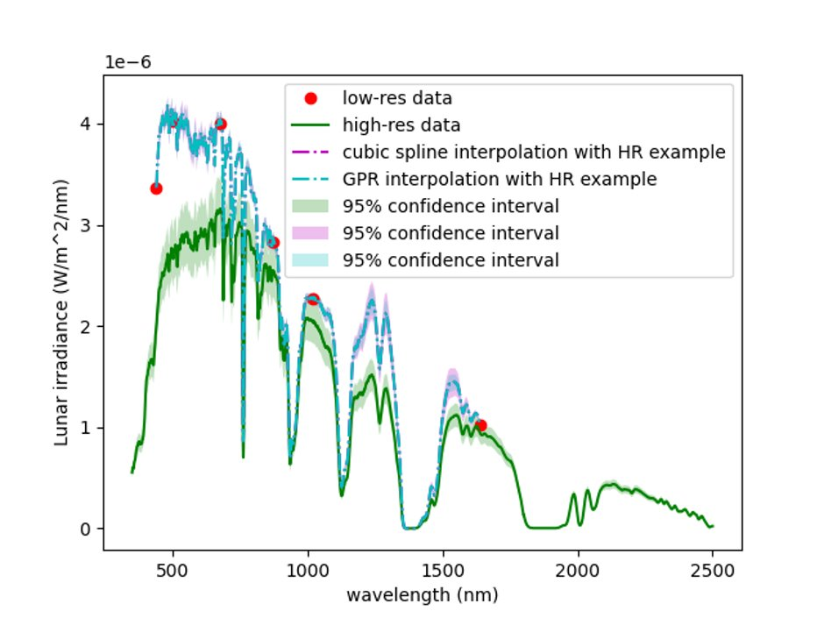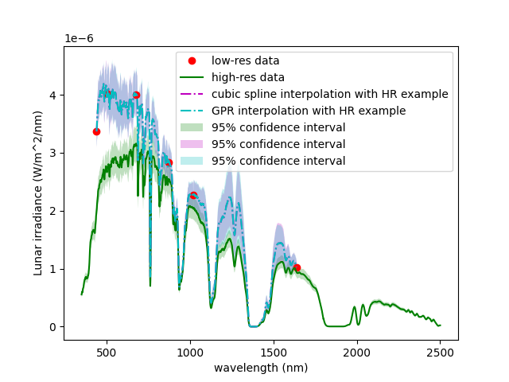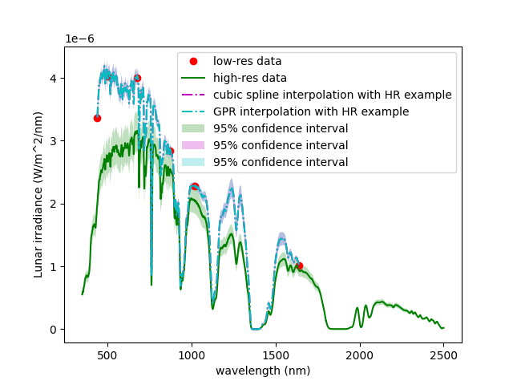
Case 1
Case 3
Case 2
Figure 1. Lunar irradiance. Red points measured full Moon high accuracy multispectral data, green data series simulated hyperspectral measurements with 5% relative uncertainty, dashed violet line cubic spline interpolation of hyperspectral data to fit multispectral points, dashed cyan line is Gaussian process Regression interpolation. Shaded areas of each curve represent 95% confidence interval. Each subplot, case 1, 2 and 3 represents different values of input uncertainty see Table 1 for details.
Table 1.Instrument requirements for hyperspectral measurements for LIME
Characteristic | Value | Comment
Spectral range | 400 nm -2500 nm | SoW
Field of view | 1° | Moon max subtends <0.6
Spectral resolution | Around 10 nm | Matches current Cimel bandwidth
 | Exemplary uncertainty for 500 nm
 | Case 1 | Case 2 | Case 3
Relative radiometric uncertainty | 0.95% | 3.00% | 0.95%
Noise | 0.02% | 3.00% | 0.50%
Non-linearity | 1.00% | 1.00% | 1.00%
Stray light | 5.00% | 2.50% | 5.00%
Temperature sensitivity | 0.10% | 0.50% | 0.10%
Total uncertainty | 5.20% | 5.05% | 5.20%

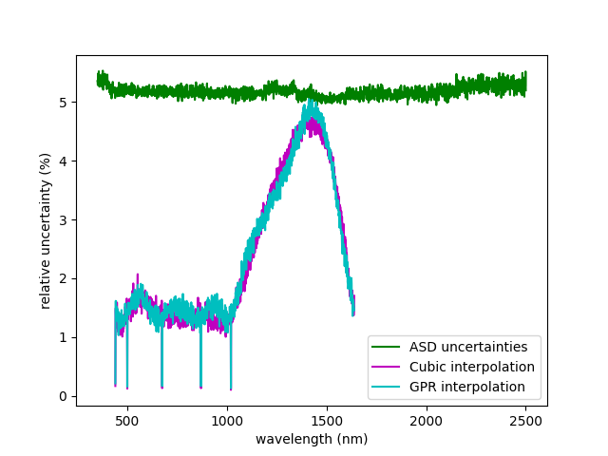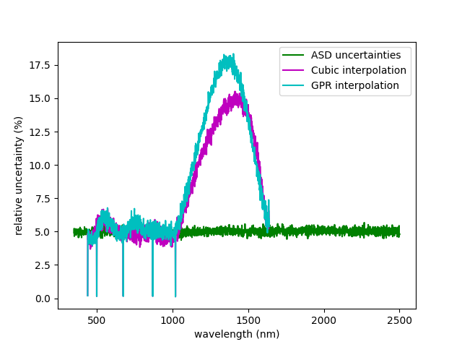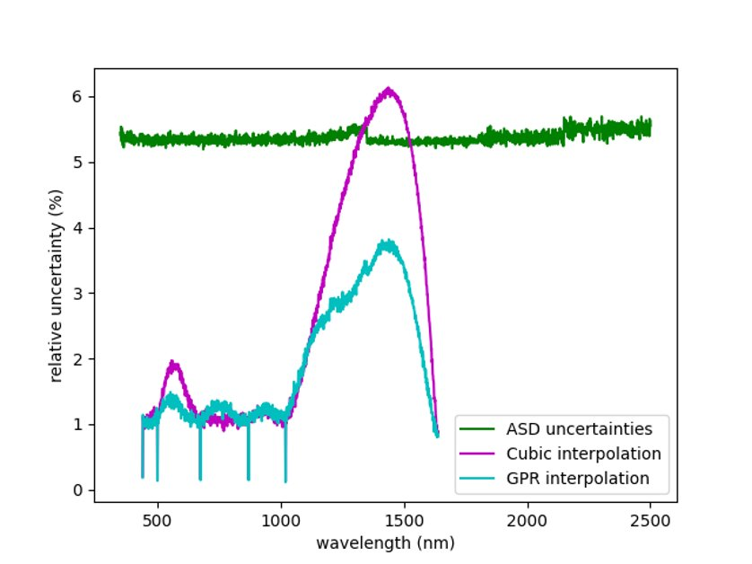
Case 3
Case 1
Case 2
Figure 2. Relative uncertainty of: synthetic hyperspectral measurements (green data series), interpolated data with high accuracy multispectral measurements using cubic method (violet data series) Gaussian process regression (cyan data series). Each subplot, case 1, 2 and 3 represents different values of input data uncertainty see Table 1 for details.
All this in hand, the requirements for the hyperspectral measurements are based on approximated uncertainty estimates which are at the level of 5%, that allows us to define the instrument requirements at this initial stage of the project. Table 1 lists a set of basic requirements for the hyperspectral instrument to be used for lunar measurements in the first set of rows, followed by the instrument characteristics with uncertainty values that were used for the interpolation simulations in cases 1-3. Therefore, the final requirement for the hyperspectral instrument should be based on the uncertainty value and type (systematic and random) and this can vary for the same instrument with changing conditions in situ. For example, the noise will vary with the moon phase angle and at some point, might become too high even with long averaging to retrieve usable signal. As a random contributor to overall uncertainty this component will become too high, and the interpolation tool will not be able to retrieve the signal with high accuracy.
Thus, to get small uncertainties on the interpolated hyperspectral data, we need small uncertainties on the CIMEL data (both random and systematic), and small random (with respect to wavelength) uncertainties on the hyperspectral data.
The ASD FieldSpec Pro 4 is a spectroradiometer available on the market that meets the set of general requirements and was chosen for this project. The set of laboratory tests were performed to verify some of the instrument’s characteristics prior to its field installation. These laboratory tests focused on the most significant instrument characteristics for lunar measurements and included spectral response function (SRF) test and field of view (FOV) and its homogeneity test and signal to noise ratio measurement. The details of the test results and further modifications that were done to enable in situ semi-autonomous deployment are described in D1, Lunar hyperspectral measurements: instrument requirement specification and observational strategy for LIME report.
The adaptation of the ASD spectroradiometer for semi-autonomous in situ use consisted of:
- setting the fore-optics (1 ° lens + scrambler) in the holder and optic fibre protective conduit
- building instrument waterproof enclosure with thermal stabilization
- development of LabVIEW software to enable automounts acquisition through the night.
The field campaign in Izaña started in April 2022 and lasted until end of June 2022, was extended for another on month of measurements in September 2022. The ASD data were then propagated to top of atmosphere (TOA) using Langley plots, and then calibrated and converted to lunar reflectances using the TSIS-1 solar irradiance. Next, measurements that are too noisy (e.g. in absorption features) were omitted. Specifically, wavelengths between 300 nm – 400 nm, 680 nm – 690 nm, 713 nm - 740 nm, 757 nm – 769 nm, 809 nm – 840 nm, 890 nm – 1000 nm, 1090 nm – 1181 nm, 1307 nm – 1540 nm, 1740 nm – 2080 nm and 2345 nm – 2500 nm are masked. These wavelengths are masked and replaced using spectral interpolation. The TOA ASD data are then divided in bins of 10° phase angles spanning from -95° to 95°. Figure 3 presents the results of lunar reflectance derived from hyperspectral measurements. The mean spectrum in each bin was then interpolated linearly to a phase angle grid with steps of 1 degree. These interpolated lunar reflectances provide the reference ASD dataset that is used within the LIME TBX.
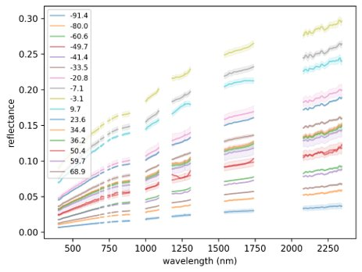
Figure 3 ASD spectroradiometer in situ measurements from Izaña binned into 10° phases angles.
The outputs from the in situ measurements after rescaling to Cimel bands are stored in DB-1.
Output Deliverables
D-1 | Lunar hyperspectral measurements: instrument requirement specification and  observational strategy for LIME
DB-1 v1 | DB of hyperspectral lunar irradiance/reflectance measurements  (measurements performed in this project)

Task 1.2: Upgrading the ESA lunar photometer with additional spectral bands
The CIMEL lunar photometer had 9 filters ranging from 340 nm to 1640 nm. The two UV bands, 340 nm and 380 nm are not suitable for the lunar observations due to too low lunar signals and were replaced with 550 nm and 780 nm (see Figure 4). The lunar photometer irradiance processing chain was updated to allow for retrieval of lunar irradiance through Langley plots in the new spectral channels and implemented with the new version software of SW-1.
Output Deliverables
HW-1 | Upgraded lunar photometer
SW-1 | Updated lunar irradiance processing chain

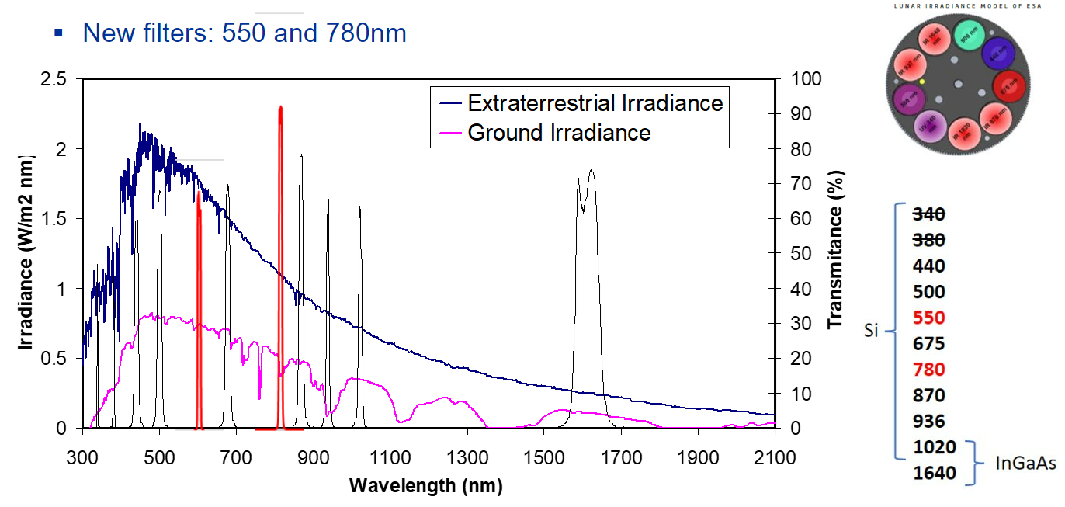
Figure 4 Filters added and removed from the Cimel Lunar photometer. (Ref a copy of slide from Lime measurements presentation at 4th Join GSICS/IVOS Lunar Calibration Workshop, Dec 2023).

Task 1.3: Improving the spectral interpolation of the LIME output
LIME (v01) was developed from SI-traceable observations at the CIMEL photometer spectral bands. This was then extended to a spectral model from 400 nm to 2500 nm using a blended spectrum from the Apollo lunar rock samples. The spectral model was further improved in this project using observations acquired with the ASD spectroradiometer in Izaña.
The algorithm and software capabilities for combining the data from the hyperspectral library with modelled reflectance at the Cimel bands were developed. By spectrally interpolating the LIME model between the Cimel bands, a hyperspectral lunar irradiance model is obtained, that can be band-integrated with the SRF of a wide range of multi-spectral satellite sensors. To improve the spectral interpolation, the data from 4-month measurement campaign with a hyperspectral ASD spectroradiometer at Izaña Observatory in Tenerife, where the Cimel is also located are used. After processing (including spectral interpolation, and interpolation with phase angle, as discussed in Section 3.1), the reference ASD dataset provides lunar reflectances between 400 and 2500 nm with a spectral sampling of 1 nm and from phase angles of -90 to 90 degrees with a sampling of 1 degree.
The ASD spectroradiometer data was subsequently used as a reference for doing the spectral interpolation between the Cimel photometer points (see Figure 5). This was done by the comet_maths module of the CoMet toolkit, by scaling the ASD data to go through the Cimel data points (after considering the Cimel SRF). This tool also propagates uncertainties through the interpolation process (including a contribution to account for the choice of interpolation method). The scaling factors at the Cimel wavelengths were then spectrally interpolated and applied to the ASD measurements. That way a spectrum is obtained that goes through the Cimel data points and has a spectral shape as similar as possible to the ASD data. This method was implemented into the LIME-TBX, using the ASD data nearest in phase angle (on the 1-degree grid) to the requested phase angle within the LIME-TBX. The same interpolation method can also optionally be applied to the Apollo lunar reflectance spectrum within the LIME-TBX.

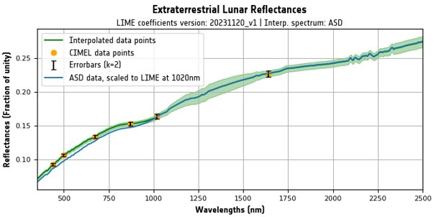
Figure 5 Example of LIME TBX window, showing ASD hyperspectral data scaled to Cimel multispectral bands. Blue data series ASD data, yellow points Cimel measurements, errors bars are k=2 uncertainty and green data series are hyperspectral data fitted though Cimel points.

Output Deliverables
DB 1 v2 | Database of hyperspectral lunar irradiance/reflectance  measurements (measurements performed in this project + available from external  sources)
D-3 | Updated LIME ATBD
SW-2v2 | Updated LIME model SW
SW-3 | LIME TBX

Task 1.4: Improving the LIME output uncertainty estimates
To enable the propagation of uncertainties up to the final model simulated hyperspectral irradiances, a Monte Carlo approach is implemented throughout the processing chain using the CoMet toolkit (www.comet-toolkit.org). The process is broken down into multiple steps. First, uncertainties on the TOA (Langley-corrected) lunar reflectance from the Cimel measurements are determined. Next, these uncertainties are propagated through fitting the LIME model. Next within the LIME-TBX, the LIME model uncertainties are propagated to the LIME reflectances for a given observation.
Uncertainties are also propagated through the derivation (i.e. from measurement through calibration and binning) of the reference ASD reflectances. Within the LIME-TBX, the ASD and LIME refelctances are combined to provide hyperspectral lunar reflectance and irradiance. The ASD and LIME reflectance uncertainties are also taken into account through this spectral adjustment process, together with a model uncertainty arising due to the interpolation process. Finally, the uncertainties in the spectral adjustment process are detailed and combined with a solar irradiance model to calculate the lunar hyperspectral irradiance uncertainties.
Output Deliverables
SW-3 | LIME TBX
D-3 | Updated LIME ATBD

Task 1.5: Comparison of LIME outputs to various datasets
The updated LIME model developed in this project was compared to several EO sensors, as well as repeating the comparisons with the GSICS implementation of ROLO (GIRO). Following EO sensors are compared with the LIME Toolbox implementation:
• Proba-V cycles of lunar acquisitions
• Sentinel-3 lunar acquisitions
• Pléïades lunar acquisitions
Figure 6 shows a flowchart of the procedure that is applied to the input to the model. Output of the procedure is the simulated lunar irradiance, which can be compared with the relevant measured irradiance.
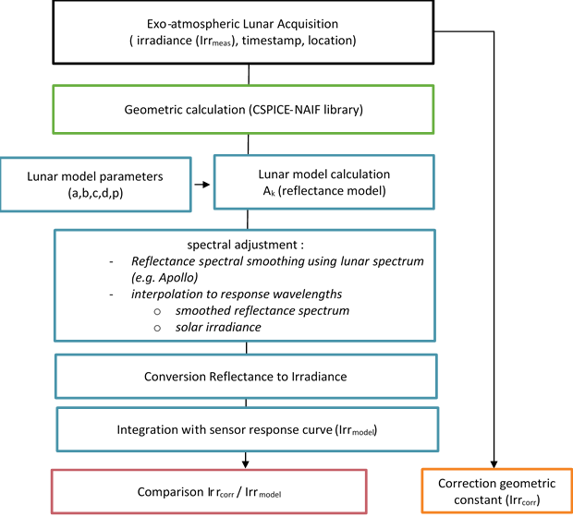
Figure 6 Measurement and LIME Model comparison procedure(Ref Figure 2 in D-4)
LIME TBX implementation provides an easy-to-use comparison tool that plots out the comparison results and comparison statistics. An exemplary result of comparison output using LIME TBX is presented in Figure 7, where both observed (Pleiades in this case) and simulated lunar irradiance data are plotted as blue and orange data series and relative difference between them as a grey data series with the values plotted on secondary y-axis for better visibility. The plot title contains information about the version of LIME coefficients used and interpolation spectrum which here is derived from hyperspectral ASD measurements, dates of the data acquisition, numbers of points in comparison and basic statistics.
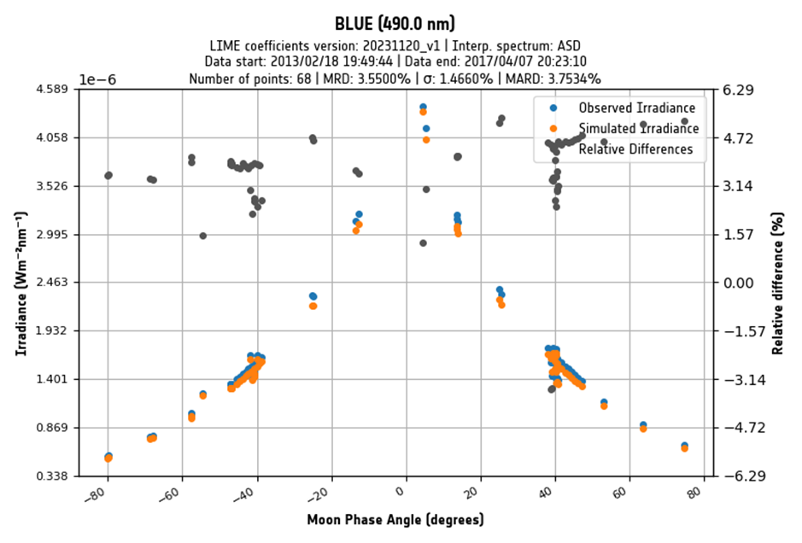
Figure 7 PHR1B band 1 (blue) result – 1088 model.
The full comparison results are reported in D-4 Updated LIME comparison to various datasets. The main conclusion from the comparison of the model with updated coefficients to PROBA -V is better agreement in the absolute level compared to PROBA-V for all VNIR bands and significant reduction of the short-term temporal variation between observations in time. Table 2 presents the average percentage difference between PROBA-V spectral bands and lime model for coefficients applies in LIME 2 project and LIME 1.
Table 2 PROBA-V comparison to the 1088 lunar model.
BAND | BLUE | RED | NIR | SWIR
% | 450 nm | 645 nm | 834 nm | 1665 nm
AVG LIME 2 | -1.547 | 1.158 | 1.472 | -70.846
STDEV LIME 2 | 3.259 | 1.529 | 1.801 | 9.588
AVG LIME 1 | 0.337 | 2.040 | 3.711 | -73.310
STDEV LIME 1 | 0.982 | 1.128 | 1.636 | 2.718

In general, the comparison results are within the expected percentage differences 2 to 4% for GIRO, below 3% for S3 (for all bands apart from 401 nm) and -1.5%to 1.5% for PROBA-V (apart from SWIR band).
However, the comparison with Pleiades shows the output of the LIME model irradiance is lower than the PLEIADES irradiance levels, calibrated with other vicarious calibration methods. The comparison with the instrument shows differences of the order of 3.5 to 6 %, depending on the spectral band. For the simulation of irradiances (LIME TBX output) the results are based upon the direct model input (phase angle, libration angles, distance correction) as provided by the satellite/instrument operator. Therefore, the intermediate step calculating from position to angles is omitted to simulate the LIME irradiance output.
The comparisons performed in this project with the current version of the lunar model have the following issues:
- A possible lunar phase dependency is observed for all bands, for low phase angles (<10 degrees).
- PROBA-V SWIR data processing is to be re-assessed for lunar data, as the results do not agree with knowledge of other absolute calibration methods.
Output Deliverables
DB-2 | Database of remote sensing lunar observations in GLOD format
D-4 | Updated LIME comparison to various datasets

Task 1.6: Assessing the impact of the LIME modelling capabilities on night aerosol retrieval
The purpose of Task1.6 was to assess the impact on the stability and accuracy of aerosol retrieval (day vs. night) of using the LIME (version v01) vs. the ROLO implementation for Moon photometry observation (RIMO) correction factor (RCF) lunar irradiance model as reference, which accounts for a correction factor to provide accurate lunar photometric aerosol measurements, comparing also the impact on Aerosol Optical Depth (AOD) using the ROLO/RIMO model.
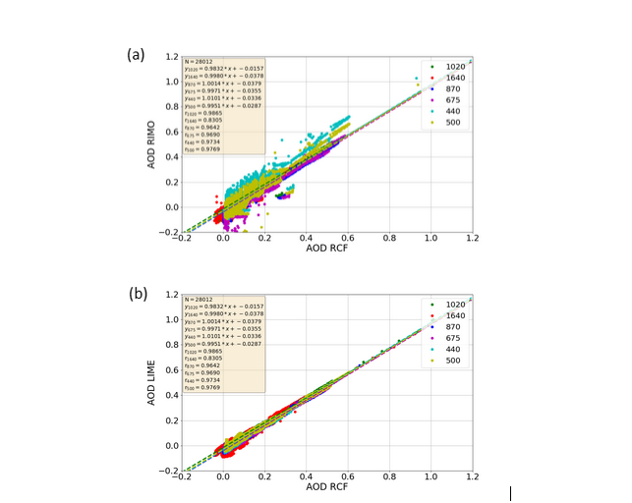
Figure 11 Scatterplot between the AOD retrieved using RCF as reference and the AOD calculated using (a) RIMO and (b) LIME, for the six different spectral bands of the CE318-TS. Statistics of the fitting plots are also included in the text box, with number of points (N), linear fitting coefficients and regression coefficient (r). Axis in (a) have been adapted to those in (b), and therefore outliers are not visible in this graph. (ref. Figure 3 in D-5)
The LIME model introduces a substantial improvement in the calculation of AOD at night in comparison to the use of the ROLO/RIMO model. Our results show AOD departures from our references (the AOD retrieved using the RCF model) quite consistent to the 2% uncertainty limit expected for the LIME model. In this sense, standard errors below 0.014 have been found in the linear fitting analysis between AOD RCF and AOD LIME. The only exception was found for those Cimel spectral bands measuring with the InGaAs detector (1020i and 1640 nm), where a higher standard error was retrieved using LIME. In the case of 1640 nm we observed standard errors of 0.027 in the RCF versus LIME comparison in contrast to the value of 0.023 found in the comparison RCF versus RIMO. These differences are one order of magnitude higher in the case of RCF-LIME comparison at Silicon 1020 nm (0.001) with respect to InGaAs 1020 nm (0.016) spectral band. Similar conclusions can be extract from the analysis of AOD differences with the optical air mass.
However, despite of these good results, we have to admit that appreciable problems still exist in the LIME v01 irradiance model, associated to low phase angles (still needed more measurements near full moon), associated to the InGaAs spectral bands, but also to the rest of spectral bands in the view of the important zenith angle dependence of the AOD retrieved at night with the LIME model (Figures A2 and 6). On the other hand, the RCF was specifically designed to achieve accurate AOD, but not accurate extraterrestrial lunar irradiance in SI units. There are fundamental differences between LIME and RCF, the main one being the SI irradiance calibration of the measurements used to derive the LIME model. This is not existing in RCF, thus the RCF cannot be used to infer lunar irradiance, only AOD. However, the AOD retrieval with LIME is a good indication of the model uncertainty and helps monitoring the model performance.
Output Deliverables
D-5 | Report on the impact of using the LIME model on the stability and accuracy of  aerosol retrieval (day vs. night)

Task 2: Development of the LIME toolbox
Within this project, the Task 2 objective was to develop a LIME toolbox (LIME-TBX) allowing to easily run the LIME model and compare its outputs to remote sensing measurements, especially ESA satellite sensors.
The LIME-TBX requirements were described in Annex 1 of the [R-0] and agreed with ESA in deliverable D6 – LIME-TBX requirement document. The main functionality is to simulate lunar observations for any observer position or satellite sensor (with specified spectral response function (SRF)) at any date/time.
The LIME model has been implemented in a software toolbox, LIME-TBX to facilitate the use of the LIME model by the scientific community, mainly for satellite Cal/Val exercises. The toolbox incorporates the novel spectral reflectance derived from hyperspectral measurements as a default option, as well as the Apollo rocks spectrum used in the previous model version as an additional option. These are used for spectral interpolation between the Cimel photometer bands. The toolbox also provides uncertainty estimates for the lunar irradiance simulations and flexible input/output, both from a user interface of the desktop application and the command line. Visualization tools and import/export of data are shown in Figure 7. Predefined and custom instrument SRF can be used to simulate the signal from actual sensors.
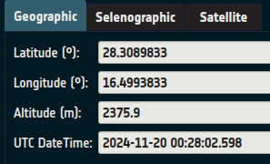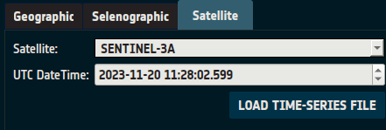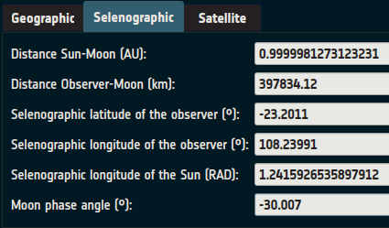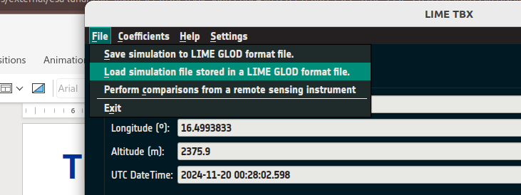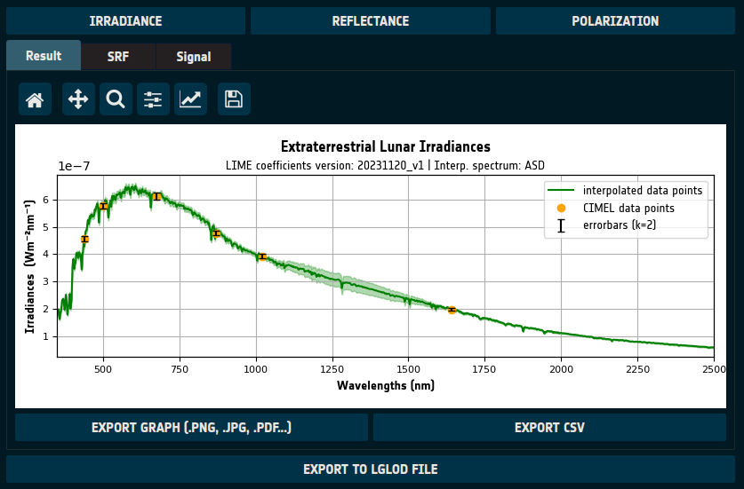
Figure 12 LIME-TBX screenshots showing its functionality.
Another function of LIME-TBX is the capability to perform and visualise (Figure 8) comparison between the LIME model and a satellite of interest or in situ measurements.
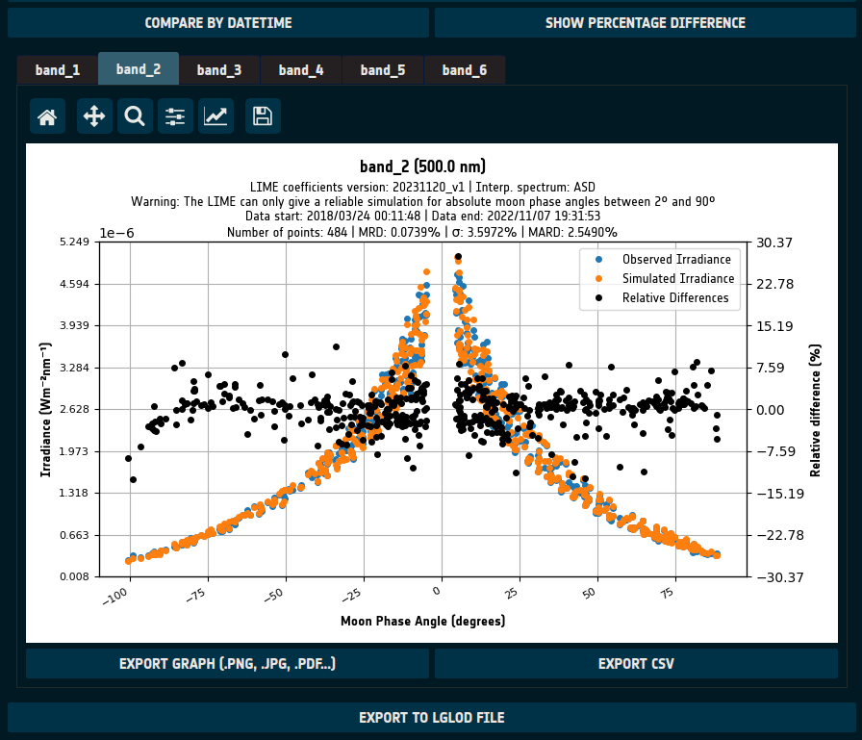
Figure 13 LIME-TBX a screenshot from comparison of model Lunar irradiance and the observed irradiance (derived from in situ measurements fitted to Langley plot)

Output Deliverables
D-6 | LIME TBX requirement document
D-7 | LIME TBX technical specification document
D-8 | LIME TBX verification plan
D-9 | LIME TBX verification report
D-10 | LIME TBX user manual
SW-3 | LIME TBX

Task 3: Project management
Task 5 covered the project management aspect of the project in accordance with the contract and project management standards set up by NPL which allowed NPL to manage the risks and issues during the delivery of the project to ensure its success. Regular communication with the customer was maintained to allow visibility of how the delivery was coordinated, alongside the official project meetings via teleconferences with Marc Bouvet of ESA, NPL, UVa and VITO. The progress of the delivery was documented as the minutes of the project’s meetings.

Project outreach, publications, and presentations
Outcomes from LIME 1 project were summarised into a peer review publication, that is currently under review.
Carlos Toledano et al., LIME: Lunar Irradiance Model of ESA, a new tool for the absolute radiometric calibration using the Moon, MS No.: egusphere-2023-1539.
The current LIME-2 project was presented at the following meetings:
- ESA - LPS 2022
- BIPMWMO, September 2022
- GSICS 2023 Annual Meeting, March 2023
- 4th Join GSICS/IVOS Lunar Calibration Workshop, Dec 2023
The deliverables from LIME 1 project and LIME model coefficients are available to the user community via COES Cal/Val portal https://calvalportal.ceos.org/lime.
The in situ data sets from multispectral and hyperspectral measurements were published on Zenodo platform:
De Vis, P., Gatón Herguedas, J., Toledano, C., González, R., MacLellan, C., & Ramsay, R. (2024). LIME ASD spectral lunar reflectance dataset (1.0.2) [Data set]. Zenodo. https://doi.org/10.5281/zenodo.10540556.
Toledano, C., González, R., Adriaensen, S., Gatón Herguedas, J., & De Vis, P. (2024). LIME Cimel spectral lunar irradiance dataset (1.0.0) [Data set]. Zenodo. https://doi.org/10.5281/zenodo.10534334 .

Project legacy and future activity
The LIME model coefficients are publicly available to the users via CEOS Cal/Val portal. The coefficients are updated annually with the increased number of in situ measurements. In total 450 Langley plots were collected from in situ measurements using Cimel photometer to fit the model. The LIME model is regarded as the one with robust uncertainty evaluation within GSICS community, as it was commented several times by Tom Stone at 4th Join GSICS/IVOS Lunar Calibration Workshop Dec 2023.
The future activities will be conducted as a CNN to the current project and will focus on further improvement of the LIME model and dissemination and maintenance of LIME-TBX.
A dedicated LIME website will be of great interest for public dissemination and use of the LIME model. It will provide all the scientific information (publications and documentation) related to the lunar model, as well as access to the Toolbox. Moreover, a forum will be created for interaction with the users. The purpose is to assist the users in the utilisation of LIME and to receive feedback that helps improving the model and the toolbox itself. Questions will be answered within a working week. As indicated in the CCR, the website will include a general presentation of LIME, access to the LIME code on a repository and Toolbox installers for linux/Windows/Mac. The access will be restricted to registered users. The collection of user data will be compliant with the GDPR (name, affiliation and email only). A quarterly report about statistics on the website registration/usage/access will be provided.
The LIME-TBX will be maintain as it is expected that the software will evolve by incorporation of new functionalities and error corrections. The documentation associated to the LIME-TBX will be maintained in line with the software evolution. Software problem reports will be tracked using the git repository functionality. The LIME requirement document will incorporate additions as per ESA request, as well as those arising from user’s feedback or relevant communities like the GSICS working group on lunar calibration. The final goal is to foster LIME improvements and evolution, both for the model itself and the Toolbox.
The measurements of a radiometrically characterized and calibrated photometer are fundamental to the LIME model. Those measurements cover the spectral range 440-1640 nm in 12 narrow spectral bands. In between those bands, the hyperspectral measurements of an ASD spectroradiometer are used to provide relative spectral response to the lunar reflectance. One of the limitations of the current model is the lack of reliable Cimel observations beyond 1640 nm, i.e. in the range 1640-2500 nm, which is the upper spectral limit of LIME. To overcome this problem, we propose to modify another Cimel radiometer by incorporating a 2200 nm spectral channel.
This CCN also aims to improve the spectral interpolation. This will be done by improving the ASD measurements as well as the data processing that is applied before providing the reference ASD dataset to the LIME-TBX. The measurements will be improved through developing new fore optics for the ASD. These fore optics will have a larger and better understood field-of-view, which will make the measurements less sensitive to small offsets and the changing shape of the moon as it goes through the lunar phases. The new system should be less sensitive to angular variation and will thus have a more robust calibration. Another improvement will come through additional quality checks and outlier removal. This will be implemented in an automated python script that checks the Langley plot results and propagates uncertainties.
The LIME model consists of 2 major parts: total lunar irradiance and the degree of linear polarisation (DoLP) predication. The latter is based on lunar phase angle only and therefore quite convenient to model. Within the scope of this project, significant improvements to both model parts are proposed:
- Extension of the DoLP with hyperspectral data,
- Improve interpolation between the different CIMEL wavelengths,
- Improve the filtering of the CIMEL data,
- Modelling of Angle of Linear Polarisation (AoLP)

The LIME uncertainty at the Cimel bands can be considered fix although according to Monte-Carlo simulations in LIME-1 project, there is small dependence of this uncertainty on phase angle.
www.comet-toolkit.org

