Abstract
This document describes the database of lunar observations and hyperspectral measurements as in DB1 and DB2

Adriaensen Stefan

VITO

18 December 2023
Description lunar irradiance databases DB1 AND DB2

This document was produced as part of the ESA-funded project “Improving the lunar irradiance model of ESA” under ESA contract number: 4000136003/21/I-DT-lr



Signatures and version history

 | Name | Organisation | Date
Written by | Stefan Adriaensen | VITO | 24-Nov -2023
Reviewed by (consortium)
Approved by (ESA) | Marc Bouvet | ESA

Version history

Version | Date | Publicly available or private to consortium?
0.1 | 24/11/2023 | created

Contents

1 Introduction 3
1.1 Purpose and Scope 3
1.2 Applicable and reference documents 3
1.2.1 Applicable Documents 3
1.2.2 Reference Documents 3
1.3 Glossary 4
1.3.1 Abbreviations 4
2 Description of the content 5
2.1 Database Organization 5
2.2 Overview of the sensors per database 5
2.3 Folder structure 6
2.4 File formats 7
2.5 Filename convention 9
3 Database content 9
3.1 DB1: reflectance spectra 9
3.2 DB2: Irradiance measurements 11
4 Conclusion 12

Introduction

Purpose and Scope
This document describes comparison of the lunar irradiance model with other datasets and models.

Applicable and reference documents

Applicable Documents
The following applicable documents are those specification, standards, criteria, etc. used to define the requirements of this representative task order.
Number | Reference
[AD1] | ESA-TECEEP-SOW-002720. Lunar spectral irradiance measurement and modelling for absolute calibration of EO optical sensors.
[AD2] | LUNAR IRRADIANCE MODEL ALGORITHM AND THEORETICAL BASIS DOCUMENT (D3)

Reference Documents
Reference documents are those documents included for information purposes; they provide insight into the operation, characteristics, and interfaces, as well as relevant background information.
Number | Reference
[RD1] | H.H. Kieffer and T.C. Stone. The Spectral Irradiance of the Moon. 2005. The American Astronomical Society. DOI:10.1086/430185.
[RD2] | http://gsics.atmos.umd.edu/bin/view/Development/GiroV1Release
[RD3] | Lunar observations data set preparation + results with the Pleiades satellites – LEO, Lachérade et al., GSICS Workshop, Darmstadt
[RD4] | PROBA-V Quarterly Calibration Report Q4 2019, http://proba-v.vgt.vito.be/en/quality/platform-status-information/quarterly-image-quality-reports, Sterckx et al
[RD5] | Wu, Yunzhao, Wang, Zhenchao, Cai, Wei, and Lu, Yu. The Absolute Reflectance and New Calibration Site of the Moon. United States: N. p., 2018. Web. doi:10.3847/1538-3881/AABAF5.
[RD6] | http://gsics.atmos.umd.edu/pub/Development/LunarWorkArea/GSICS_ROLO_HighLevDescript_IODefinition.pdf

Glossary

Abbreviations

Abbreviation | Stands For | Notes
ESA | European Space Agency | Project customer
NPL | National Physical Laboratory | Project partner
DOLP | Degree of Linear Polarization
EO | Earth Observation
GIRO | GSICS Implementation of the ROLO model
GLOD | GIRO Lunar Observation Database
SWIR | Short-Wave InfraRed
USGS | U. S. Geological Survey
UVa | University of Valladolid | Project partner
VITO | Flemish Institute for Technological Research;(Vlaamse Instelling voor Technologisch Onderzoek) | Project partner
VNIR | Visual and Near InfraRed

Description of the content

Database Organization

This document contains the overview of folder structure with data from extraterrestrial lunar observations, as well as measurements (both multi and hyperspectral) performed from earth stations.

The database consists of several folders and subfolder with files single lunar observations for several optical sensors. The file set contains 2 databases:
- DB1 is a hyperspectral database with different lunar reflectance spectra which could be used to experiment with the different interpolations in between LIME model spectral points.
- DB2 contains total irradiance measurements taken by various sensors with a measurement sample in the VNIR/SWIR range, for both hyperspectral and multispectral observations.
Two versions are currently maintained: a private and public version of the folder structure.

Overview of the sensors per database

DB1 contains hyperspectral reflectance measurements from 4 different instruments or campaigns:
- AIR-LUSI
- APOLLO 16
- ASD
- GOAFEN2

DB2 contains lunar observations from 5 different instruments or campaigns:
- AIR-LUSI
- CIMEL
- PLEIADES-1B
- PROBA-V
- S3-OLCI
The underlined sensor names are publicly available (or a subset).

Folder structure

The LIME project private database has the following underlying top level file structure. Folder names are the commonly known names for the sensors. In the DB2 database, a subfolder is dedicated to the sensor response functions.

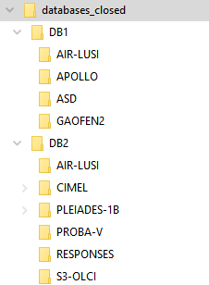
Figure 1: LIME project private database top level file structure

File formats

The files contain an attribute section, with the required information as been described in [RD6]. It can be seen as a header to the file, giving information on the origin of the data, meta data convention, … .
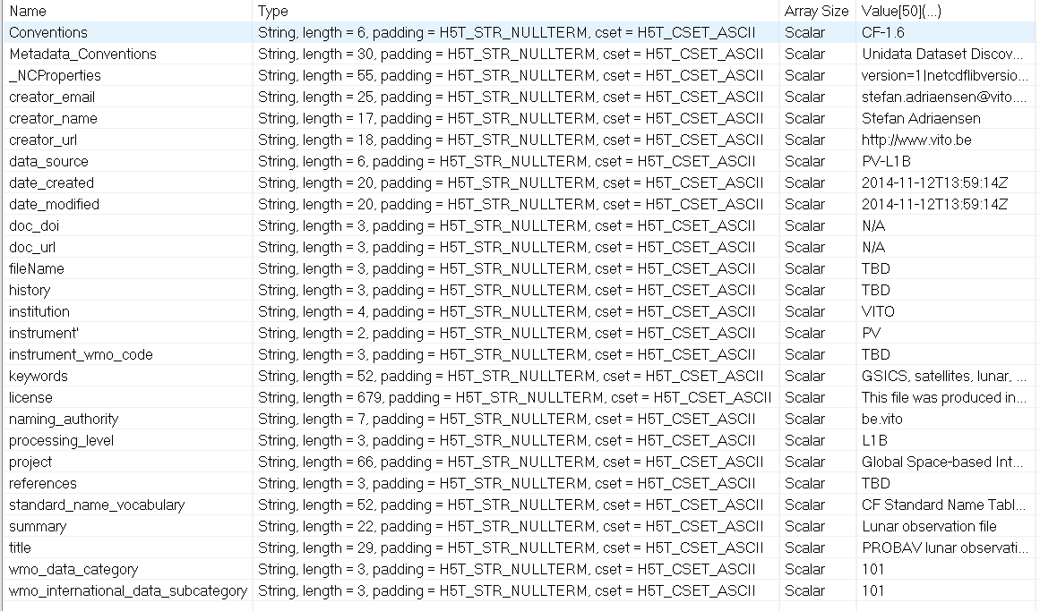
Figure 2: Attributes example PROBA-V

For DB1, a simple netCDF file format was adopted, storing reflectance data as well as the wavelength and uncertainties. The header of the file (attributes section) is general the same, although some extra info is added, i.e. phase angle at which the data recorded.
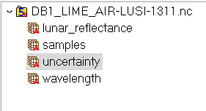
Figure 3: DB1 reflectance netCDF file example

For DB2, the database files are directly insertable into the LIME TBX, so it is chosen to adopt the complete standard of the GSICS GLOD recommendation. However, it is emphasized that for the different sensors, not always the same metadata can be offed, as they are not always provided. A full description of the format can be found in [RD6].

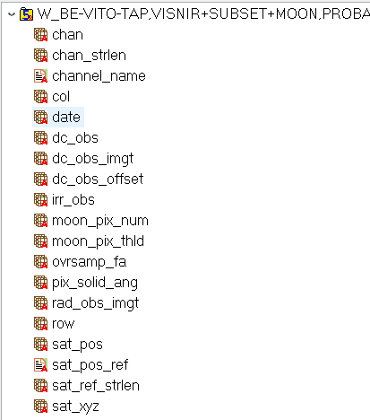

Figure 4: DB2 irradiance netCDF file example

In the subfolder RESPONSES SRF files are stored in the GLOD format. In Figure 5 the layout of the file is depicted.
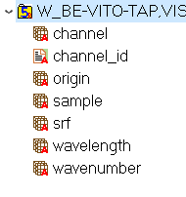
Figure 5: DB2 SRF netCDF example

Filename convention

The filenames in the database all follow the same convention as described in [RD6]. W_‘WMO_location_indicator’,VISNIR+SUBSET+MOON,‘Satellite_Name’+‘Instrument_Name’_C_‘WMO_CCCC_Code’_‘Moon_observation_time_YYYYMMDDHHMMSS’_‘version_number’.nc
Example filename for a PROBA-V observation
W_BE-VITO-TAP,VISNIR+SUBSET+MOON,PROBAV+PV_C_CCCC_20140215130436_01.nc

Database content

DB1: reflectance spectra

The database DB1 contains the hyperspectral measurements of the integrated moon disc or lab measurements. An example can be found in Figure 6.

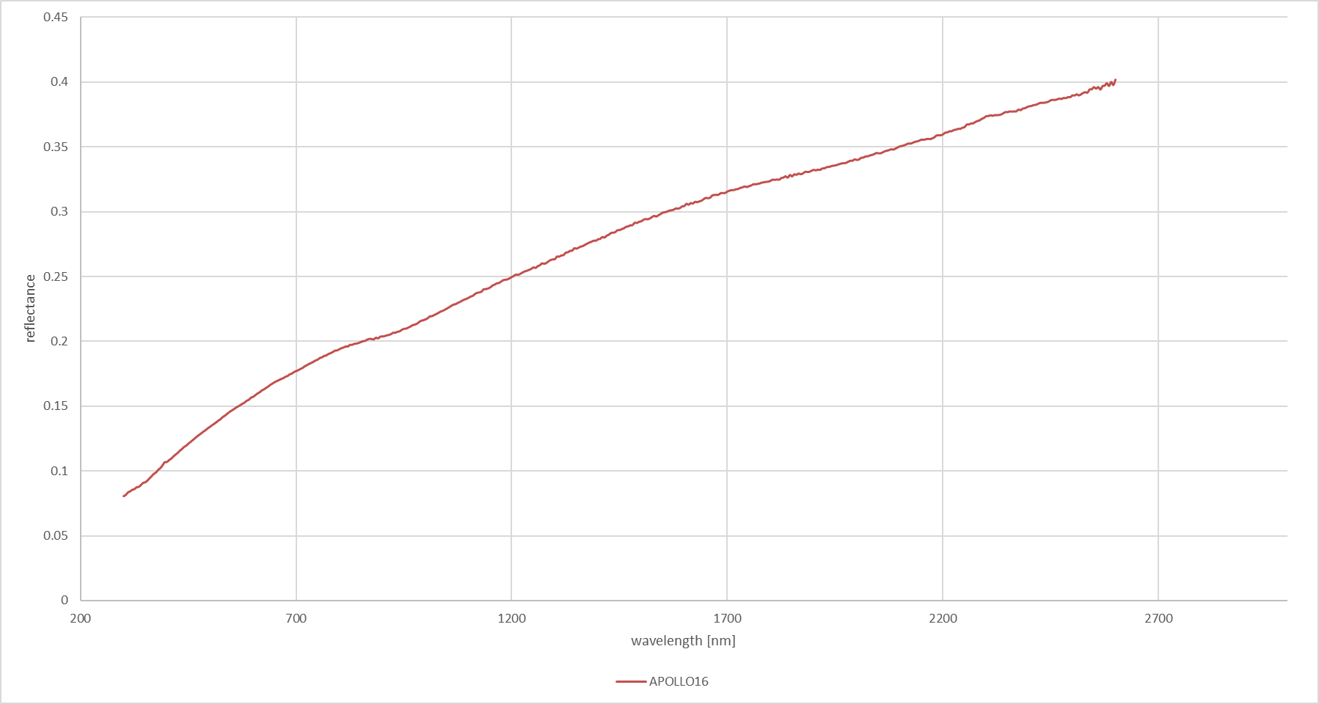
Figure 6: Example reflectance for APOLLO-16

In Table 1 a brief overview of the content of DB1 is listed. In total 9 reflectance files are present in the database. In the case of the ASD, the file contains 180 reflectance spectra.

Table 1: DB1 overview
DB1
SENSOR | NR_OBS | WL[nm] | phase [deg]
AIR-LUSI | 1 | 351,1099 | 9.38
APOLLO-16 | 3 | 300,2500 | 7*
ASD | 180 | 350,2500 | -90/90
GOAFEN2 | 4 | 350,2395 | 85.01,86.6,95.5,108.2

Description of the ASD dataset :
The ASD dataset is the result of a measurement campaign with an ASD instrument with a spectral range from 350 to 2500 nm. The instrument was installed in the low airmass areas of the Pico Teide in Tenerife, where many other instruments are operated. The instrument measured 3 full cycles of the lunar phase. From these measurements, by means of various processing steps, 180 reflectance spectra have been derived by means of averaging and interpolation. The spectra cover the full range of phase angles, between -90 and 90 degrees, with a step of 1 degree.

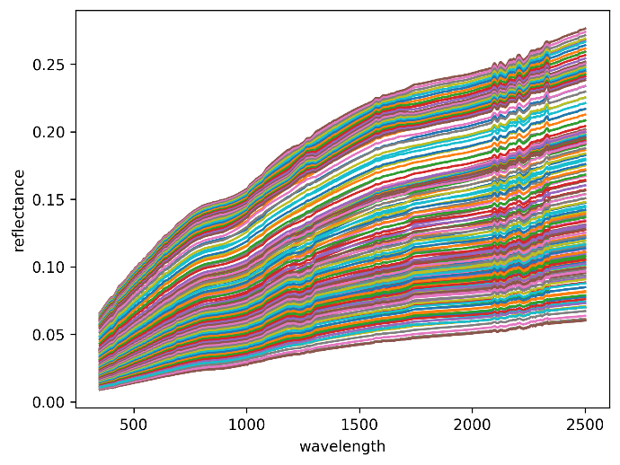
Figure 7: ASD reflectance spectra inside the single database file

In document [AD2] a full description of the ASD spectra can be found, with more details on the description of the procedure to derive the reflectance spectra.

DB2: Irradiance measurements

The DB2 has lunar irradiance measurements with its annotated data (phase angles,…) inside the GLOD files. The number of files per sensor depends on the availability of the dataset, as they are published by the data owners.

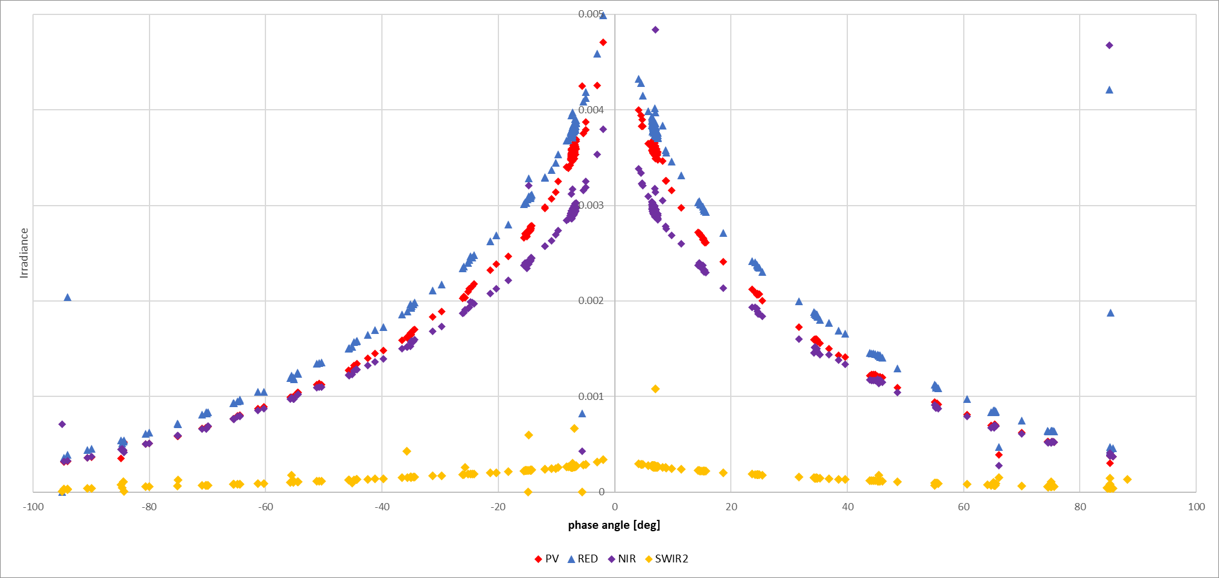
Figure 8: PROBA-V irradiance measurements

The dataset contains a unique file for every measurement timestamp. Some sensors provide a different timestamp to every spectral band separately. This means that there will be a separate file for every measurement/band. I.e. for PROBA-V, this is the case. This means that the number of files in the DB2 are 4 times (4 spectral bands) the number of measurements.

Table 2: DB2 overview
DB2
SENSOR | NR_OBS | WL[nm] | bands | phase [deg]
AIR-LUSI | 4 | 351,1099 | 950 | 9.38,21.00,33.26,45.94,58.50
CIMEL | 440 | 440/1600 | 6 | -90/90
PLEIADES-1B* | 68 | 430/950 | 5 | -90/90
PROBA-V | 302 | 440/1600 | 4 | -90/90
S3-OLCI | 2 | 400/1020 | 21 | -7

PLEIADES-1B remark:
For the PLEIADES-1B dataset, the platform positions are unknow, so inside database the phase and libration angles, as well as distances are included in the file, the platform position holds dummy values. There are 2 datasets for PLEIADES-1B, one uncalibrated and one calibrated. The latter has calibration factors provided by the data provider applied.
For the LIME-TBX, this requires (internally) a slightly different approach as opposed to the standard. Pleiades data only holds the geometric constant factor (no distances between bodies), so this is the only reference to compensate for it. Another way to calculate the factor is based on ephemeris data (TLE files), but this might introduce errors, when either factors are calculated wrongly.

Conclusion

This document gives a bird eye view on the databases that are compiled during the LIME project and who are to be used in the operation of the LIME TBX. The purpose of this dataset is the ability to test the LIME-TBX as well as the ability for users to have a fast-track operation of the toolbox. It is also an opportunity to release some of the datasets to the public in a uniform way.

