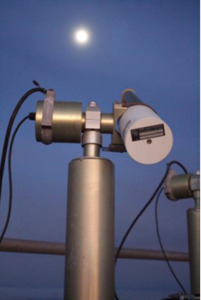 | ABSTRACT  This document provides the LIME Toolbox user guide.  Javier Gatón  Ramiro González  Carlos Toledano  Pieter De Vis  Jacob Fahy  Stefan Adriaensen  UVa , NPL, VITO  8 January 2024
LIME TOOLBOX USER GUIDE

 | This document was produced as part of the ESA-funded project “Improving the Lunar Irradiance Model of ESA” under ESA contract number:


Signatures and version history

 | Name | Organisation | Date
Written by | Javier Gatón | UVa | 8 January 2024
Reviewed by (consortium) |  | NPL, VITO
Approved by (ESA) |  | ESA

Version history

Version | Date | Publicly available or private to consortium?
0.1 | 21/12/2023
0.2 | 08/01/2024

Contents
Signatures and version history 2
Version history 2
Contents 2
1. Introduction 3
1.1 Purpose and Scope 3
1.2.1 Applicable Documents 3
1.3 Glossary 3
1.3.1 Abbreviations 3
2. Installation 4
2.1 Windows 5
2.2 Mac 5
2.3 Debian (Ubuntu) 6
2.4 Linux 6
3. Performing simulations 6
3.1 Simulation from Geographic coordinates 7
3.2 Simulation from Selenographic coordinates 8
3.3 Simulation from Satellite 9
3.4 Simulation output 9
3.4.1 Exporting graph as image or PDF 10
3.4.2 Exporting simulation as CSV 10
3.5 Spectral Response Function 10
3.6 Integrated Irradiance 11
3.7 Exporting to LGLOD format 11
4. Performing Comparisons 12
4.1 Changing to comparisons page 12
4.2 Perform the comparisons 13
4.2.1 GLOD format extensions 14
4.3 Comparisons output 15
4.3.1 Compare by moon phase angle 16
4.4 Exporting to LGLOD format 17
5. LGLOD format files 17
5.1 Loading LGLOD datafiles 17
5.2 LGLOD format details 18
5.2.1 Attributes 18
5.2.2 Dimensions 18
5.2.3 Variables 19
6. Coefficients versions 21
6.1 Updating the coefficients 21
6.2 Choosing the coefficients version 21
7. Interpolation settings 21
7.1 Selecting the interpolation reference 22
7.2 Selecting the output SRF 22
7.3 Showing CIMEL anchor points 22
7.4 Showing the interpolation reference spectrum 22
7.5 Skipping the uncertainties calculation 22
8. Command line Interface (CLI) 22
8.1 Main options 22
8.1.1 Earth 23
8.1.2 Lunar 23
8.1.3 Satellite 24
8.1.4 Comparison 24
8.1.5 Interpolation settings 24
8.2 Output 25
8.2.1 Simulation 25
8.2.2 Comparison 25
8.3 Other options 27
8.3.1 SRF 27
8.3.2 Timeseries 27
8.3.3 Coefficients Version 27
8.3.4 Interpolation Spectrum 28
9. Other 28
9.1 Adding satellites 28
9.1.1 Adding a new satellite 28
9.1.1.1 Adding a satellite with Orbit Scenario Files 28
9.1.1.2 Adding a satellite with TLE files 29
9.1.1.3 How to obtain TLE files 30
9.1.2 Adding an orbit file of an existing satellite 30
9.1.3 Extending PROBA-V TLE files 30
9.2 Logging 31
9.2.1 Log files’ location 31
9.2.2 Setting the log level to “debug” 31
9.2.3 Contacting support 31

Introduction

1.1 Purpose and Scope
This document provides the LIME Toolbox (TBX) user guide, therefore all the auxiliar information of the software of the toolbox itself. The scope is to ensure that the user knows how to correctly operate the LIME TBX and the LIME model.
1.2 Applicable and reference documents

1.2.1 Applicable Documents
The following applicable documents are those specification, standards, criteria, etc. used to define the requirements of this task.
Number | Reference
[AD0] | ESA-EOPG-EOPGMQ-SOW-24. Improving the Lunar Irradiance Model of ESA.

1.3 Glossary

1.3.1 Abbreviations

Abbreviation | Stands For | Notes
ASD | Analytical Spectral Devices | Instrument manufacturer
Cimel | (Not an abbreviation) | Instrument manufacturer, also used as shorthand for instrument itself
EO | Earth Observation
ESA | European Space Agency | Project customer
FOV | Field of View
GIRO | GSICS Implementation of the ROLO Model
GSICS | Global Space Based Inter-calibration System
GUI | Graphical User Interface
KO | Kick-off meeting
LIME | Lunar Irradiance Model of ESA
NPL | National Physical Laboratory | Project partner
ROLO | RObotic Lunar Observatory
SoW | Statement of Work
TBX | Toolbox
TOA | Top of Atmosphere
UVa | University of Valladolid | Project partner
VITO | Vlaamse Instelling voor Technologisch Onderzoek; Flemish Institute for Technological Research | Project partner

2. Installation

2.1 Windows
- Download the Windows install wizard.
- Execute it.
- Follow the wizard instructions.
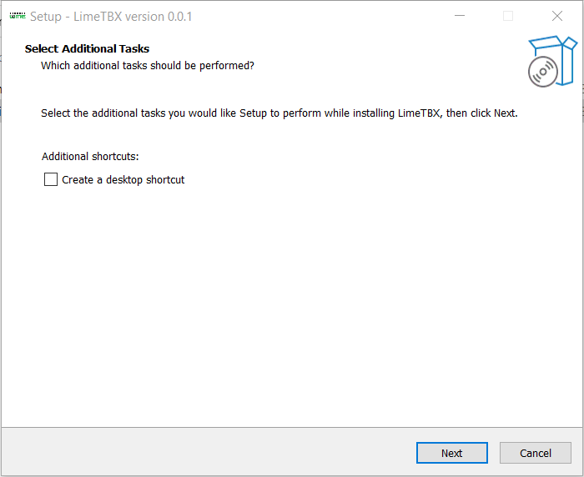

2.2 Mac
- Download the appropriate Mac .pkg for your architecture
- Execute it
- Follow the pkg wizard instructions
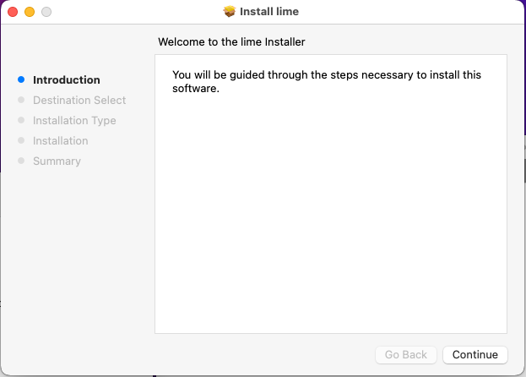

2.3 Debian (Ubuntu)
- Download the .deb package
- Execute the following command (substituting <package> with the package path and name):
sudo dpkg -i <package>

2.4 Linux
- Download the Linux .zip installer
- Extract the files in a folder
- Inside that folder, execute the following command:
sudo ./lime_installer.sh
Now you can delete the zip and the data extracted from it.

3. Performing simulations
Simulations are performed using the simulation page, which is the initial page that appears when opening the LIME Toolbox. From that page, the user can choose to perform the simulation using geographic coordinates, selenographic coordinates, or a Satellite position.
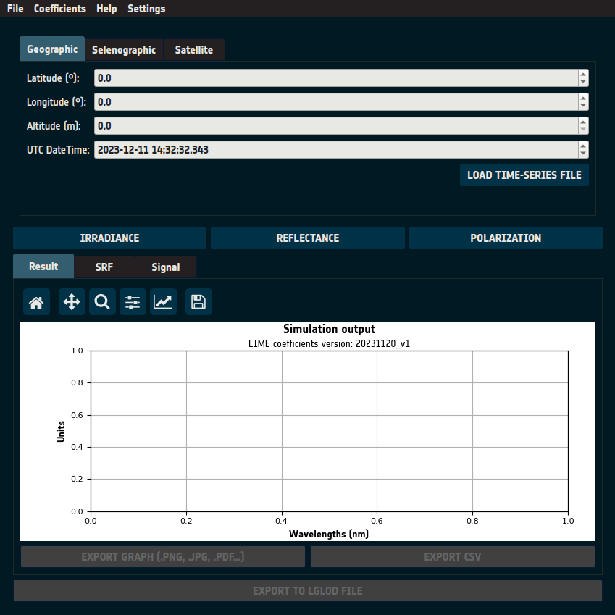

3.1 Simulation from Geographic coordinates
Selecting the tab “Geographic” allows the user to input the data needed to perform a simulation from geographic coordinates. There, the user can set the latitude and longitude in decimal degrees, the altitude in meters, and the UTC date and time.
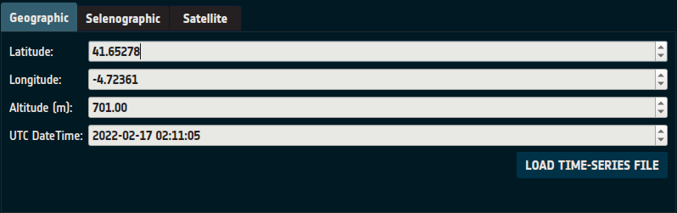
In case that the user wants to input multiple UTC datetimes, the “LOAD TIME-SERIES FILE” button can be pressed, and the DateTime input will change to the following:
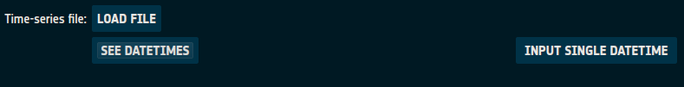

Here, the user can press the “LOAD FILE” button, where they will be prompted with a file selection dialog, where the user can select the CSV with the date time series.
The file must have one datetime per line, and each line should commit to the following format:
yyyy,mm,dd,HH,MM,SS

For example:
2022,01,17,02,02,04

To go back to manually introducing just one DateTime, the user can press the “INPUT SINGLE DATETIME” button.

3.2 Simulation from Selenographic coordinates
Selecting the tab “Selenographic” allows the user to input the data needed to perform a simulation from selenographic coordinates. There, the user can set the distance between the Sun and the Moon in astronomical units, the distance between the observer and the Moon in kilometers, the selenographic latitude and longitude of the observer in decimal degrees, the selenographic longitude of the Sun in radians, and the Moon phase angle in decimal degrees.
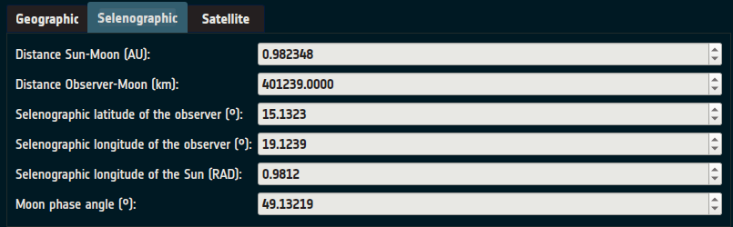

3.3 Simulation from Satellite
Selecting the tab “Satellite” allows the user to input the data needed to perform a simulation from satellite information. There, the user can select the satellite from a list of satellites and set the UTC DateTime that is going to be simulated.
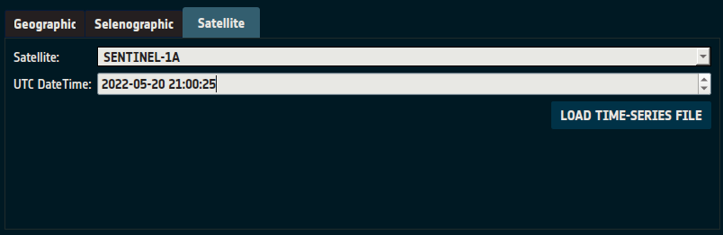
As in the simulation from geographic coordinates, the user can select a time-series file instead of a single UTC DateTime.

3.4 Simulation output
Beneath the Simulation input, there is the simulation output. It shows a graph with the irradiance/reflectance/polarization values for each wavelength present in the currently selected SRF.
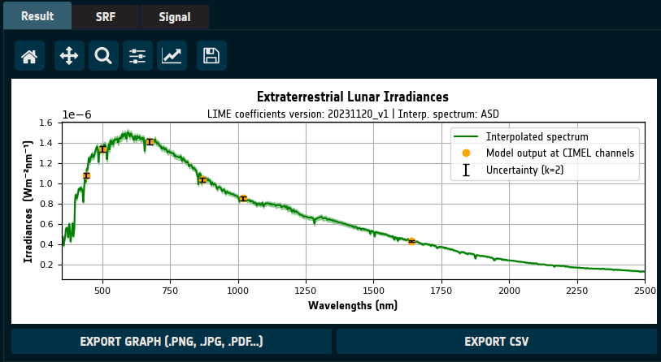

3.4.1 Exporting graph as image or PDF
On the bottom left, there is the “EXPORT GRAPH” button. If the user presses it, a filesystem dialog is opened, where the user can select the name and location of the file. To select the file format, the only needed action is to modify the extension, and the software will automatically export it with that format.
The format can be jpg, png, pdf, and other similar formats.

3.4.2 Exporting simulation as CSV
To export the results to a CSV file, the user must press the “EXPORT CSV” button at the bottom right. When pressed, a file system dialog is presented to the user, where they will be able to choose the name and location of the new file.

3.5 Spectral Response Function
The SRF tab shows the currently selected spectral response function in the graph, with two black vertical lines marking the lower and upper limits of what the LIME can correctly simulate.
The user can load different spectral response functions, pressing the “LOAD” button at the top right. When pressed, a file system dialog is presented to the user, where they will have to select the SRF file in GLOD format (netCDF) which they want to load.
After that, the user can change between different loaded SRFs with the combo box that is next to the “LOAD” button.
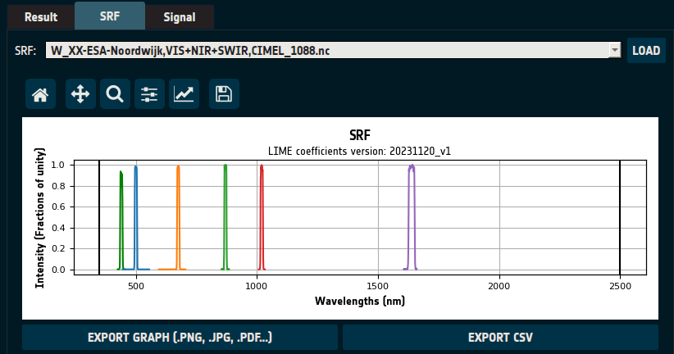
The SRF can be exported as an image and as a CSV file.

3.6 Integrated Irradiance
The integrated irradiance tab shows the irradiance per each channel of the currently selected Spectral Response Function. It can be exported as a CSV file.
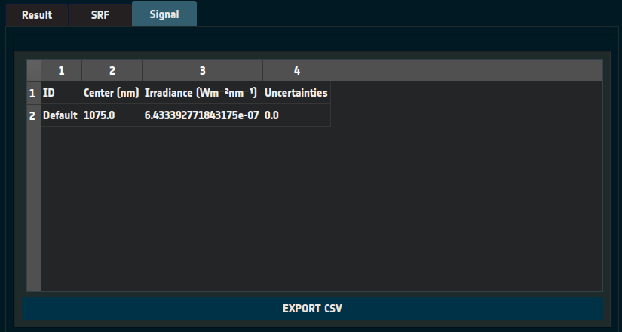

3.7 Exporting to LGLOD format
The simulation can be exported as a whole, letting the user load it again in another session, or to store it for the future.
This can be achieved by pressing the “EXPORT TO LGLOD FILE” button present at the bottom of the page.
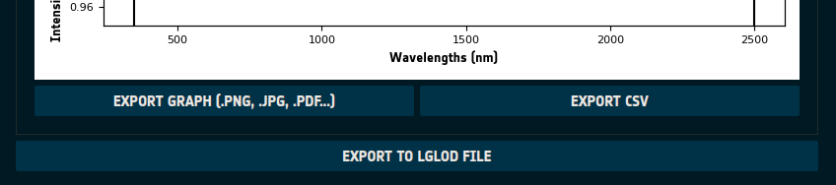

4. Performing Comparisons
The LIME Toolbox also allows performing comparisons from GLOD format data files.

4.1 Changing to comparisons page
To perform the comparisons, one must change to the comparison page, which can be done following these two steps:
- Open the “File” option in the action menu, located on the top left of the app, by clicking it.
- Now a list of options should be available. The “Perform comparisons…” option should be selected
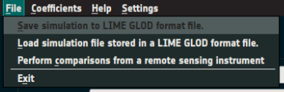
If done correctly, the app should look like the following image:
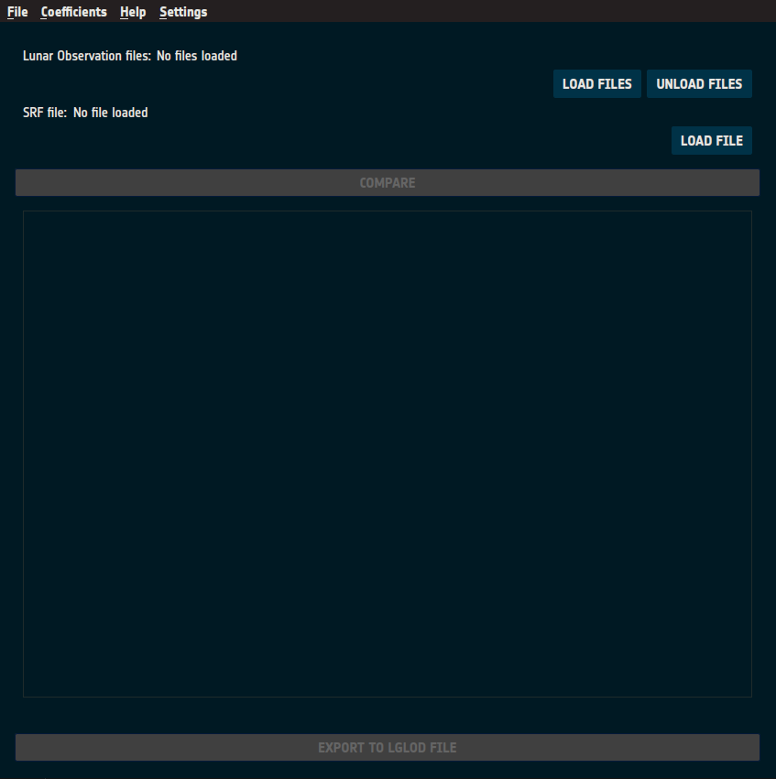

4.2 Perform the comparisons
Firstly, the “LOAD FILES” button should be clicked, which allows the user to load 1 or more netCDF files in GLOD format containing the observations. The user can press the button multiple times and the previously loaded files will still be loaded.
In case that the user wants to unload all the loaded observations, they should push the “UNLOAD FILES” button.
After having loaded all the wanted observation files, one must load the correct spectral response function file to perform the comparisons. To do that one must press the “LOAD FILE” button and select the file. This SRF file should have at least all the channels that are present in any observation.
Finally, the “COMPARE” button should become enabled, and if pushed, the comparison process should start, leaving something like this:
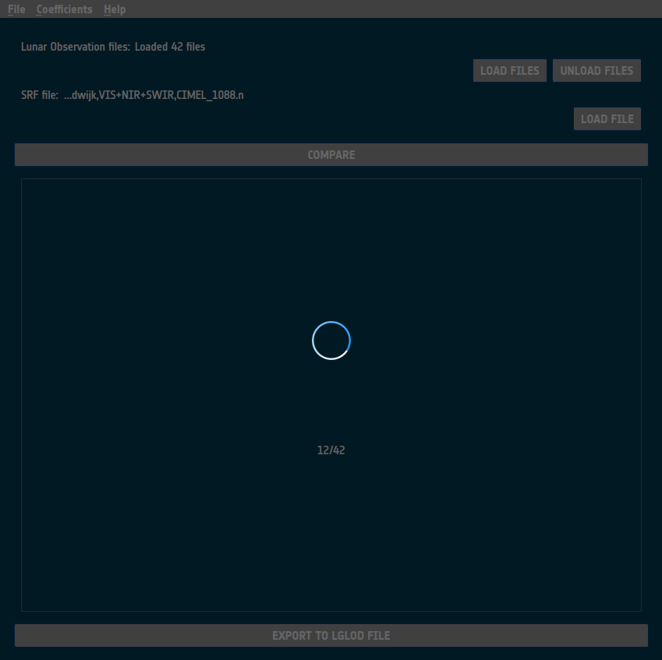

4.2.1 GLOD format extensions
The input files must be in GLOD format, but in the case that the “sat_pos” value is not present or that all the coordinates equal the fill value, the LIME TBX will look for the selenographic coordinates directly. In that case, the coordinate names must follow the following schema:
Variable name | Mandatory | Description
distance_sun_moon | Yes | Distance between the sun and the moon in AU
sun_sel_lon | Yes | Selenographic longitude of the sun in radians
distance_sat_moon | Yes | Distance between the satellite and the moon in km
sat_sel_lon | Yes | Selenographic longitude of the satellite in degrees
sat_sel_lat | Yes | Selenographic latitude of the satellite in degrees
phase_angle | Yes | Moon phase angle in degrees
sat_name | No | Satellite name in case that any mandatory variable is missing
geom_factor | No | Geometric constant by which the observed irradiance has been divided by at normalization.

These variables will have ‘date’ as their coordinate.
In case any of these mandatory values are missing, the TBX will calculate them automatically. To do so, the TBX uses the SPICE library for the first two, and the SPICE and EOCFI libraries for the latter 4. For these 4 latter mandatory variables, the TBX needs the satellite name stored in the variable “sat_name” as a string. This satellite must be present in the LIME TBX satellite list.
The variable “geom_factor” is the geometric constant by which the observed irradiance has been divided at the normalization step, which is useful in case any of the mandatory variables is missing so the TBX will normalize its simulated irradiance using this value instead of the one calculated using the given/calculated distances if this variable is present. It’s also allowed for the variable to be called “geom_const” instead of “geom_factor”.
Another optional value is the attribute “to_correct_distance”. If that attribute (it’s an attribute, not a variable) is present and with the value of 1, the ‘irr_obs’ value will be modified to normalize its value using the observation’s distances. Useful for when the irradiance is not normalized, and the distances are being calculated by the TBX.

4.3 Comparisons output
When the comparisons are finished, the comparison page should look something like the following image:
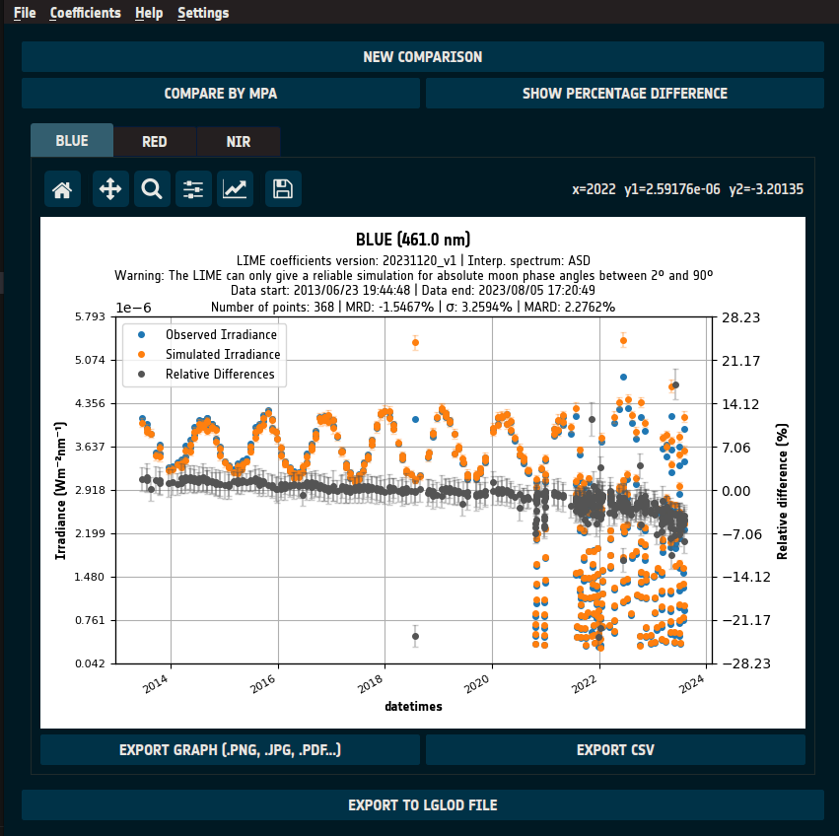
At the center of the app, one can see the comparison output.
One can move between each one of the channels with the channel tabs, where here in this image says “band_1”, “band_2”, “band_3”, etc.
Inside each one of the channel tabs, we can find a graph that compares the irradiance per datetime of the observations with the simulation's result. And in pink we can see the relative differences between those values.
Each one of these graphs can be exported as an image file or as a CSV in the same way the Simulation output could.
At the top of the page there is the “NEW COMPARISON” button. When pressed, a dialog is presented to the user, asking if they want to clear the comparison and start a new one.
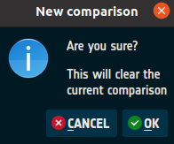

4.3.1 Compare by moon phase angle
Below the “NEW COMPARISON” button, one can find the “COMPARE BY MPA” button. When pressed, all the comparison graphs change, and they are now comparing data based on moon phase angle, instead of datetimes.
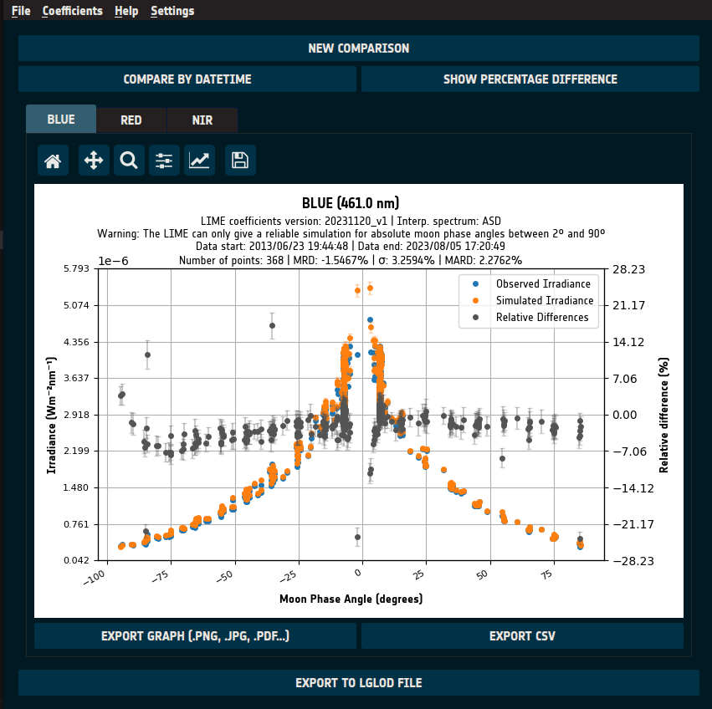

4.4 Exporting to LGLOD format
The comparisons can be exported to an only file in LGLOD, letting the user load it again in another session, or in order to store it for the future.
This can be achieved by pressing the “EXPORT TO LGLOD FILE” button present at the bottom of the page.
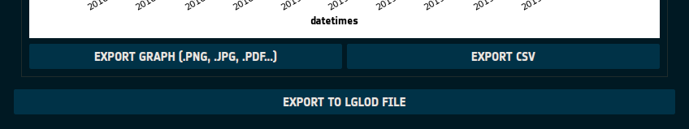

5. LGLOD format files
The LIME-GLOD or LGLOD format is a netCDF format inspired by the GLOD format, that stores the status and the output of the simulation and comparisons performed with the TBX, allowing the user to load them again in the future.

5.1 Loading LGLOD datafiles
In previous sections it has been explained that simulations and comparisons can be exported to a single netCDF file in LGLOD format, which is a modification of the GLOD format.
To load these files, one must click the “File” option in the upper menu, and then select the “Load simulation file stored in a LIME GLOD format file.” option.
After doing it, a file selection dialog is presented to the user, where they should select the LGLOD file that is going to be opened. If that file was created using a concrete spectral response function, which will always be the case for comparisons, the user will be immediately prompted with another file selection dialog, where they should select the spectral response function file that was used for that simulation/comparison.
The toolbox will automatically identify if the file is a simulation file or a comparison one and will perform accordingly.

5.2 LGLOD format details
LGLOD format files store information of simulations or of comparisons and depending on which one it is, the attribute values will be different, and they will have different variables.

5.2.1 Attributes
The LGLOD format contains the same attributes as the GLOD format for observations, and four more:
- not_default_srf: int [0, 1]. 0 if the SRF used for the simulation was the default LIME TBX SRF, 1 if it was a custom user defined SRF.
- spectrum_name: str. Interpolation spectrum name.
- skipped_uncertainties: int [0, 1]. 0 if the simulation/comparisons were computed calculating the uncertainties, 1 if not.
- is_comparison: int [0, 1]. 0 if it’s a comparison LGLOD file, 1 if it’s a simulation LGLOD file.

5.2.2 Dimensions
The dimensions are almost the same in both Simulation LGLOD files and Comparison LGLOD files, except two extra in the Simulation LGLOD files. They are the following:
Dimension | LGLOD Type | Description
chan | Both | Number of channels of which data is present.
chan_strlen | Both | Max length of the channel name strings.
date | Both | Number of timestamps present.
number_obs | Both | Number of positions for which at least one simulation for one channel is present.
sat_ref_strlen | Both | Max length of the satellite reference strings.
sat_name_strlen | Both | Max length of the satellite name strings.
col | Both | Constant: 0. Inherited from GLOD format, not used.
row | Both | Constant: 0. Inherited from GLOD format, not used.
sat_xyz | Both | Constant: 3. Number of dimensions used for defining a satellite location.
wlens | Simulation | Constant: 2151. Number of wavelengths in the full-spectrum simulation.
wlens_cimel | Simulation | Constant: 6. Number of CIMEL wavelengths.

5.2.3 Variables
The variables vary depending on the LGLOD type and they are the following:
Variable | LGLOD Type | Dimensions | Type
date | Both | (date) | float64
outside_mpa_range | Both | (number_obs) | int8
mpa | Both | (number_obs) | float64
channel_name | Both | (chan, chan_strlen) | |S1
sat_pos | Both | (number_obs, sat_xyz) | float64
sat_pos_ref | Both | (number_obs, sat_ref_strlen) | |S1
sat_name | Both | (sat_name_strlen) | |S1
irr_obs | Both | (number_obs, chan) | float64
irr_obs_unc | Both | (number_obs, chan) | float64
irr_comp | Comparison | (number_obs, chan) | float64
irr_comp_unc | Comparison | (number_obs, chan) | float64
irr_diff | Comparison | (number_obs, chan) | float64
irr_diff_unc | Comparison | (number_obs, chan) | float64
perc_diff | Comparison | (number_obs, chan) | float64
perc_diff_unc | Comparison | (number_obs, chan) | float64
mrd | Comparison | (chan) | float64
mard | Comparison | (chan) | float64
mpd | Comparison | (chan) | float64
std_mrd | Comparison | (chan) | float64
number_samples | Comparison | (chan) | float64
wlens | Simulation | (wlens) | float64
irr_spectrum | Simulation | (number_obs, wlens) | float64
irr_spectrum_unc | Simulation | (number_obs, wlens) | float64
refl_spectrum | Simulation | (number_obs, wlens) | float64
refl_spectrum_unc | Simulation | (number_obs, wlens) | float64
polar_spectrum | Simulation | (number_obs, wlens) | float64
polar_spectrum_unc | Simulation | (number_obs, wlens) | float64
cimel_wlens | Simulation | (wlens_cimel) | float64
irr_cimel | Simulation | (number_obs, wlens_cimel) | float64
irr_cimel_unc | Simulation | (number_obs, wlens_cimel) | float64
refl_cimel | Simulation | (number_obs, wlens_cimel) | float64
refl_cimel_unc | Simulation | (number_obs, wlens_cimel) | float64
polar_cimel | Simulation | (number_obs, wlens_cimel) | float64
polar_cimel_unc | Simulation | (number_obs, wlens_cimel) | float64

Variable | Description
date | Time of lunar observation, seconds since epoch.
outside_mpa_range | 1 if the observation is outside the Moon phase angle valid range. 0 if inside.
mpa | Moon phase angle in degrees.
channel_name | Channel/Sensor band identifier.
sat_pos | Satellite position in (x,y,z) coordinates for sat_pos_ref frame.
sat_pos_ref | Reference frame of the satellite position
sat_name | Name of the satellite (or empty if it wasn’t a satellite measure).
irr_obs | Simulated integrated lunar irradiance for each channel.
irr_obs_unc | Uncertainties of the simulated integrated lunar irradiance for each channel.
irr_comp | Integrated lunar irradiance for each channel observed with the instrument, obtained from the GLOD files.
irr_comp_unc | Uncertainties of the integrated lunar irradiance for each channel observed with the instrument, obtained from the GLOD files.
irr_diff | Lunar irradiance comparison difference for each channel.
irr_diff_unc | Uncertainties of the lunar irradiance comparison difference for each channel.
mrd | Mean relative difference.
std_mrd | Standard deviation of the mean relative difference.
number_samples | Number of comparisons for each channel
wlens | Wavelengths for irr_spectrum, refl_spectrum and polar_spectrum.
irr_spectrum | Simulated lunar irradiance per wavelength.
irr_spectrum_unc | Uncertainties for the simulated lunar irradiance per wavelength.
refl_spectrum | Simulated lunar reflectance per wavelength.
refl_spectrum_unc | Uncertainties for the simulated lunar reflectance per wavelength.
polar_spectrum | Simulated lunar degree of polarization per wavelength.
polar_spectrum_unc | Uncertainties for the simulated lunar degree of polarization per wavelength.
cimel_wlens | CIMEL wavelengths
irr_cimel | Simulated lunar irradiance for the CIMEL wavelengths
irr_cimel_unc | Uncertainties for the simulated lunar irradiance for the CIMEL wavelengths.
refl_cimel | Simulated lunar reflectance for the CIMEL wavelengths.
refl_cimel_unc | Uncertainties for the simulated lunar reflectance for the CIMEL wavelengths.
polar_cimel | Simulated lunar degree of polarization for the CIMEL wavelengths.
polar_cimel_unc | Uncertainties for the simulated lunar degree of polarization for the CIMEL wavelengths.

6. Coefficients versions
The LIME Toolbox uses multiple coefficients for equations of different computational models.
These models are constantly being improved, updating the coefficients every time.

6.1 Updating the coefficients
To update the coefficients, “Coefficients” option in the upper menu should be pressed.
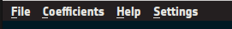
After doing that, the user will be presented with two options: “Download updated coefficients” and “Select coefficients”. In this case the user should select “Download updated coefficients”.

6.2 Choosing the coefficients version
To choose a concrete coefficients version, the “Coefficients” option must be pressed, but this time the user must select the “Select coefficients” option.
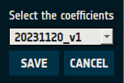
After doing so, the user will be presented with a small window that will contain a combo box with all the coefficients versions inside. To select a different version, the user must open all the options, select one and press the “SAVE” button.

7. Interpolation settings
To modify the interpolation settings, the “Settings” option must be pressed, and then the sub-option “Interpolation settings” must be selected.
After doing so, the following window is presented to the user:
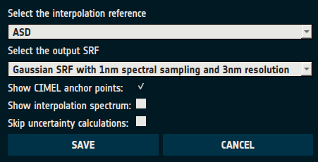

7.1 Selecting the interpolation reference
The first dropdown shows the currently selected interpolation reference. To change it the user must click it and select the new one. After that they should press “Save” to save it, or “Cancel” to discard the change.

7.2 Selecting the output SRF
The second dropdown shows the currently selected output SRF reference. To change it the user must click it and select the new one. After that they should press “Save” to save it, or “Cancel” to discard the change.

7.3 Showing CIMEL anchor points
The simulated data at the CIMEL band wavelengths that is used for interpolation can be shown in the graphs or hidden. If the checkbox is in the activated state, it means that the CIMEL points will be shown.

7.4 Showing the interpolation reference spectrum
Below the two dropdowns there is a checkbox that if checked it indicates that the toolbox will show the interpolation spectrum in the simulation plots. To change it the user must click the checkbox and change it to the desired state. After that they should press “Save” to save it, or “Cancel” to discard the change.

7.5 Skipping the uncertainties calculation
At the bottom of the window, there is a checkbox that if checked indicates that the toolbox will skip the uncertainties calculation, operations that when skipped might speed up the TBX moderately. To change it the user must click the checkbox and change it to the desired state. After that they should press “Save” to save it, or “Cancel” to discard the change.

8. Command line Interface (CLI)
The LIME Toolbox is also designed as a command line utility, letting the user create simulations and comparisons from the command line, or integrate the toolbox with another system.

8.1 Main options
There are six main options/flags, and the lime-cli won’t work unless it is given only one of the options (-h|-v|-u|-e|-l|-s|-c|-i).
Options:
Flag | Long option | Description
-h | --help | Displays the help message.
-v | --version | Displays the version name.
-u | --update | Download updated coefficients.
-e | --earth | Performs simulations from a geographic point.
-l | --lunar | Performs a simulation from a selenographic point.
-s | --satellite | Performs simulations from a satellite point.
-c | --comparison | Performs comparisons from observations files in GLOD format.
-i | --interpolation-settings | Change the interpolation settings. Can be used alone or with another option.

8.1.1 Earth
This option performs simulations from a geographic point.
Flag format:
-e lat_deg,lon_deg,height_m,%Y-%m-%dT%H:%M:%S
For example, in order to perform a simulation from 35º of latitude, -25.2º of longitude, 400 meters, and at the date and time of 2022-01-20 02:00:00h, the executed command should start with:
lime -e 35,-25.2,400,2022-01-20T02:00:00

8.1.2 Lunar
This option performs a simulation from a selenographic point.
Flag format:
-l distance_sun_moon,distance_observer_moon,selen_obs_lat,selen_obs_lon, selen_sun_lon,moon_phase_angle
So to perform a simulation with 0.98 AU of distance between Sun and Moon, 420000 km between the observer and the Moon, 20.5º and -30.2º as the selenographic latitude and longitude of the observer, 0.69 radians as the selenographic longitude of the Sun, and 15º as the moon phase angle, the executed command should start with:
lime -l 0.98,420000,20.5,-30.2,0.69,15

8.1.3 Satellite
This option performs simulations from a satellite point.
Flag format:
-s sat_name,%Y-%m-%dT%H:%M:%S
In order to perform a simulation of the satellite PROVA-B at the date and time of 2020-01-20 02:00:00h, the executed command should start with:
lime -s PROBA-V,2020-01-20T02:00:00

8.1.4 Comparison
This option performs comparisons from observations files in GLOD format.
-c "input_glod1.nc input_glod2.nc ..."
So, to perform a comparison of the files input_1.nc, input_2.nc and input_3.nc, the executed command should start with:
lime -c "input_1.nc input_2.nc input_3.nc"
It’s also possible to use glob patterns to indicate paths, thus if one were to perform a comparison of all the .nc files inside a directory called “files”, they could use:
lime -c "files/*.nc"

8.1.5 Interpolation settings
This option changes the interpolation settings. It can be used alone or in combination with another main simulation option (-e|-l|-s|-c). The input data shall be a json string containing at least one of the following parameters:
- interp_spectrum: Sets the interpolation spectrum. The valid values are 'ASD' and 'Apollo 16 + Breccia'.
- interp_srf: Sets the output SRF. The valid values are 'asd', 'interpolated_gaussian' and 'interpolated_triangle'.
- show_interp_spectrum: Sets if the graphs should show the spectrum used for interpolation. The valid values are 'True' and 'False'.
- skip_uncertainties: Sets if the ToolBox should skip the uncertainties calculations. The valid values are 'True' and 'False'.
For example:
lime -i '{"interp_spectrum": "ASD"}'

8.2 Output
The output option (-o or --output) lets the user select the output path and the format of those output files. If the main option chosen by the user is an option between (-e | -l | -s | -c), the output flag is a mandatory flag; If not included the command will fail.
The way it works varies depending on which is the main option chosen.
One of the possibilities is to store the output as a graph. That means that the user must choose the format between pdf, jpg, png and svg.

8.2.1 Simulation
If the main option is a type of simulation (-e | -l | -s), the result can be outputted as graphs, csv files, or a netCDF file in LGLOD format:
- GRAPH: Output all graphs into image files.
  - Format:
-o graph,(pdf|jpg|png|svg),reflectance,irradiance,polarization

- CSV: Output all values into csv files.
  - Format:
-o csv,reflectance.csv,irradiance.csv,polarization.csv, integrated_irradiance.csv

- LGLOD (netCDF): Store the simulation in a netCDF file in LIME GLOD format.
  - Format: -
-o nc,output_lglod.nc

8.2.2 Comparison
Comparisons can be based on comparing by datetime or comparing by moon phase angle. For LGLOD files this is not important, but for CSV and image files it is, because one must choose which parameter should define the comparison.
That’s why there is the (DT|MPA|BOTH) choice box, which must be substituted by one of the three elements it contains:
- DT: Comparisons based on datetimes
- MPA: Comparisons based on moon phase angle
- BOTH: Comparisons based on datetimes and on moon phase angle. There will be double the output files, although the command structure should remain the same.
Comparisons can be measured using the relative difference or the percentage difference. To choose between both, the user must select between ‘rel’ and ‘perc’.
If the main option is comparison (-c):
- GRAPH: Output all channel values into graphs.
  - Format:
-o graph,(pdf|jpg|png|svg),(DT|MPA|BOTH),(rel|perc),comparison_channel1, comparison_channel2,...

- CSV: Output all channel values into csv files.
  - Format:
-o csv,(DT|MPA|BOTH),(rel|perc),comparison_channel1.csv,comparison_channel2 .csv,...

- GRAPH directory: Output all channel values into graph files inside a given directory path (If the directory doesn’t exist it will be created).
  - Format:
-o graphd,(pdf|jpg|png|svg),(DT|MPA|BOTH),(rel|perc),comparison_folder

- CSV directory: Output all channel values into csv files inside a given directory path (If the directory doesn’t exist it will be created).
  - Format:
-o csvd,(DT|MPA|BOTH),(rel|perc),comparison_folder

- LGLOD (netCDF): Store the comparison in a netCDF file in LIME GLOD format.
  - Format:
-o nc,output_lglod.nc

8.3 Other options

8.3.1 SRF
The SRF option (-f, --srf) allows the selection of the file that contains the Spectral Response Function in GLOD format.
Flag format:
-f filepath.nc
For example, if one wanted to use folder/srf.nc as the SRF file, the command should contain the following:
... -f folder/srf.nc

8.3.2 Timeseries
The timeseries option (-t, --timeseries) allows the selection of a CSV file with multiple datetimes instead of directly inputting only one datetime. It’s only valid if the main option is -e or -s.
The file shall contain one datetime per line in the following format:
yyyy,mm,dd,HH,MM,SS
For example:
2022,01,17,02,02,04 .
Flag format:
-t filepath.csv
If this option is included, the datetime argument of the command is ignored, but can still be included. For example, the following line is the correct way of doing it:
lime -s PROBA-V -t files/timeseries01.csv
But one can also execute:
lime -s PROBA-V,2020-01-20T02:00:00 -t files/timeseries01.csv

8.3.3 Coefficients Version
The coefficients option (-C, --coefficients) allows the selection of the coefficients version to use and to be set as selected for the execution and all the following ones until it’s changed again.
lime -s PROBA-V,2020-01-20T02:00:00 -C 20230123_v1

8.3.4 Interpolation Spectrum
The interpolation spectrum option (-i, --interpolation) allows the selection of the interpolation spectrum to use and to be set as selected for the execution and all the following ones until it’s changed again.
lime -s PROBA-V,2020-01-20T02:00:00 -i 'Apollo 16 + Breccia'

9. Other

9.1 Adding satellites
The list of available satellites is defined thanks to a file called “esa_sat_list.yml”, that contains all the information needed for calculating the satellites position.
This file is in the “eocfi_data” folder, and the location of that folder varies between the OS.
In Windows, it’s in the installation folder.
In Linux, it’s in “/opt/esa/LimeTBX/”.

9.1.1 Adding a new satellite
To add a new satellite, the needed files should be added to the “eocfi_data” folder, and the previously mentioned file “esa_sat_list.yml” should be modified.
In that file there is a list in YAML format containing all satellites. We will have to add another element for the satellite that we want to add.

9.1.1.1 Adding a satellite with Orbit Scenario Files
The most common entry in the satellite list is the one that uses orbit scenario files (EOF or EFF) to define the satellites. In the following image it is described how the SENTINEL-2B is defined in the file.
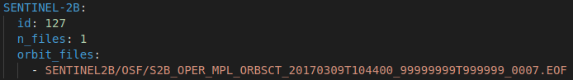
The first line contains the name of the satellite. Then there are three attributes, the id, the number of files available, and a list with the location of those files.
Firstly, we should put our EFF/EFF file/s under the “eocfi_data/data/mission_configuration_files/” directory, in another newly created directory or even directly there.
To add a new satellite from EOF/EFF files, we can copy an existing entry of another satellite like the SENTINEL-2B and modify the data.
Instead of SENTINEL-2B there should be the name of the new satellite. Instead of “127” after the “id” attribute, there should be the id number of the satellite. The id number is the one used by the EO CFI library, and can be found in the EO CFI GeneralSUM manual, in https://eop-cfi.esa.int/index.php?option=com_content&view=article&id=92&Itemid=495&jsmallfib=1&dir=JSROOT/releases/4.24/C-Docs/SUM&download_file=JSROOT/releases/4.24/C-Docs/SUM/GeneralSUM.pdf in the section 7.2 General Enumerations. If the satellite is not present, it’s enough to set 200 as the id.
Instead of a “1” after the “n_files” attribute, there should be the number of added orbit files. And under the “orbit_files” attribute, there should be one line per orbit file, with their path after the “mission_configuration_files” directory.

9.1.1.2 Adding a satellite with TLE files
In the satellite list there are also entries that use TLE files instead of EOF/EFF files. These are the ones for PROBA-V and ENVISAT.
In the following image one can see the PROBA-V entry.
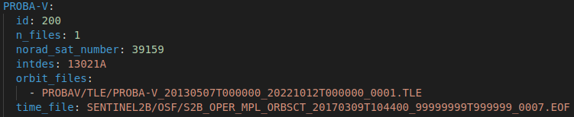
The attributes are similar to the satellites with orbit scenario files, but with three extra attributes. “norad_sat_number” is the satellite catalog number, “intdes” is the International Designator, and “time_file” is the file that is used for calculating all the time equivalences.
Firstly, we should put our TLE file or files under the “eocfi_data/data/mission_configuration_files/” directory, in another newly created directory or even directly there.
To add a new entry, one should copy the PROBA-V entry and modify its data. Instead of PROBA-V there should be the satellite name, instead of “200” as the id it should be the EO CFI satellite id, as described in the previous section, instead of “1” as the n_files value it should be the number of TLE files, instead of “39159” as the norad value it should be the norad number of the satellite, instead of “13021A” as the “intdes” value it should be the international descriptor or the satellite, and under “orbit_files:” there should be the added TLE files path after the mission_configuration_files folder. As the time_file value one could add a new file with the time equivalences, but if the SENTINEL-2B file is left there, it will work fine. Finally, the satellite entry name must be the same as the name that it has inside the TLE file’s first line.
The NORAD can be found in https://celestrak.org/satcat/search.php, and the international descriptor can be found inside the TLE files. For example, for the PROBA-V the second line of the TLE file is as follows:
1 39159U 13021A 13127.15871345 -.00000045 00000+0 00000+0 0 14
Where the international descriptor is the third element, “13021A” in this case.

9.1.1.3 How to obtain TLE files
To obtain a TLE file for a satellite for a concrete time-period, one must access to https://celestrak.org/NORAD/archives/request.php?FORMAT=tle.
Once accessed, one must fill all the values, and wait until the file is sent to the given email.
The NORAD can be found in https://celestrak.org/satcat/search.php.
After receiving the file via email, the name of the file must be changed before adding it to the LIME toolbox data. It should follow a <text><initial_date>_<ending_date>_0001.TLE format.
The <text> part can be whatever or even be left empty, and the dates are the range that was given at the celestrak webpage. They should follow the format yyyymmddThhmmss. For example, the date 2013/05/07 00:00:00 would be 20130507T000000.

9.1.2 Adding an orbit file of an existing satellite
If one wants to add a new orbit file to improve the range of the available calculations, one should add that file inside the “eocfi_data/data/mission_configuration_files” directory. Then, the “esa_sat_list.yml” file must be modified. The “n_files” attribute of the satellite must be increased by one, and the newly added file path (after the mission_configuration_files folder) must be added as another line under the orbit_files attribute. The order of the orbit files in the attribute marks the priority. If two files cover the same date, the software will use the one which is upper in the list.

9.1.3 Extending PROBA-V TLE files
The PROBA-V uses TLE files instead of prediction orbit scenario files because the PROBA-V doesn’t follow anymore the so-called ‘reference orbit’; the altitude and the MLST appear to be decreasing. Therefore, the datafiles that allow the calculation of its position must be updated regularly.
To do so, one should access the webpage https://celestrak.org/NORAD/archives/request.php?FORMAT=tle, set the NORAD value to 39159, and wait until receiving the datafile. Then, the name of the file should be modified, as it’s explained in the section “How to obtain TLE files”.
After doing so, the file should be added to the “eocfi_data/data/mission_configuration_files” directory, preferably under the directory “PROBAV/TLE”.
Finally, the “esa_sat_list.yml” file must be edited. The attribute “n_files” must be increased by one, and the newly added file path (after the mission_configuration_files directory) should be added to the attribute “orbit_files” list.

9.2 Logging
The LimeTBX generates logging files where log messages are stored. These log messages go from trivial information to the output message of possible warnings or errors.

9.2.1 Log files’ location
The location of the log files varies depending on the operating system.
Windows:
%appdata%\LimeTBX\

Mac:
~/Library/Application Support/LimeTBX/

Linux:
~/.LimeTBX/

9.2.2 Setting the log level to “debug”
By default, the log files don’t include debug messages, as they would bloat the log files with mostly useless information. Nevertheless, that information can be useful in case the software malfunctions. To activate those log messages, the user must set an environment variable named “LIME_DEBUG” with the value “DEBUG” and execute the LimeTBX from the environment that contains that variable.

9.2.3 Contacting support
While LimeTBX has undergone extensive testing, glitches may still occur. If you encounter any issue, please reach out to lime_tbx@goa.uva.es. Provide a detailed description of the problem, include some screenshots if they are available, and attach the latest log file. This will help resolve the error as quickly as possible.

