Abstract
This document describes the results of the comparison of the Lunar Model with several lunar datasets.

Adriaensen Stefan

VITO

18 December 2023
comparison of the lunar spectral irradiance model to several datasets
Delivery 4

This document was produced as part of the ESA-funded project “Lunar spectral irradiance measurement and modelling for absolute calibration of EO optical sensors” and “Improving the lunar irradiance model of ESA” under ESA contract numbers: 4000121576/17/NL/AF/hh and : 4000136003/21/I-DT-lr



Signatures and version history

 | Name | Organisation | Date
Written by | Stefan Adriaensen | VITO | 28-May-2019
Reviewed by (consortium) | Emma Woolliams | NPL | 8-Dec-2019
Approved by (ESA) | Marc Bouvet | ESA | 12-Dec-2019
Updated by | Stefan Adriaensen | VITO | 25-Jan-2024

Version history

Version | Date | Publicly available or private to consortium?
0.1 | 28/05/19 | created
0.2 | 08/07/19 | Added section on model smoothing
 |  | Added new results for PV
0.3 | 29/08/2019 | All sections, new results with latest model
0.4 | 06/09/2019 | New sections on 1088 model, including PV and Pleiades context
0.5 | 10/09/2019 | Update text, mainly on conclusions sections
0.6 | 04/11/2019 | Updated all sections with newly revised results. Input measurement data delivered on 28/09/2019
0.7 | 22/11/2019 | update on all sections, resolving reviews and textual anomalies
0.8 | 8/12/2019 | Review by Emma Woolliams
0.9 | 12/12/2019 | Approved by Marc Bouvet
1.0 | 18/12/2018 | FINAL version
1.1 | 19/12/2019 | update extension project 2019  - model coeffs (section 2.2) 1088 and 1088+933 model  - update PROBA-V results  - Added 2 sections, one on geometry and one on trending  - Updated all PLEIADES results  - Updated all GIRO  - (conclusions on the results remain the same, numbers have changed very little)
1.2 | 03/12/2020 | update extension project 2020  - model coeffs (section 2.2) 1088 and 1088+933 model  - update PROBA-V results  - update 2 sections, one on geometry and one on trending  - Updated all PLEIADES results  - Updated all GIRO  - (conclusions on the results remain the same, numbers have changed very little)  - Added appendix with results of the comparison with a lunar acquisition of S3A and B
1.3 | 31/03/2022 | update extension project 2020  - model coeffs (section 2.2) 1088 and 1088+933 model  - update PROBA-V results  - Updated all PLEIADES results  - Updated all GIRO  - Updated S3 results  - (conclusions on the results remain the same, numbers have changed very little)
1.4 | 10/03/2023 | Update 2023:  - model coeffs (section 2.2) 1088 and 1088+933 model  - update PROBA-V results  - Updated all PLEIADES results  - Updated all GIRO  - Updated S3 results
1.5 | 24/11/2023 | Update to the new LIME TBX  - Removal of 1088+933 model references  - Changed Plots LIME/GIRO with band comparisons

Contents
1 Purpose and Scope 4
1.1 Applicable and reference documents 4
1.1.1 Applicable Documents 4
1.1.2 Reference Documents 4
1.2 Glossary 4
1.2.1 Abbreviations 4
2 Introduction 6
2.1 Model 6
3 Measurement to model comparison procedure 7
3.1 Input to the model 7
3.2 Algorithmic steps 8
3.3 Apply distance factor 9
3.4 Measurement and model comparison 10
4 PROBA-V 11
4.1 Instrument 11
4.2 PROBA-V Lunar acquisitions 11
4.3 Processing steps 12
4.4 SWIR data 13
4.5 Result for PROBA-V compared to the LIME TBX. 13
4.6 Geometric considerations 15
4.7 Trending analysis 16
4.8 Improvement to the previous model version 17
4.9 Conclusion PROBA-V comparison 18
5 PLEIADES data 18
5.1 PLEIADES instrument 18
5.2 Pleiades-1B lunar acquisitions 19
5.3 Results with LIME model 21
5.4 Conclusion Pleiades 1B comparison 25
6 Comparison with the GIRO model 25
6.1 Input data 25
6.2 Results GIRO model comparisons 26
6.3 Conclusion GIRO comparison 30
7 Conclusions 31
APPENDIX A – MODEL IMPLEMENTATION VALIDATION 32
APPENDIX B – Comparison Sentinel 3 OLCI with LIME 34
APPENDIX B – PLOTS Irradiance comparison between LIME and GIRO 37
APPENDIX B – Calculating the uncertainty associated with the comparison to a satellite sensor 45

Purpose and Scope
This document describes comparison of the lunar irradiance model with other datasets and models.

Applicable and reference documents

Applicable Documents
The following applicable documents are those specification, standards, criteria, etc. used to define the requirements of this representative task order.
Number | Reference
[AD1] | ESA-TECEEP-SOW-002720. Lunar spectral irradiance measurement and modelling for absolute calibration of EO optical sensors.
[AD2] | LUNAR IRRADIANCE MODEL ALGORITHM AND THEORETICAL BASIS DOCUMENT (D4)

Reference Documents
Reference documents are those documents included for information purposes; they provide insight into the operation, characteristics, and interfaces, as well as relevant background information.
Number | Reference
[RD1] | H.H. Kieffer and T.C. Stone. The Spectral Irradiance of the Moon. 2005. The American Astronomical Society. DOI:10.1086/430185.
[RD2] | http://gsics.atmos.umd.edu/bin/view/Development/GiroV1Release
[RD3] | Lunar observations data set preparation + results with the Pleiades satellites – LEO, Lachérade et al., GSICS Workshop, Darmstadt
[RD4] | In-Orbit Radiometric Calibration and Stability Monitoring of the PROBA-V Instrument, Sterckx S. et al, Remote Sensing, 2016
[RD5] | PROBA-V Quarterly Calibration Report Q4 2019, http://proba-v.vgt.vito.be/en/quality/platform-status-information/quarterly-image-quality-reports, Sterckx et al

Glossary

Abbreviations

Abbreviation | Stands For | Notes
ESA | European Space Agency | Project customer
NPL | National Physical Laboratory | Project partner
DOLP | Degree of Linear Polarization
EO | Earth Observation
GIRO | GSICS Implementation of the ROLO model
GLOD | GIRO Lunar Observation Database
SWIR | Short-Wave InfraRed
USGS | U. S. Geological Survey
UVa | University of Valladolid | Project partner
VITO | Flemish Institute for Technological Research;(Vlaamse Instelling voor Technologisch Onderzoek) | Project partner
VNIR | Visual and Near InfraRed

Introduction
As described in [AD2the LIME model coefficients are derived from the the CIMEL CE318-TP9 (annotated as 1088 instrument). The instrument was procured, fully calibrated, installed and currently operated within the context of the LIME project at the Meteorological institute of Izaña in Tenerife. This dataset is currently extending to a period between March 2018 and November 2022.
In this report, the LIME Toolbox is compared with the spectral imagers PROBA-V and PLEIADES-HR-1B (Pleiades).
In addition, the model is compared to the GIRO model, which is the EUMETSAT reference implementation of the ROLO model as published in [RD1].

Model
As mentioned, the comparison will be applied to the LIME lunar irradiance. The two figures below are the simulated irradiances (in blue) for one model spectral band (440 nm) and on top (in orange) the measurements used the generate the reflectance model.
It must be stated that for both models, the measurements are pre-filtered before being introduced into the regression procedures. The following tables contain the latest derived model parameters, which are applied during the following comparison exercise.

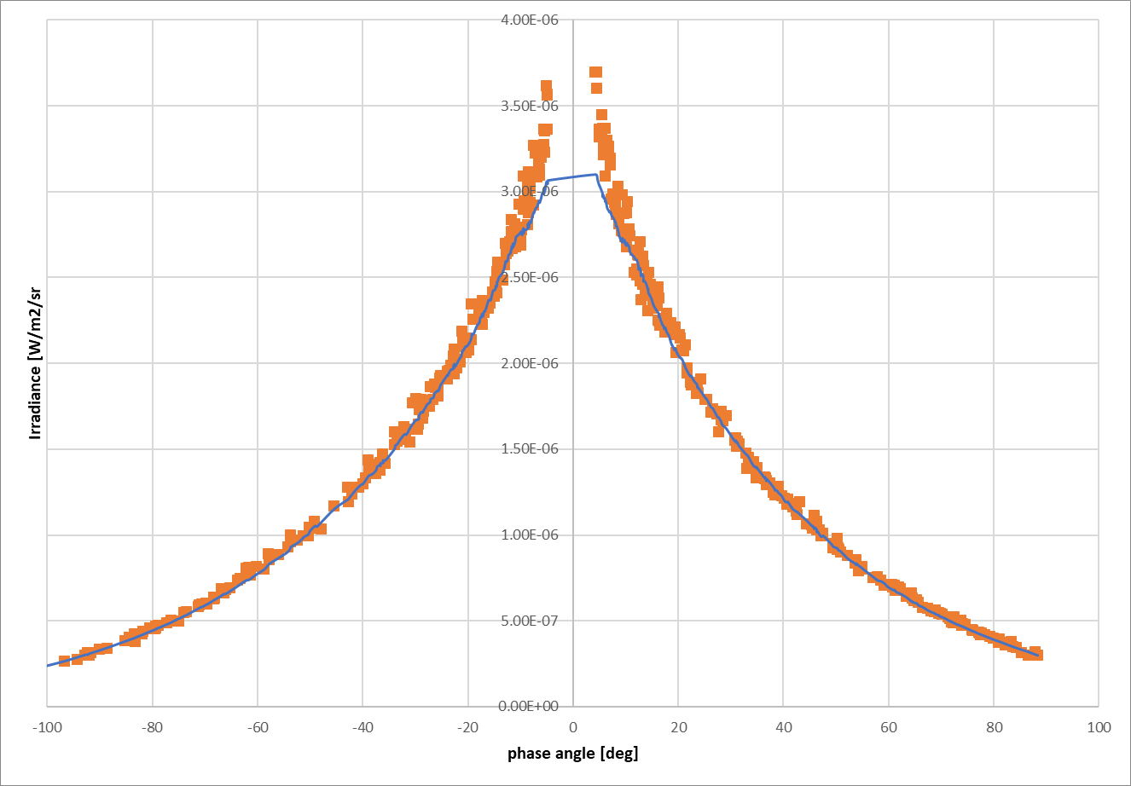

Figure 1: Simulated reflectance (blue) at 440 nm from 1088 model based on the plotted measurements from the 1088 Model coefficients.

Table 1: Table 2: Model coefficients derived from the 1088 instrument measurements.
wl  [nm] | a0 | a1 | a2 | a3 | b1 | b2 | b3
440 | -2.2512 | -2.18724 | 1.079583 | -0.47752 | 0.048273 | 0.022578 | -0.01016
500 | -2.1239 | -2.08042 | 0.958826 | -0.4252 | 0.044062 | 0.018495 | -0.00692
675 | -1.8828 | -1.99794 | 0.983553 | -0.4559 | 0.04588 | 0.017006 | -0.00741
870 | -1.74906 | -1.86916 | 0.856575 | -0.4009 | 0.047385 | 0.01586 | -0.00421
1020 | -1.68441 | -1.8366 | 0.871022 | -0.41836 | 0.053858 | 0.017565 | -0.0066
1640 | -1.37617 | -1.55937 | 0.70443 | -0.38787 | 0.048349 | 0.010047 | -0.00412
wl  [nm] | c1 | c2 | c3 | c4 | d1 | d2 | d3
440 | 0.000994 | -0.0004 | 0.001578 | 0.000952 | 1.49109 | -0.00624 | -0.00571
500 | 0.00043 | -0.00103 | 0.001204 | 0.000463 | 1.637928 | -0.01004 | -0.00273
675 | 0.00074 | -0.00123 | 0.001562 | 0.000982 | 0.699086 | -0.0025 | -0.00594
870 | 0.00049 | -0.00098 | 0.001677 | 0.00069 | 0.503896 | -0.00192 | -0.00342
1020 | 0.000386 | -0.00128 | 0.001503 | 0.000597 | 0.491352 | -0.00314 | -0.00255
1640 | 0.000315 | -0.00091 | 0.001347 | 0.001181 | 0.373388 | -0.00227 | 3.48E-06
 | p1 | p2 | p3 | p4
all | 1.393821 | 15.10385 | 12.07322 | 8.061068

Measurement to model comparison procedure
In this section the procedure to compare the lunar model with different lunar measurements is described.
Any irradiance measurement of the moon disk can be compared with the model. The model provides as an output the lunar irradiance for a given viewing geometry and spectral response. The following limitations of the model have to be taken into account:
- Lunar Phase angle between 2 and 90 degrees
- Spectral range between 400 nm and 2500 nm
Simulations outside the phase angle range produce a result, but these are unsupported. When an instrument spectral response falls (partially) outside the spectral range, an error is raised.

Input to the model
The model requires a minimum set of input parameters to allow for the comparison with lunar acquisitions:
- Timestamp of the acquisition [Julian Day]
- Position of the instrument/platform (J2000 coordinates – x ,y, z [km] )
Extra input (for comparison):
- EO sensor Integrated Irradiance from lunar acquisition
The irradiance observed by the EO sensor acquisition is provided to the software for comparison purposes. Using these input parameters, the model calculates the geometric parameters per acquisition required for the comparison:
- Phase angle
- Solar selenographic longitude
- Observer selenographic latitude and longitude
- Distances between Sun, Moon and observer.
All geometric parameters are calculated using the NASA SPICE toolkit. The instrument spectral response curve is used to calculate the model irradiance. The output irradiance is referenced to the instrument geometry (including correction to the actual distances) and can be compared directly to the provided measured irradiance.
Extra configuration needed for the model is required:
- Model Coefficients
- Spectral response curves
- Spectral band identifier (the model run are band specific)
- Reflectance Spectrum
- Solar Irradiance Spectrum (i.e. TSIS-1spectrum)
- Spice kernels (fixed)
- DOLP (Degree of Linear Polarization) model location

Algorithmic steps
The following figure is a flowchart of the procedure that is applied to the input to the model. Output of the procedure is the simulated lunar irradiance, which can be compared with the correlated measured irradiance.

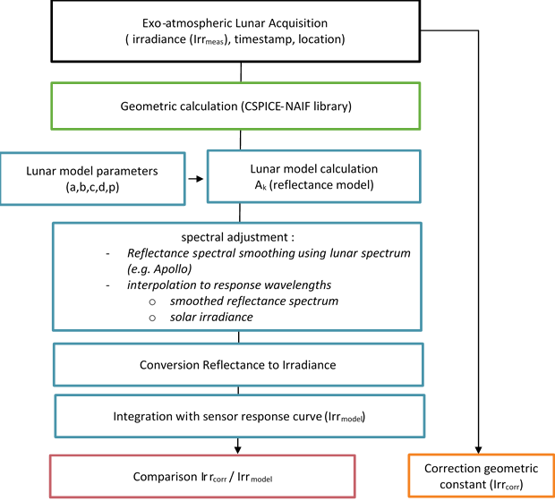
Figure 2: Measurement and Model comparison procedure.
The different steps that are applied to obtain the simulated sensor irradiance are:
- Calculate geometry (NAIF spice),
- Calculate model reflectance for all model wavelengths,
- Spectral adjustment,
  - Smoothing of lunar reflectance spectrum to model reflectance,
  - Spectral interpolation reflectance to sensor spectral response curve,
  - Interpolation of the solar irradiance to sensor spectral response curve,
- Conversion reflectance spectrum to irradiance spectrum,
- Integration with sensor response curve,
- Correction for the distance factor of the output irradiance value.
Finally, the obtained modelled or simulated reflectance can be compared against the correlated sensor lunar measurement. The smoothing, interpolation and integration procedures are explained in detail in [AD-2].

Apply distance factor
For a direct comparison of the measured irradiance with the model irradiance output, the distance factor needs to be considered.

$$E_{k_mmodel}^{'}=E_{k_{model}}× f_{d}$$
And
$$f_{d}= {\left(\frac{D_{S-M}}{[1 AU]}\right)}^{2}×{\left(\frac{D_{V-M}}{[384400 km]}\right)}^{2}$$

Where $D_{S-M}$ is the distance between Sun and Moon in AU, $D_{V-M}$ the distance between viewer and moon in km. $E_{k_meas}^{'}$ is measured irradiance ($E_{k_meas}$) after correction for distances.

Measurement and model comparison
In general, the Lunar Model is compared to sensor irradiance recordings of the Moon. By defining the radiometric ratio between the instrument and the lunar model, the instrument performance is evaluated.

$$C_{k}=\frac{E_{k_meas}^{}}{{E'}_{k_model}}-1$$
The ratio between instrument and model irradiance, expressed in percentage.
In this study, the lunar model output is compared to:
- PROBA-V instrument measurements
- Pleiades 1B instrument measurements
- The GIRO model measurements

PROBA-V

Instrument
The PROBA-V instrument is a multi-spectral imager with four broad spectral bands: BLUE, RED NIR and SWIR: 450, 645, 834 and 1665 nm central wavelength (Figure 3).

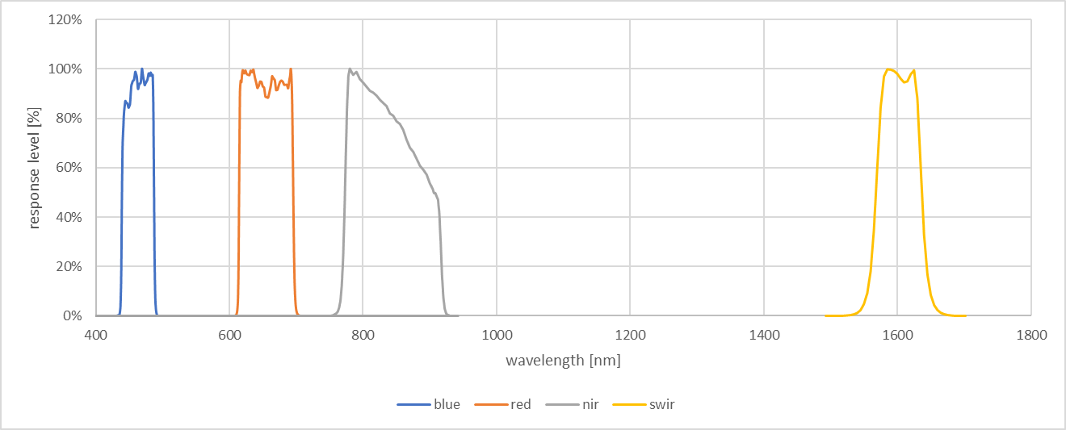
Figure 3 : PROBA-V spectral response functions.
The spatial GSD for the central camera is 100 m. The combinations of three cameras allows for daily global coverage at 1 km resolution. The main applications for PROBA-V observations are for vegetation and crop monitoring and yield prediction.

PROBA-V Lunar acquisitions
PROBA-V lunar images are acquired twice every month, approx. 7 degrees before and after full Moon. Since the beginning of the launch, the Moon has been recorded. Currently about 450 lunar acquisitions are recorded with since 23/6/2013.
PROBA-V has three cameras (LEFT, CENTER and RIGHT) to ensure a ground sampling swath of approx. 2000 km. Each camera has three line-sensing VNIR bands and one line-sensing SWIR band. To reach the same on-ground swath, three SWIR sensors are butted next to each other.
The moon is recorded with the CENTER camera only, the SWIR channel only with the center SWIR strip (SWIR2).

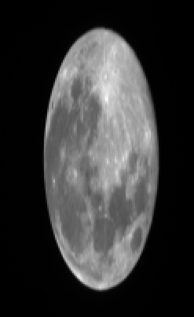
Figure 4 : PROBA-V BLUE lunar acquisition

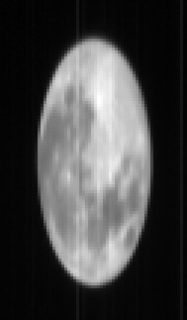
Figure 5: PROBA-V SWIR lunar acquisition
Example VNIR (BLUE) and SWIR acquisition is shown both Figure 4 and Figure 5.

Processing steps
The PROBA-V lunar data is processed through the Data Ingestion Facility (DIF) up to level 1A (L1A). This is the basic level, after decompressing and reorganizing the downlinked data packets into HDF5 logic files. All platform and instrument data are combined into one file, image data is in raw sensor DNs.
In the operational scenario, the data is picked up by the Instrument Quality Center (IQC) and processed further through a dedicated workflow.
To prepare the L1A PROBA-V data for comparison with the lunar model, 5 major processing steps are required (the same for all strips):
- Find all moon-pixels in the image – masking,
- Locate the center row of the moon and get the exact timestamp and satellite position (J2000-coords) for this central row,
- Convert moon-pixels into radiance (apply instrument calibration parameters,)
- Integrate all moon-pixels,
- Calculate the solid angle of a pixel and find oversampling factor.
The oversampling factor is a measure for the number of times the moon has been imaged. With a push-broom sensor like PROBA-V, the moon is recorded during a pitch maneuver of the satellite. During the maneuver, the moon is scanned. The rotational speed of the platform and the sensor line sampling period defines the oversampling factor of the lunar acquisition.
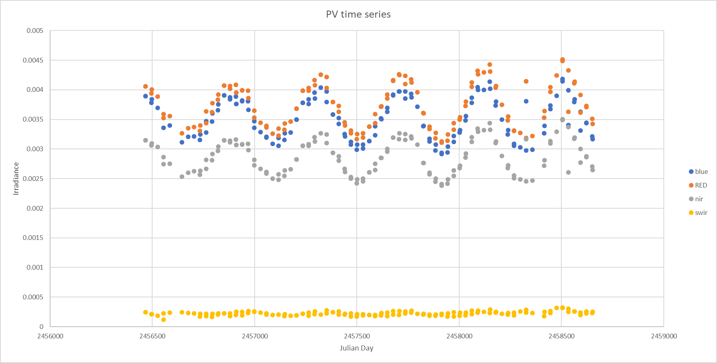
Figure 6: PROBA-V measured lunar irradiances in [W/(m² nm)].

SWIR data
During the process of the model development and comparison exercises, it became clear that for the PROBA-V SWIR data an extra iteration is required to get decent values out of the processing. The basis for the processing is masking, which appears to be rather difficult for the noisier SWIR channel. As an example, Figure 7 shows the failure of the masking in the image processing. The masking is the basis for all further processing and therefore the SWIR results, certainly the absolute level of the lunar irradiances should be assumed immature.

Figure 7: failed SWIR masking.

Result for PROBA-V compared to the LIME TBX.

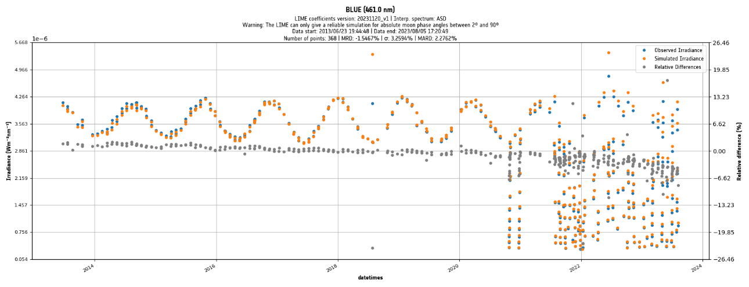
Figure 8 : PROBA-V BLUE irradiance compared to the LIME TBX.

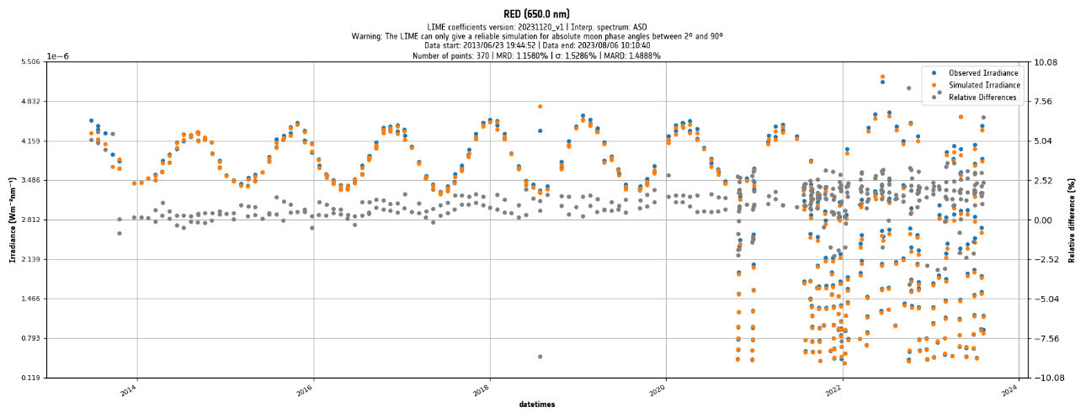
Figure 9 : PROBA-V RED irradiance compared to the LIME TBX.
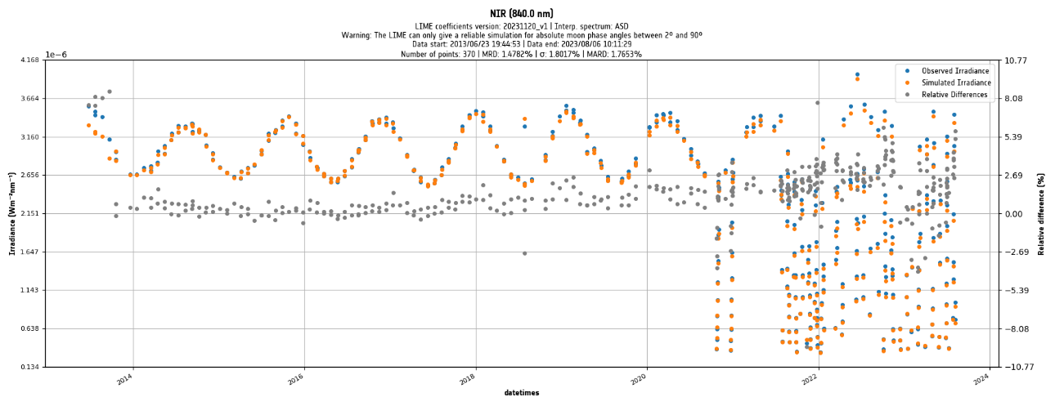
Figure 10 : PROBA-V NIR irradiance compared to the LIME TBX.
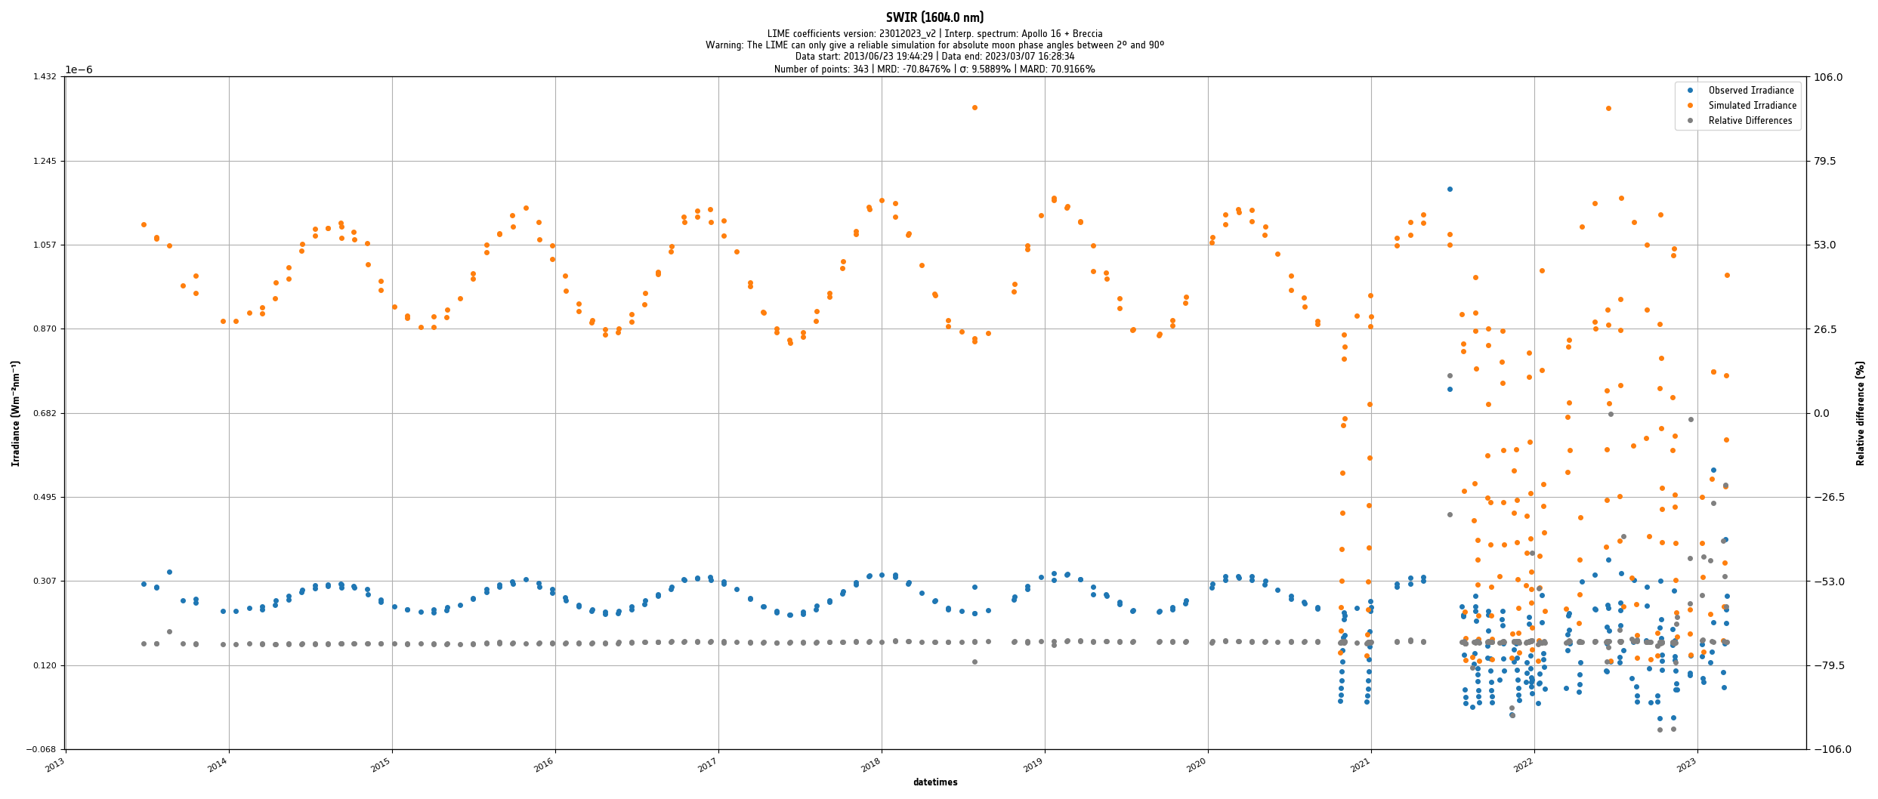
Figure 11 : PROBA-V SWIR irradiance compared to the LIME TBX.

Table 3: PROBA-V comparison to the 1088 lunar model.
BAND | BLUE | RED | NIR | SWIR
% | 450nm | 645nm | 834nm | 1665nm
AVG | -1.547 | 1.158 | 1.472 | -70.846
STDEV | 3.259 | 1.529 | 1.801 | 9.588

Geometric considerations

The results presented in section 4.5, obtained with the LIME model, show some temporal variations. The origin is unclear but an explanation could be found in the temporal variation or inclusion in the model, through the CIMEL data. In [AD2], a short paragraph is presented with the current status of the geometric coverage of the 1088 instrument measurements.
Figure 12 shows the observer libration coverage (observer selenographic longitude and latitude) of both the 1088 measurements and the PROBA-V lunar acquisitions. The period of acquisitions between PROBA-V and the 1088 instrument measurements campaign overlap in the period March 2018 up to November 2023. No major difference is to be observed any longer between PV and CIMEL. The missing positions have been filled largely by the CIMEL measurements.
The model based on the 1088 measurements only, is built from a limited set of lunar irradiance data and by consequence it is not capable of simulating the geometric cases that fall outside this area. This will improve with the continuation of the measurements. In [AD2], a total period of 6 years of lunar measurements is suggested.

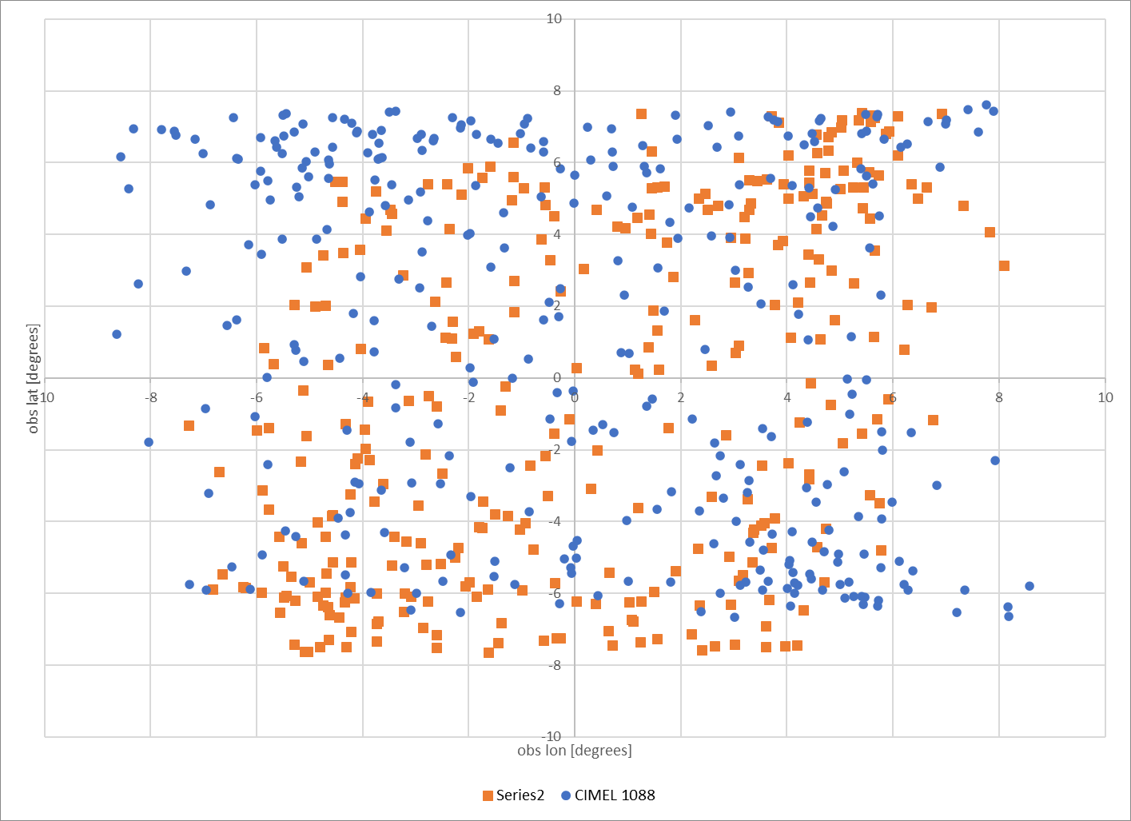
Figure 12: Selenographic lat/lon overlapping positions for the CIMEL 1088 measurements and PV lunar acquisitions.

Trending analysis
A limited analysis is done, to evaluate trending capabilities of the LIME model. The lunar model has been applied in the past to evaluate possible PROBA-V instrument degradation. The moon has high reflectance/irradiance stability over time and consequently yearly trends of ~1% can be detected with sensor lunar acquisitions. PROBA-V has monthly lunar data over +7 years, therefore it is a good dataset to check the trending capabilities of the lunar model.
These trends are cross checked and confirmed by application of other methods to PROBA-V sensor data, like PICS desert (Libya-4). More detailed results can be found in [RD5].

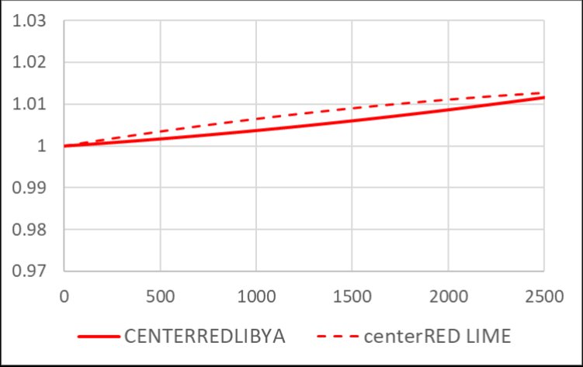
Figure 13: Trending analysis of LIME results compared to Libya4 (x – axis are the days since launch, y – axis is the relative change in calibration parameters wrt. mission start).
When calculating the linear regression trend for 2 separate methods for the RED spectral bands of PROBA-V, it is confirmed that the same evolution is found. Over more than 8 years, the total discrepancy for both methods is less than 0.3%.

Improvement to the previous model version

With respect to the previous releases of the model, the model software was re-implemented and interpolation was adapted [AD2].
When analysing the results of the PROBA-V simulations, the following improvements can be observed :
- Better agreement in the absolute level compared to PROBA-V for all VNIR bands,
- Significant Reduction of the short-term temporal variation between observations in time (i.e. compared to Figure 14).
This can be seen as one of the achievements of the project with the re-implementation of the model calculation processes into the LIME-TBX.
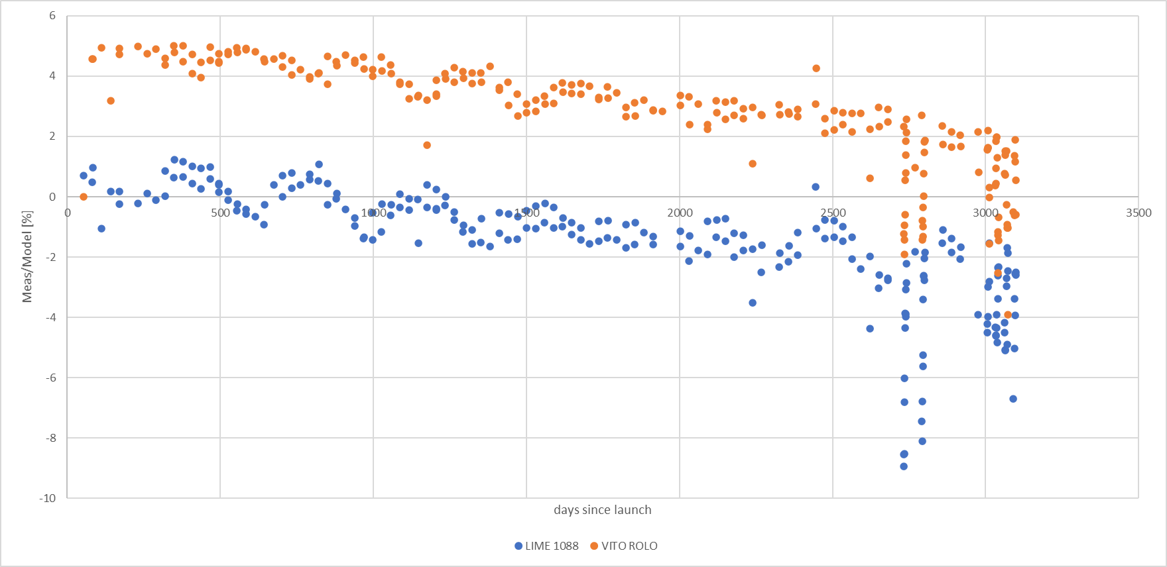
Figure 14 : PROBA-V BLUE irradiance compared to the 1088 lunar model (blue plot) from previous model implementation.

Conclusion PROBA-V comparison
One can observe that the absolute irradiance level of lunar model lies around 1.5 % below (RED, NIR) for the VNIR channels and 1.5 % above (BLUE). This level appears to be quite in line with the instrument lunar observations irradiance level.
Trending analysis is consistent up to sub-percent level with respect to other methods.

PLEIADES data

PLEIADES instrument
The Pleiades-1B HR imaging instrument (also called PHR1B) is a high resolution multi-spectral imager. It has five spectral bands in the VNIR region. The fifth band is a pan-chromatic band with a ground sampling distance (GSD) of 0.5 meter the other bands have a GSD of 2 meter.

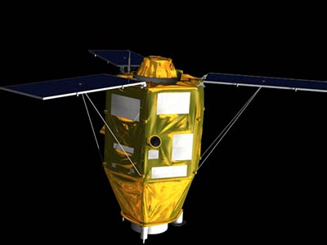
Figure 15: Pleiades 1B satellite.
In Figure 16 you can see the spectral response functions of Pleiades 1B. All in the visible area of the spectrum: Blue: 430-550 nm Green: 490-610 nm Red: 600-720 nm and Near Infrared: 750-950 nm. Panchromatic band occupies 480-830 nm.

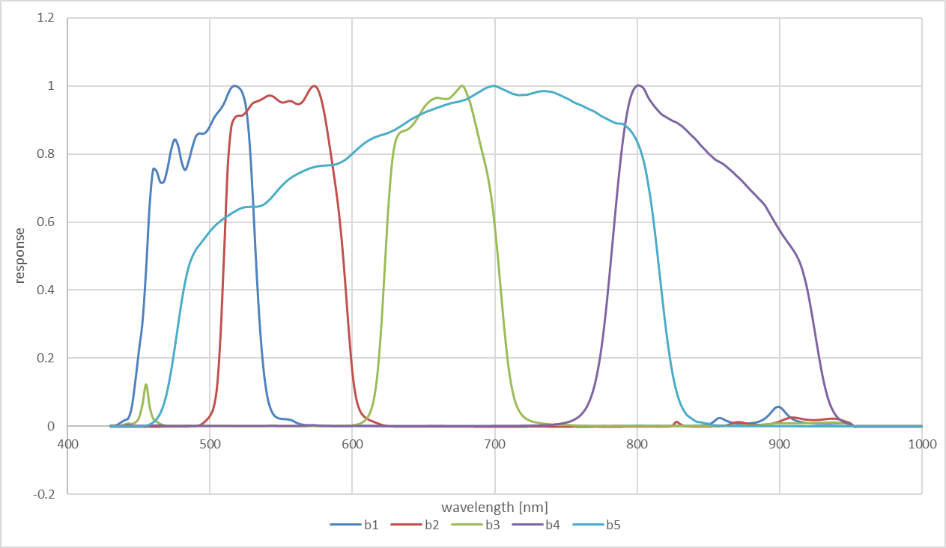
Figure 16: Pleiades-1B spectral response functions.

Pleiades-1B lunar acquisitions
In total 68 lunar observations are provided to the project, spanning the period between 18/02/2013 until 07/04/2017. The measurements are a combination of 2 campaigns in 02/2013 and 03/2013 recording at sparse lunar phase angles over the entire cycle, added with more routine-based observations around 40 degrees phase angle for several years, once every few months.
When looking at Figure 17, one can observe the sparsity or the measurements with respect to the lunar phase angle, but these cover a considerably wider range of phase angles than the PROBA-V observations.
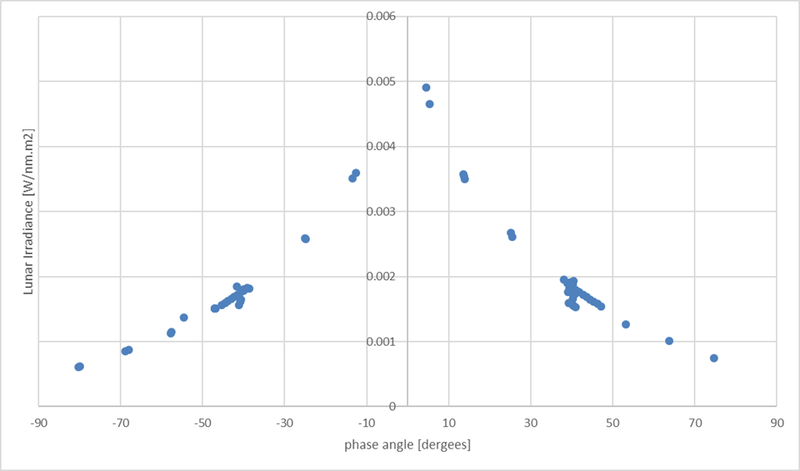
Figure 17: Pleiades Blue band lunar irradiance acquisitions.
For every acquisition the model input parameters are delivered:
- Phase angle
- Observer selenographic latitude and longitude
- Sun selenogragphic longitude
- Geometric factor (distance sun and observer to the Moon)
- Timestamp of the observation
- Irradiance value for every band
- Irradiance value calculated with the version of the ROLO model, output provided by CNES.
Apart from the necessary input parameters a set of calibration parameters is added for the period of the measurements. The so called PHR1B official calibration table:
Table 4: PHR1B calibration table.
Date | B0 | B1 | B2 | B3 | PAN
01/12/2012 | 1.117 | 1.085 | 1.075 | 1.015 | 1.034
01/09/2013 | 1.112 | 1.079 | 1.071 | 1.013 | 1.034
01/12/2013 | 1.110 | 1.078 | 1.070 | 1.012 | 1.034
01/03/2014 | 1.108 | 1.076 | 1.069 | 1.011 | 1.034
01/06/2014 | 1.106 | 1.074 | 1.067 | 1.011 | 1.034
01/09/2014 | 1.104 | 1.072 | 1.066 | 1.010 | 1.034
01/12/2014 | 1.103 | 1.070 | 1.065 | 1.009 | 1.034
01/03/2015 | 1.100 | 1.068 | 1.064 | 1.008 | 1.034
01/06/2015 | 1.099 | 1.066 | 1.062 | 1.008 | 1.034
01/09/2015 | 1.097 | 1.064 | 1.062 | 1.007 | 1.034
01/12/2015 | 1.095 | 1.061 | 1.062 | 1.006 | 1.034
01/03/2016 | 1.093 | 1.061 | 1.062 | 1.006 | 1.034
01/06/2016 | 1.090 | 1.056 | 1.054 | 1.003 | 1.032
01/09/2016 | 1.089 | 1.055 | 1.053 | 1.003 | 1.031
01/01/2017 | 1.087 | 1.053 | 1.050 | 1.001 | 1.029
01/03/2017 | 1.085 | 1.051 | 1.048 | 1.000 | 1.028

The calibration is applied to the Pleiades irradiance measurements, taking the temporal changes into account.

Results with LIME model
For all Pleiades observations and spectral bands, a model output is generated and presented in Figure 18 up to Figure 22. The difference (in %) is calculated and plotted against the phase angle. With the Pleiades data, the results of the CNES implementation of the ROLO model are delivered as well. The comparison with these results is plotted as well (in blue) as an extra reference.
Important Notice: for the following figures ‘rolo cnes’ is the USGS ROLO model applied to the CNES output of the PLEIADES 1B Lunar observations.
This comparison was performed with the latest model coefficients release, available through the toolbox. The software used to run the model is the LIME SW2 latest version, to accommodate for the absence of platform position coordinates in the input data.
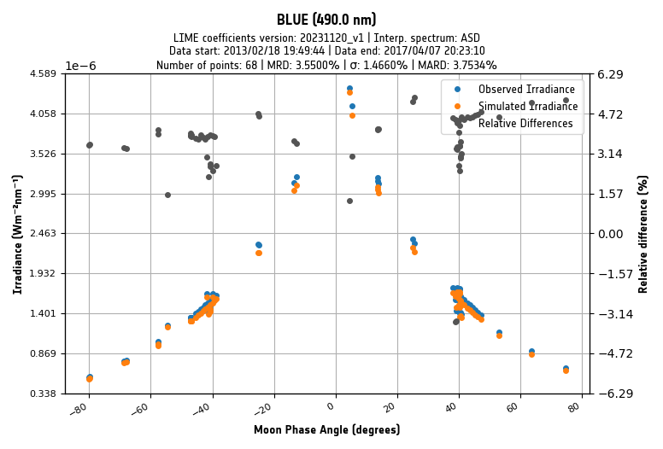
Figure 18: PHR1B band 1 (blue) result – 1088 model.
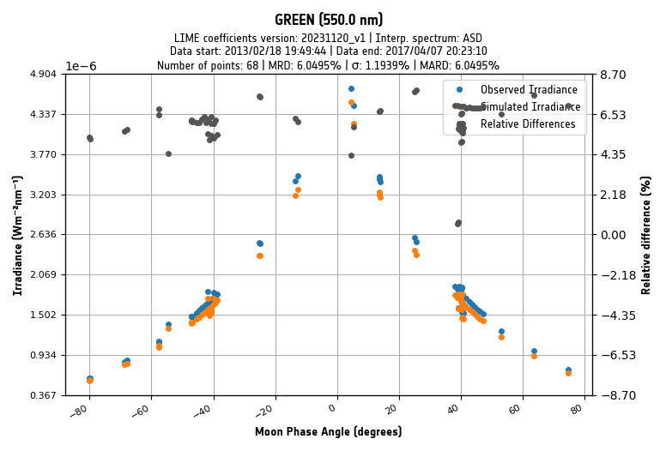
Figure 19: PHR1B band 2 (green) result - 1088 model.

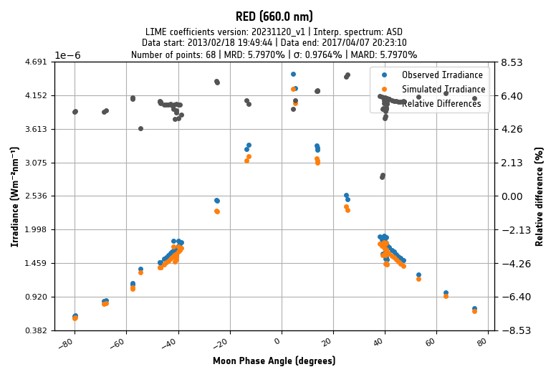
Figure 20: PHR1B band 3 (red) result - 1088 model.

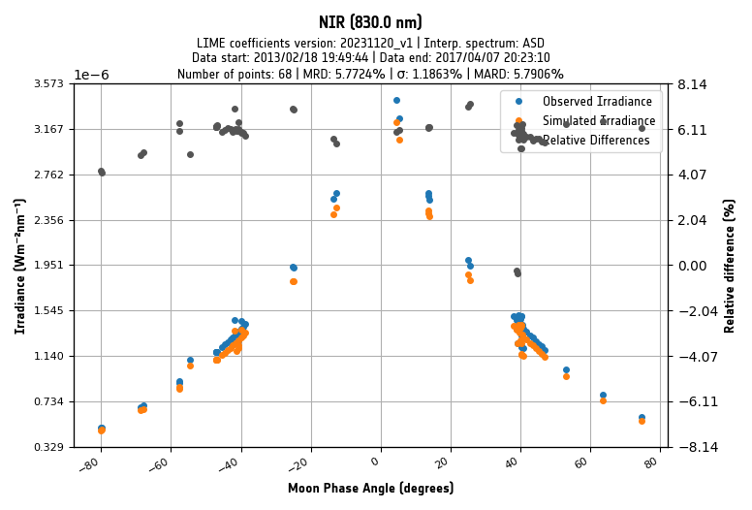
Figure 21: PHR1B band 4 NIR) result - LIME model.

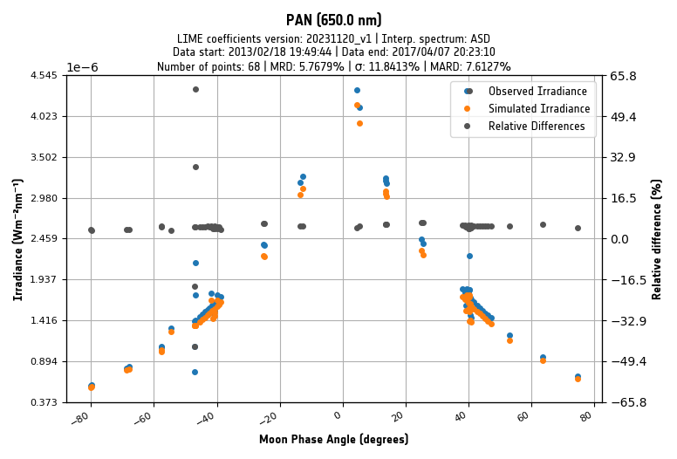

Figure 22: PHR1B band 5 (pan) result - LIME model
Table 5 presents the overview of the comparison between the Pleiades 1B and 1088 lunar model.

Table 5: Average and Stdev of Pleiades data agains the 1088 model
% | BLUE | GREEN | RED | NIR | PAN
AVG | 3.550 | 6.050 | 5.797 | 5.772 | 5.768
STDEV | 1.466 | 1.194 | 0.976 | 1.860 | 11.841

Conclusion Pleiades 1B comparison
The comparison with Pleiades shows:
The output of the LIME model irradiance is lower than the PLEIADES irradiance levels, calibrated with other vicarious calibration methods. The comparison with the instrument shows differences of the order of 3.5 to 6 %, depending on the spectral band.
The observed offset between PLEIADES 1B and LIME is slightly larger than expected. The cause is unclear, it is not in line with the comparisons of the GIRO (2 to 4%) nor the PROBA-V (-1.5 to 1.5%) comparisons.
For the simulation of irradiances (LIME TBX output) the results are based upon the direct model input (phase angle, libration angles, distance correction) as provided by the satellite/instrument operator. Therefore, the intermediate step calculating from position to angles is omitted to simulate the LIME irradiance output.

Comparison with the GIRO model

The GIRO model was developed at EUMETSAT in collaboration with T. Stone to create a functional copy of the original USGS ROLO model as a second reference implementation. Benchmarks have shown numerical “identity” between both models.
The GIRO model is distributed to parties that incorporate data into the GLOD, a database with several sets of lunar acquisitions, formatted and stored by EUMETSAT. The agreement was made to share data of the current project with the GLOD, in order to get a license to use the GIRO as a comparison to the currently developed model.
Both models are setup the use the CIMEL sensor spectral responses.

Input data
A set of geometries was generated to directly compare the irradiance output. These geometries have been applied to both the GIRO and LIME TBX. The geometries are generated without a timestamp, they can be seen as a direct input grid to the model, without the need to convert the
Comparison is done for 8 spectral bands, with central wavelengths 442,550,670, 765,870,1380,1640 and 2350 nm. The central wavelengths of few bands fall in close agreement with the CIMEL bands central wavelengths and consequently the model internal wavelengths, before interpolation or extrapolation of the final irradiannce values.
Table 6: Selected spectral bands for the comparison between GIRO and LIME
CWL[nm] | application
442 | ocean color, aerosol photometer (ideally also 412 nm for ocean color)
550 | max solar irradiance, Moon characterization, land
670 | ocean color, aerosol photometer, land
765 | ocean color reference band
870 | atmospheric window, Moon characterization, ocean color reference, aerosol photometer, land
1380 | cirrus detection (all applications)
1640 | atmosphere, aerosol photometer, land

The geometry input is generated with the boundaries given in the next table. Notify that the solar selenographic latitude is kept to zero.

Table 7: Geometry minimum and maximum values for the geometry grid.
 | phase_angle [deg] | obs_sel_lon [deg] | obs_sel_lat [deg] | sun_sel_lon [deg] | sun_sel_lat [deg]
min | -90 | -12 | -8 | -98 | 0
max | 90 | 12 | 8 | 102 | 0
count | 20 | 7 | 5 | 249 | 1

Results GIRO model comparisons

Figure 23: LIME model to GIRO @ 442 nm.
Figure 24: LIME model to GIRO @ 550nm.
Figure 25: LIME model to GIRO @ 670 nm.
Figure 26: LIME model to GIRO 765 nm.

Figure 27: LIME model to GIRO @ 870 nm.
Figure 28: LIME model to GIRO @ 1380 nm.

Figure 29: LIME model to GIRO @ 1640 nm.
Figure 30: LIME model to GIRO @ 2350 nm.

Table 8: overview of LIME model compared to GIRO
% | 442 | 550 | 670 | 765 | 870 | 1380 | 1640 | 2350
AVERAGE | 2.628 | 2.416 | 1.675 | 3.915 | 3.251 | 2.900 | 0.708 | 6.173
STDEV | 2.334 | 2.377 | 1.899 | 1.454 | 1.639 | 2.531 | 2.402 | 5.272

Conclusion GIRO comparison

In general, three important conclusions can be taken from this comparison:
- For all bands the ESA model gives higher lunar irradiance than the GIRO model in the VNIR and SWIR
- This difference is highest at 2350 nm possibly due to the fact that LIME simulations not well constrained by the CIMEL 1088 measurements (stopping at 1640 nm).
- In general at very larger phase angles the two models are in closer agreement than lower phase angles.

The LIME model and the GIRO have different outputs, both for the absolute level as the dependency on the phase angle. When looking at the PROBA-V and Pleiades results, the absolute level of the model is closer to the sensor compared to their specific ROLO implementations. What is observed from the GIRO results, they appear to be quite in-line with that conclusion.

Conclusions

For the absolute level of the model the following conclusions can be drawn:
- The overall absolute level of model agrees quite well with the PROBA-V radiometry and with the GIRO model,
- The model compares slightly less with PLEIADES 1B measurements. The cause is under investigation.
To summarize the comparisons, it is the current version of the lunar model has some issues:
- In general a possible lunar phase dependency is observed for all bands, for low phase angles (<10 degrees).
- The irradiance level difference between LIME and GIRO is below 5% in the VNIR.
- PROBA-V SWIR data processing is to be re-assessed for lunar data, as the results do not agree with knowledge of other absolute calibration methods.
This study isn’t final:
- More measurements with the CIMEL instrument are needed to increase the number of points in the regression process and increase confidence in the model.
- After deriving new parameters for the model from the instrument data, this comparison will be reproduced and re-assessed.
- Comparison with other references is to be considered (i.e. from the GLOD)

APPENDIX A – MODEL IMPLEMENTATION VALIDATION

As an extra test, a comparison between the implementation described in paragraph 3.2 done within the project is compared to the GIRO model output. Simply feeding the ROLO model coefficients from [RD-1] into the software allows comparison of both implementations.
Visual inspection of intermediate results show that the calculation of the ROLO reflectance values are identical for both GIRO and the project software. Differences exist between the output irradiances of both implementations, are thus due to the model ‘post-processing’ of paragraph 3.2.
In the next figures one can observe, that for the PROBA-V bands, there is generally a very small difference (~0.1 % absolute), except for the blue band. In the blue band, the offset between both implementations is about 1 %.
Following possible reasons are identified:
- Different reflectance interpolation for model central wavelengths (no knowledge of responses is available for the ROLO channels)
- Slightly Different procedure:
  - Spline interpolation implementation
  - Least Absolute Difference regression implementation
There is currently no conclusion yet on the exact reason. There appears to be a dependency on wavelengths. This needs further investigation in one of the next model iterations.
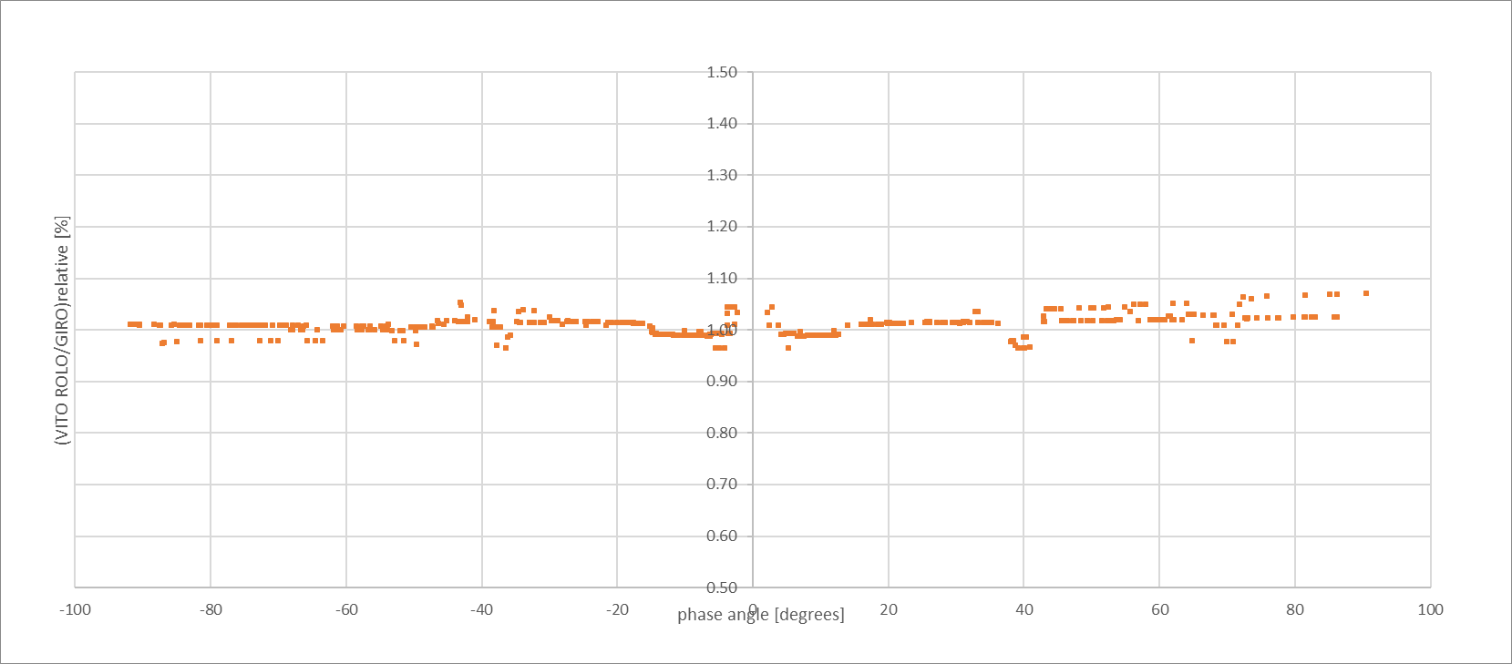
Figure 31: Relative difference between project software using GIRO model coefficients and GIRO output for 461 nm.
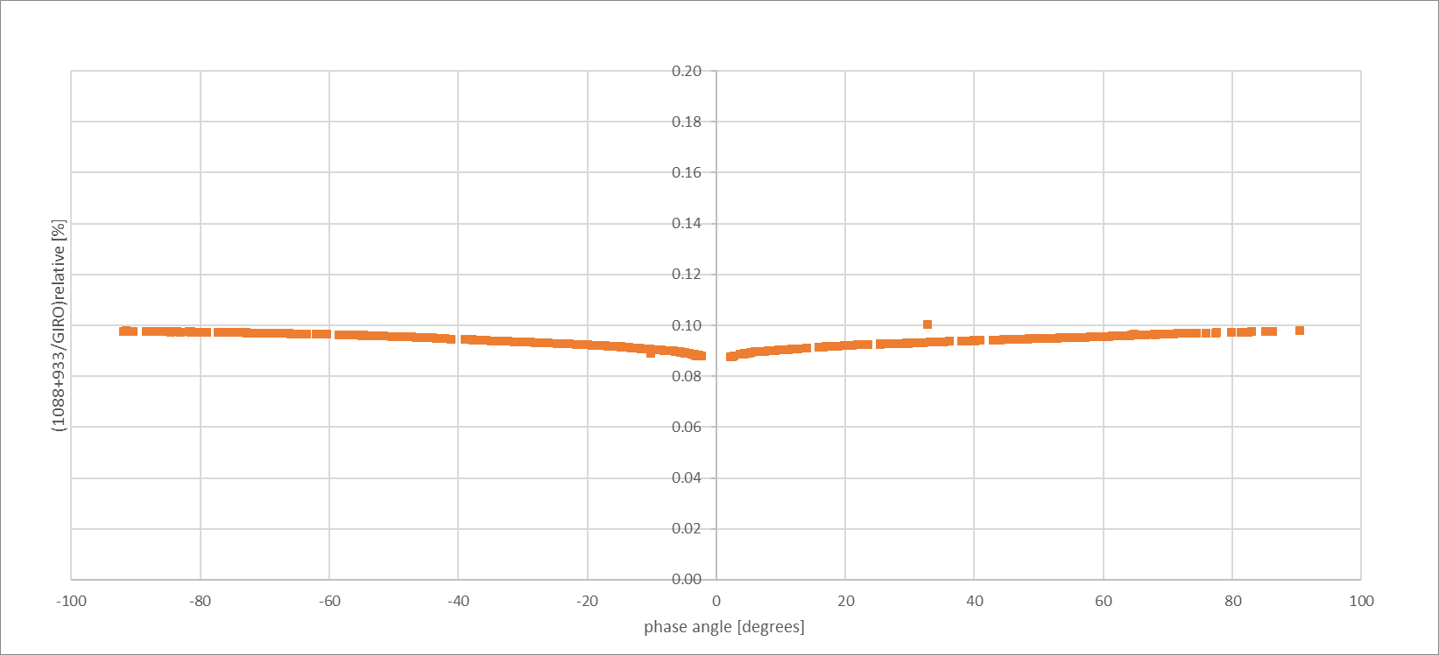
Figure 32 : Relative difference between project software using GIRO model coefficients and GIRO output for 650 nm.

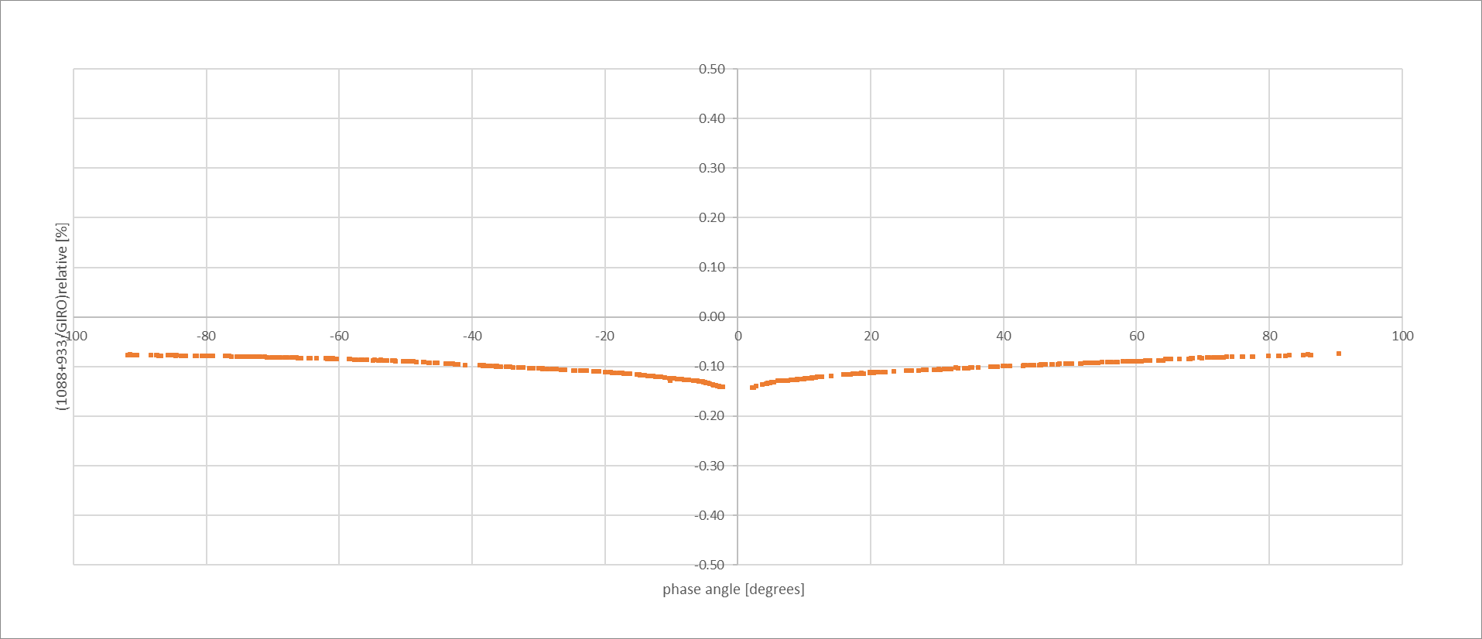
Figure 33 : Relative difference between project software using GIRO model coefficients and GIRO output for 840 nm.

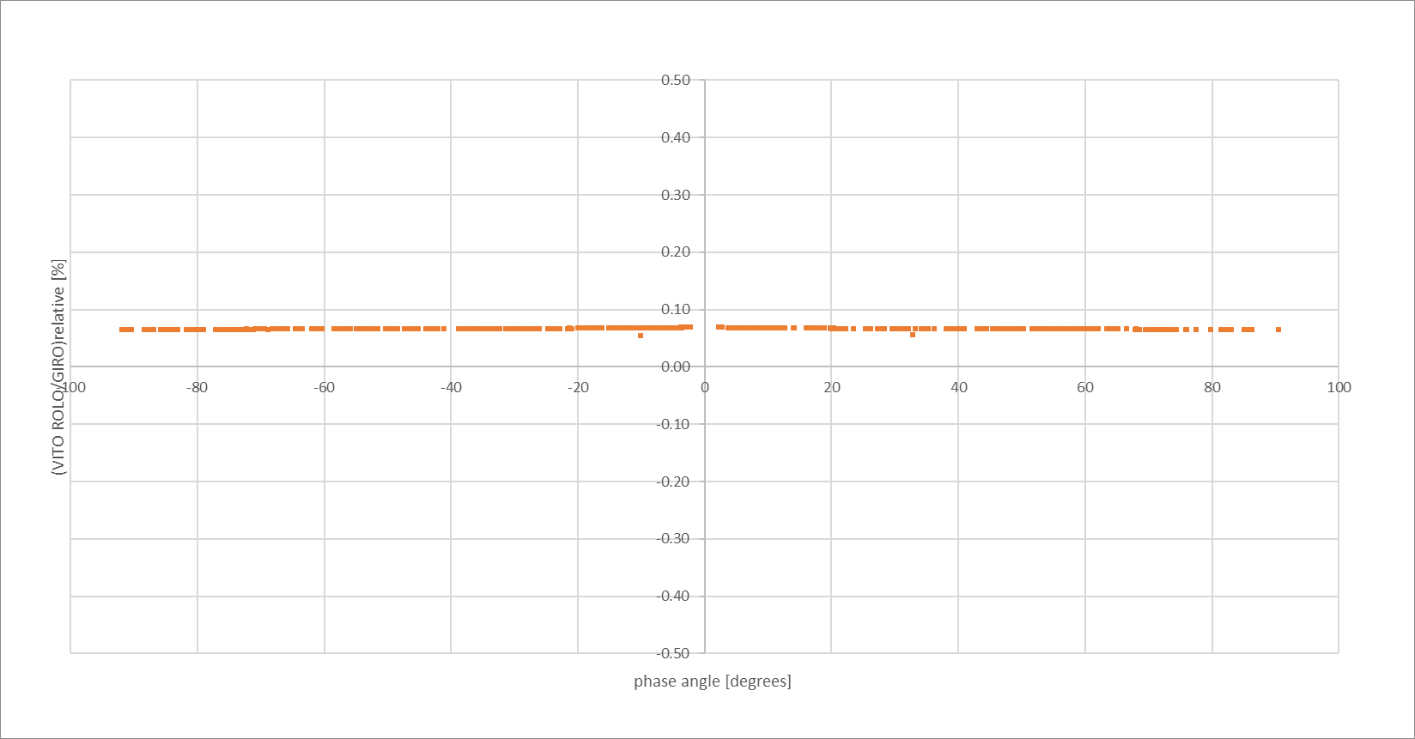
Figure 34: Relative difference between project software using GIRO model coefficients and GIRO output for 1604 nm.

APPENDIX B – Comparison Sentinel 3 OLCI with LIME

In this paragraph Sentinel-3 lunar acquisitions are compared with the most the LIME model. Two acquisitions have been performed, one for S3A and one for S3B.
The Sentinel 3B spectral response functions of the instrument are shown in Figure 35. There are 21 bands over the visible range between 400 and 1050nm roughly. The spectral bands are 40,20,10 and 7.5 nm wide. Three specific narrow bands in the area of 765nm are 2.5,3.75 and again 2.5 nm wide. These are spectral bands for specific application of atmospheric correction purposes.

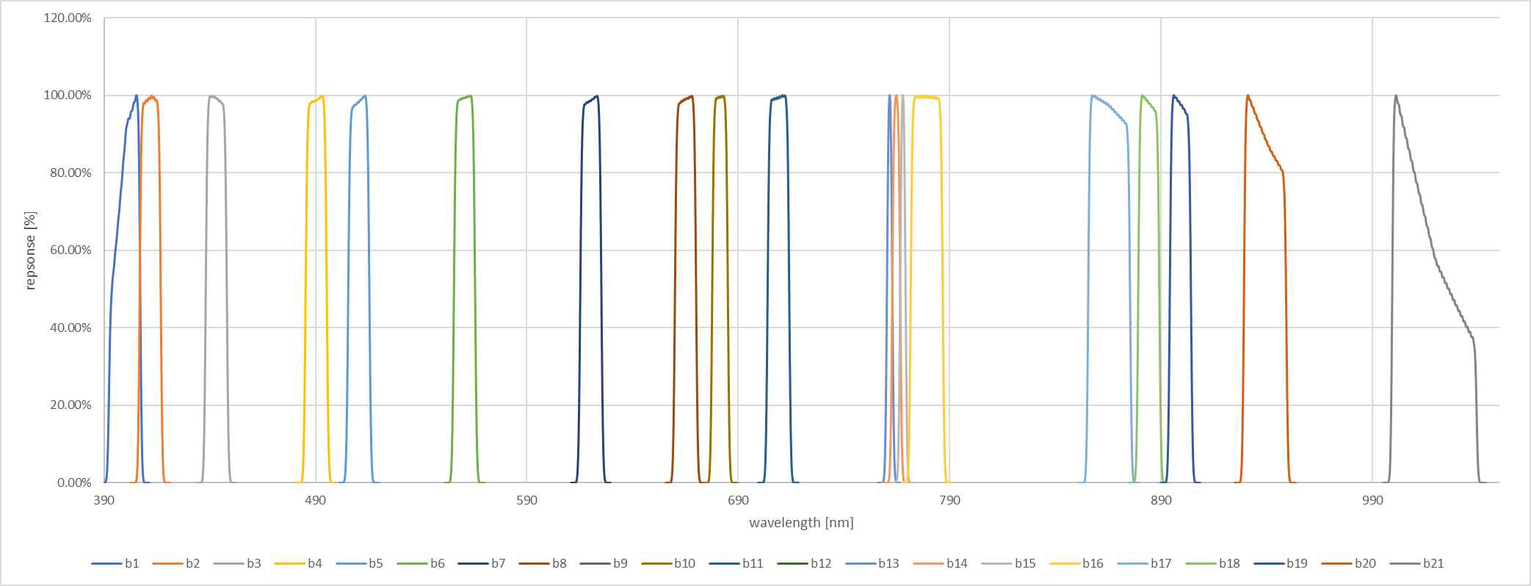
Figure 35: Sentinel 3B OLCI mean Relative Spectral Response curves
Timestamps and sensor locations are:
Table 9:Timestamp and location of S3A/B lunar observations
Sensor | Timestamp | X(J2000) [km] | Y(J2000) [km] | Z(J2000) [km]
S3B | 2018-07-27T05:22:43 | 956.429 | -6474.182 | -2969.739
S3A | 2020-07-04T16:13:05 | -1367.947 | -6186.552 | -3386.554
The push-broom imager performs a line-by-line scan of the Moon during a rotational maneuver of the platform. This approach requires specific processing of the data, taking into account the oversampling factor for every line, using the platform telemetry. The processing to retrieve the irradiances from the image is performed by Maciek Neneman of ESA-ESTEC. His results and the comparison of the S3B and the previous version of LIME is published:
Neneman, M.; Wagner, S.; Bourg, L.; Blanot, L.; Bouvet, M.; Adriaensen, S.; Nieke, J. Use of Moon Observations for Characterization of Sentinel-3B Ocean and Land Color Instrument. Remote Sens. 2020, 12, 2543.

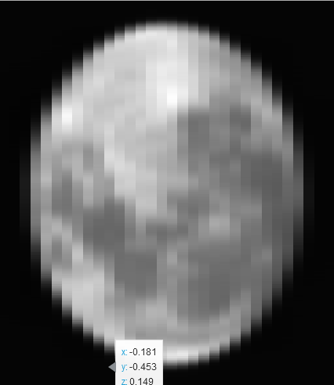
Figure 36: S3B lunar acquisition quick look for band 5.
Figure 36 is a quick look of the spectral band 5 in DN values. The processing that is performed is comparable to the PROBA-V processing sequence, apart from specific implementations like DN to Radiance conversion sensor model. The Irradiance values for both sensors are plotted in Figure 37. The differences that are observed are due to the difference in observation geometry (phase angle, libration) and sensor differences. The irradiances are normalized for distances between Sun, Moon and observer.
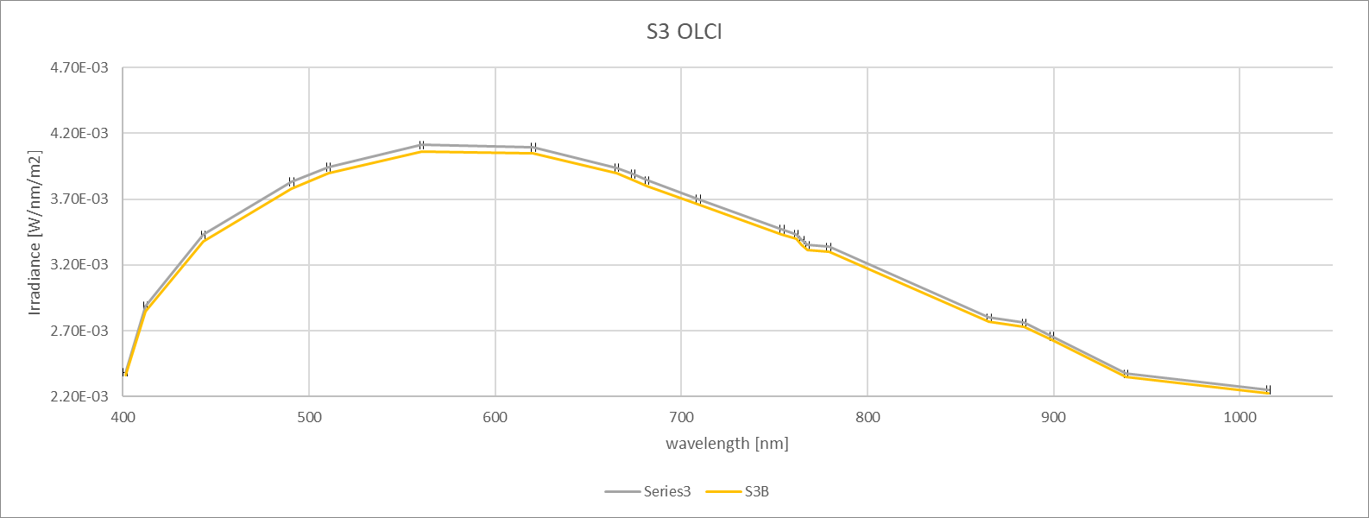
Figure 37: Irradiance levels for both S3A and S3B Lunar acquisitions.
Direct comparison between LIME and the observations of both S3A and B are plotted in Figure 38.

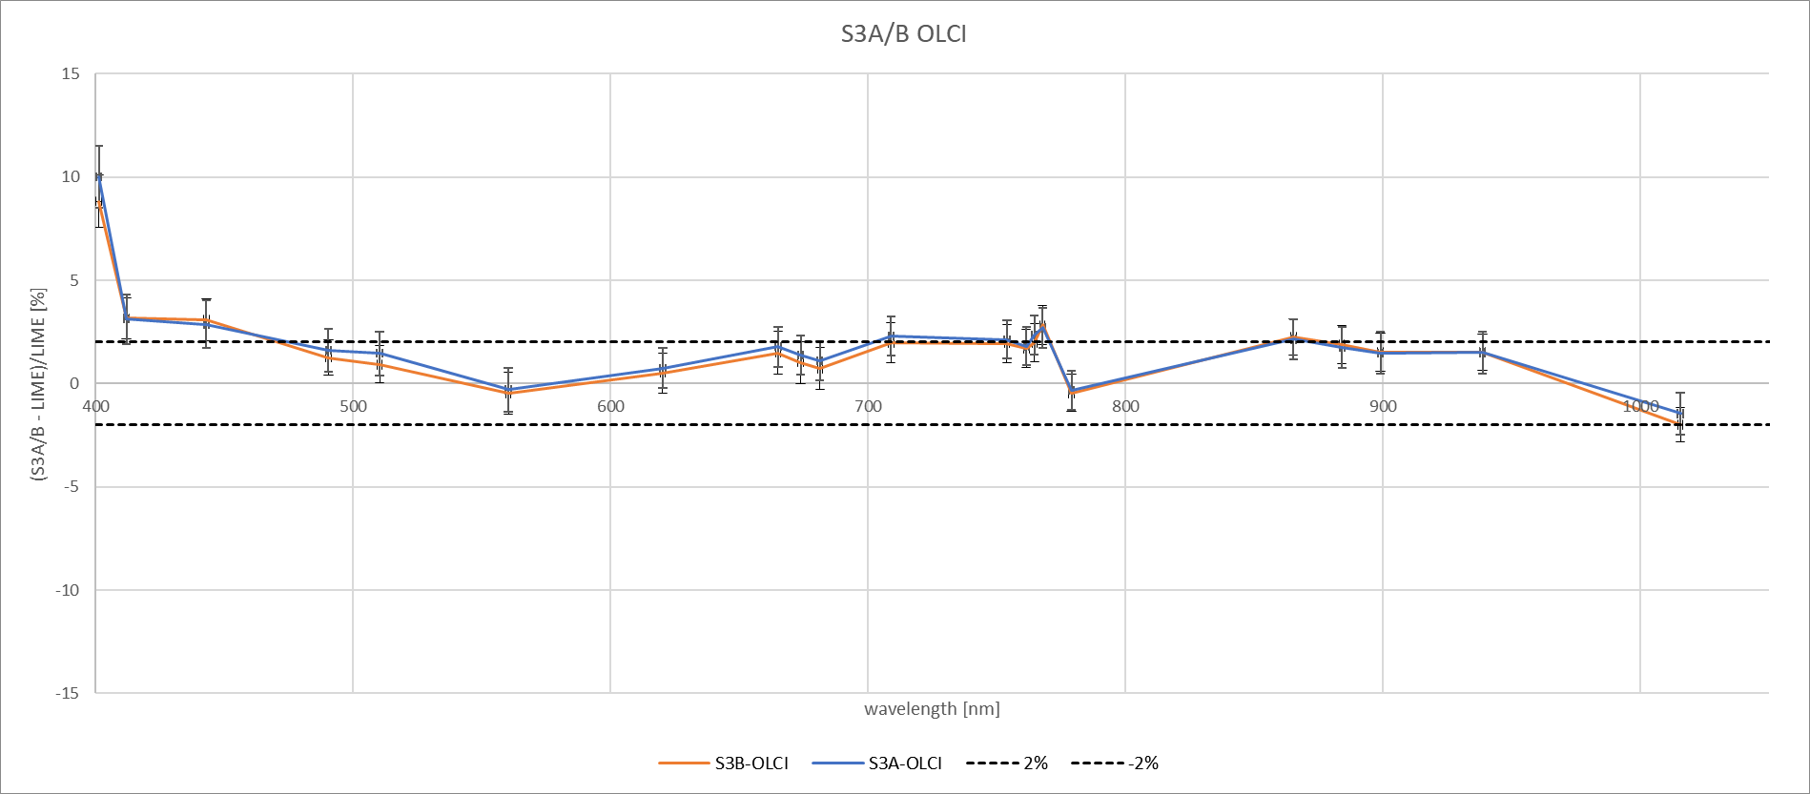
Figure 38: Comparison between S3A and B OLCI and LIME.
When taking the 2% model uncertainty into account, the plot shows that for both S3A and B most bands fall within the 2% absolute requirement level. In general, S3A appears to be slightly higher then S3B. The uncertainties plotted on top of the difference values are outputted by the model. Band Oa01 for both A and B OLCI sensors appears to be outside the 5% area. The central wavelength of this band is at the edge of the spectral range of the LIME model reflectance wavelengths.
In Table 10 the tabulated plot values can be found:
Table 10: S3A and B difference between measured and LIME irradiance in %
 | S3A |  | S3B
WL[nm] | diff% | unc | diff% | unc
401 | 10.0049 | 1.4866 | 8.8250 | 1.2711
412 | 3.1257 | 1.2020 | 3.1569 | 1.0067
443 | 2.8698 | 1.1489 | 3.0771 | 1.0222
490 | 1.6208 | 1.0429 | 1.2545 | 0.8619
510 | 1.4574 | 1.0668 | 0.9210 | 0.8993
560 | -0.2998 | 1.0741 | -0.4831 | 1.0187
620 | 0.7425 | 0.9717 | 0.5163 | 0.9731
665 | 1.7808 | 0.9691 | 1.4899 | 1.0277
674 | 1.3888 | 0.9484 | 1.0167 | 1.0158
681 | 1.1129 | 0.9378 | 0.7304 | 1.0056
709 | 2.3065 | 0.9472 | 1.9789 | 0.9782
754 | 2.1270 | 0.9262 | 1.9423 | 0.9157
762 | 1.8109 | 0.9413 | 1.7042 | 0.9262
765 | 2.3448 | 0.9458 | 1.9661 | 0.9291
768 | 2.6987 | 0.9654 | 2.8355 | 0.9356
779 | -0.3302 | 0.9284 | -0.4620 | 0.9006
865 | 2.1419 | 0.9828 | 2.2611 | 0.8852
884 | 1.7426 | 0.9929 | 1.8799 | 0.9218
899 | 1.4802 | 1.0104 | 1.5164 | 0.9132
939 | 1.4927 | 1.0348 | 1.5237 | 0.8890
1016 | -1.4564 | 1.0160 | -1.9927 | 0.8437

APPENDIX B – PLOTS Irradiance comparison between LIME and GIRO

The included plots are a 3D representation with the plots of relative difference between both models, the phase angle in degrees and the selenographic longitude of the sun.
Figure 39: comparison irradiance LIME and GIRO 442 nm.
Figure 40: comparison irradiance LIME and GIRO 550 nm.

Figure 41: comparison irradiance LIME and GIRO 670 nm.

Figure 42: comparison irradiance LIME and GIRO 765 nm.

Figure 43: comparison irradiance LIME and GIRO 870 nm.

Figure 44: comparison irradiance LIME and GIRO 1380 nm.

Figure 45: comparison irradiance LIME and GIRO 1640 nm.

APPENDIX B – Calculating the uncertainty associated with the comparison to a satellite sensor

Extending the uncertainties of the model and measurement comparisons, could be incorporated in future work. More and more instrument and mission operators attempt to provide a value the uncertainty. These can be combined with model uncertainties with the below formulations.
The hyperspectral lunar model is convolved with the (normalised to unit area) spectral response function of the satellite sensor and the modelled integral is compared with the sensor measurement. This is ideally done to compare the uncertainties of the two ‘observations’. We can do this in terms of absolute uncertainties:
$$Δ_{\text{model}}=\frac{\left({\overline{E}}_{\text{sensor}}-{\overline{E}}_{\text{model}}\right)}{k\sqrt{u^{2}\left({\overline{E}}_{\text{sensor}}\right)+u^{2}\left({\overline{E}}_{\text{model}}\right)+u^{2}\left({\overline{E}}_{\text{matchup}}\right) }}$$
Or in terms of relative uncertainties
$$Δ_{\text{model,rel}}=\frac{\left(\frac{{\overline{E}}_{\text{sensor}}}{{\overline{E}}_{\text{model}}}-1\right)}{k\sqrt{u_{\text{rel}}^{2}\left({\overline{E}}_{\text{sensor}}\right)+u_{\text{rel}}^{2}\left({\overline{E}}_{\text{model}}\right)+u_{\text{rel}}^{2}\left({\overline{E}}_{\text{matchup}}\right) }}$$
The uncertainty associated with the sensor measurement is taken as the nominal uncertainty. The uncertainty associated with the match up, is the uncertainty due to any mismatch between the model and the sensor. This uncertainty is likely to be small when the required inputs (timestamp and platform and sensor position) are well defined and have very small uncertainties themselves.
The uncertainty associated with the model is obtained by performing the spectral convolution for each of the 1000 hyperspectral models that we have through the MCUA and determining the standard deviation of those convolved quantities.
$k$ is the coverage factor. If the distribution is Gaussian, then $k=2$ provides a confidence interval of 95 %. We would therefore expect $Δ_{\text{model}}$ to be less than one 95 % of the time.
For the moment, the sensor and matchup uncertainties are unknowns and therefore the current baseline only compares the sensor and model results. However, it is an interesting exercise to look in the future developments of the model.

