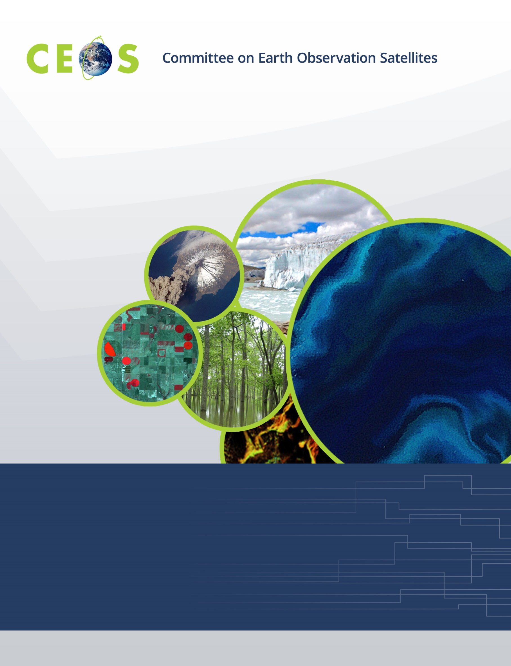
Working Group on Calibration and Validation
CEOS WGCV #47, Virtual Meeting
Hosted by Webex
July 14 to 17, 2020
Agenda
Version 1.1 July 06, 2020

Tuesday 14 July 2020
WGCV Business and Meeting Introduction
14:00 GMT | Chair/Vice Chair welcome, opening & agenda | C. Ong / A. Kuze
14:10 | Overview on WGCV of continuing and new workplans | Cindy Ong
14:20 | Introduction of incoming vice chair | Cindy Ong
14:25 | CEOS 2020-2022 workplan | Kerry Sawyer
14:40 | Q&A
Sub Group and Task Reports
14:50 | The Land Product Validation Sub Group highlights, progress and updates on the Biomass Validation and Vegetation Surface Reflectance Inter-comparison Tasks | Fernando Camacho
15:10 | The Infrared Optical Visible Sensors Sub Group highlights | Nigel Fox
15:30 | The Atmospheric Composition Sub Group highlights | Jean Christopher Lambert
15:50 | Q&A
16:10 Adjourn
DIAL IN INFORMATION
-- Do not delete or change any of the following text. --
Welcome to CSIRO Webex Conferencing featuring: audio, video and presentation capabilities. You can join this conference from:
Desktop or Mobile Devices
https://csiro.webex.com/csiro/j.php?MTID=mf2e7b42ced95850b590ffcde4d676bf9

Once connected to your meeting remember to start your audio and video

Video Conferencing (VC) Rooms
Use the remote control or touch panel and dial the number indicated below:
CSIRO VC Room 1657572728# (hash required)
External VC Room 1657572728@csiro.webex.com

Phones - AUDIO ONLY
Primary Australia +61 2 6246 4433
Quick Dial +61262464433,1657572728%23%23

Other Global Numbers https://conferencing.csiro.au/Call-in.php

Meeting Number/Access Code 165 757 2728

Password (if prompted)
D6aPbJaRq28
________________________________________
First time joining a Webex meeting? Watch this short video to get started:
https://conferencing.csiro.au/videos/videos.php?tab=join
Need further help? Take a look at the link below for user guides, videos and FAQs:
https://conferencing.csiro.au/index.php?meeting-number=1657572728&site=csiro.webex.com
Wednesday 15 July 2020
Agency Presentations
14:00 GMT | NASA | Kurt Thome
14:10 | USGS | Greg Stensaas
14:20 | NOAA | Jason Choi
14:30 | DLR | Albrecht von Bargen
14:40 | ESA | Philippe Goryl
14:50 | Belspo | Jean Christopher Lambert
15:00 | UKSA | Nigel Fox
Collaborations with other WGs and VCs
15:10 | WG Climate and the GHG Task | Albrecht von Bargen
15:30 | LSI-VC and the engagement with industry on ARD | Nigel Fox
15:50 | Q&A
16:00 Adjourn
DIAL IN INFORMATION
-- Do not delete or change any of the following text. --
Welcome to CSIRO Webex Conferencing featuring: audio, video and presentation capabilities. You can join this conference from:
Desktop or Mobile Devices
https://csiro.webex.com/csiro/j.php?MTID=m11655365fc4a67a0f804000cb1ab9087

Once connected to your meeting remember to start your audio and video

Video Conferencing (VC) Rooms
Use the remote control or touch panel and dial the number indicated below:
CSIRO VC Room 1652511484# (hash required)
External VC Room 1652511484@csiro.webex.com

Phones - AUDIO ONLY
Primary Australia +61 2 6246 4433
Quick Dial +61262464433,1652511484%23%23

Other Global Numbers https://conferencing.csiro.au/Call-in.php

Meeting Number/Access Code 165 251 1484

Password (if prompted)
tZzNecH23n6
________________________________________
First time joining a Webex meeting? Watch this short video to get started:
https://conferencing.csiro.au/videos/videos.php?tab=join
Need further help? Take a look at the link below for user guides, videos and FAQs:
https://conferencing.csiro.au/index.php?meeting-number=1652511484&site=csiro.webex.com
Thursday 16 July 2020
Sub Group Reports
5:00 GMT | The Microwave Sub Group highlights and the microwave standards task | Xiaolong Dong
5:10 | The Terrain Mapping Sub Group and progress and updates on DEM Inter-comparison task | Peter Strobl
5:20 | Q&A
Agency Presentations
5:30 GMT | JAXA | Akihiko Kuze
5:40 | GA | Medhavy Thankappan
5:50 | AIR, CAS | LingLing Ma
6:00 | NRSCC | Xiaolong Dong
6:10 | CSIRO | Cindy Ong
6:20 | ISRO | Santhi Sree B
Collaborations with other WGs and VCs
6:35 | WGISS – the interoperability lab | Robert Woodcock
6:50 | Q&A
7:00 Adjourn
DIAL IN INFORMATION
-- Do not delete or change any of the following text. --
Welcome to CSIRO Webex Conferencing featuring: audio, video and presentation capabilities. You can join this conference from:
Desktop or Mobile Devices
https://csiro.webex.com/csiro/j.php?MTID=mb71c6f3f5264ad21a74ee0e10a5a8201

Once connected to your meeting remember to start your audio and video

Video Conferencing (VC) Rooms
Use the remote control or touch panel and dial the number indicated below:
CSIRO VC Room 1659325836# (hash required)
External VC Room 1659325836@csiro.webex.com

Phones - AUDIO ONLY
Primary Australia +61 2 6246 4433
Quick Dial +61262464433,1659325836%23%23

Other Global Numbers https://conferencing.csiro.au/Call-in.php

Meeting Number/Access Code 165 932 5836

Password (if prompted)
P23bQ7dfUtn
________________________________________
First time joining a Webex meeting? Watch this short video to get started:
https://conferencing.csiro.au/videos/videos.php?tab=join
Need further help? Take a look at the link below for user guides, videos and FAQs:
https://conferencing.csiro.au/index.php?meeting-number=1659325836&site=csiro.webex.com
Friday 17 July 2020
Collaboration with other WGs and VCs
5:00 GMT | The CARD4L Assessment Process | Medhavy Thankappan
5:15 | Terminology | Nigel Fox
WGCV Business
5:25 | Cal Val Portal | Philippe Goryl
5:35 | Maturity Matrix | Philippe Goryl
5:55 | New workplan tasks/proposals???
6:05 | Meeting Summary | Cindy Ong
6:20 | Future directions and meetings | Cindy Ong
6:30 Adjourn
DIAL IN INFORMATION
-- Do not delete or change any of the following text. --
Welcome to CSIRO Webex Conferencing featuring: audio, video and presentation capabilities. You can join this conference from:
Desktop or Mobile Devices
https://csiro.webex.com/csiro/j.php?MTID=mb1bebbaea8e5df6d8389f8e797a35e75

Once connected to your meeting remember to start your audio and video

Video Conferencing (VC) Rooms
Use the remote control or touch panel and dial the number indicated below:
CSIRO VC Room 1658396001# (hash required)
External VC Room 1658396001@csiro.webex.com

Phones - AUDIO ONLY
Primary Australia +61 2 6246 4433
Quick Dial +61262464433,1658396001%23%23

Other Global Numbers https://conferencing.csiro.au/Call-in.php

Meeting Number/Access Code 165 839 6001

Password (if prompted)
Zmp3Y9GUYm3
________________________________________
First time joining a Webex meeting? Watch this short video to get started:
https://conferencing.csiro.au/videos/videos.php?tab=join
Need further help? Take a look at the link below for user guides, videos and FAQs:
https://conferencing.csiro.au/index.php?meeting-number=1658396001&site=csiro.webex.com

