CEOS WGCV #47, Virtual Meeting
Hosted by Webex
July 14 to 17, 2020

Friday 17 July 2020
Attendance: Medhavy Thankappan
Cindy Ong
Ian Lau
Philippe Goryl
Kurt Thome
Akihiko Kuze
Fernando Camacho
Albrecht Von Bargen
Greg Stensaas
Peter Strobl
Dong Xiaolong
Patrice Henry
Santhi Sree (Santhi Basavaraju)
Jean Christopher Lambert
Erin Lynch
Nigel Fox
Collaboration with other WGs and VCs
5:00 GMT | The CARD4L Assessment Process | Medhavy Thankappan
(5:07) | Steps of the CARD4L assessment process:  - Data provider completes self-assessment against CARD4L  - Data provider submits request for CARD4L endorsement to LSI-VC  - WGCV receives CARD4L peer-review request from LSI-VC  - WGCV verifies submitted CARD4L documentation  - WGCV Acceptance Review Panel specific to PFS is set up  - WGCV PoC interacts with data provider for any clarifications  - Review Panel provides recommendation for a vote by WGCV  - WGCV membership votes on recommendation  - WGCV communicates outcome to LSI-VC  - Data provider notified of outcome by LSI-VC  CARD4L Submissions from LSI-VC for Peer Review by WGCV  - USGS Landsat Surface Reflectance (Collection 2)  - USGS Landsat Surface Temperature (Collection 2)  - ESA Sentinel-2 Surface Reflectance (self-assessed at ‘Threshold’ only)  - CARD4L Review Panels for Landsat and Sentinel-2 products  Landsat CARD4L Review Panel  - Nigel Fox  - Valentina Boccia  - Darren Ghent  - Jeffrey Czapla-Myers  - Medhavy Thankappan  Sentinel-2 CARD4L Review Panel  - Nigel Fox  - Cody Anderson  - Darren Ghent  - Fernando Camacho  - Medhavy Thankappan  Landsat- Land surface Reflectance Review is complete.  Landsat- Land surface Temperature Review is complete.  ESA-Sentinel 2 Surface Reflectance. Review Pending (requested at Threshold level, not target level).  - Awaiting ESA response: for clarification (from 5th May 2020)  Summary of Feedback from CARD4L Evaluation  - Need to modify items in the requirements document for clarity  - Clear evidence to support compliance claims  - Partially complete self-assessments, need for gate-keeping  - Terminology used in self-assessment  - Timely assessment to support product development  Items for feedback from WGCV:  - Panel assessment turnaround: 6 weeks from receiving documents / summary from Point of Contact (PoC)  - Format / content of self-assessment documentation: current PFS documents  - Format and content of Review Panel summary: latest is USGS assessment summary  - Lead time for vote by WGCV membership: documents submitted 4 weeks in advance  - Reporting at LSI-VC meetings: by WGCV PoC + LSI-VC feedback session with Panel  - Anticipated future CARD4L requests from Industry: what is our position ?  - CARD4L Review Panel: currently drawn from an existing pool of members, need more  Medhavy: Planet, Maxar come forward with products for CARD4L, DLR EnMap products. Other industry want to get stuff reviewed, how prepared are we to do more?  Cindy: It is like a journal paper, peer review process. If it is larger than what we can do, we go outside the group and get assistance. I can see that it is already taking up a lot of peoples time:  Medhavy: Do we need to raise this with CEOS SIT committee to decide?  Greg: When you look at the self assessment table, there a lot of pieces in there that are WGCV related but also a lot of atmos-correction, WGIS data access. By reviewing the info in the assessment the best group could be assessed to review the application.  Medhavy: But we still have to do the peer-review process.  Cindy: Still our responsibility unless we need to draw on other people.  Philippe: We do this as a service to LSI-VC,  Nigel: Is there an evolution of CARD4L which allows a category or classification that is not as demanding as the threshold categories, and then it may be possible that more commercial companies would be interested. But this would be easier to meet. Those doing the self-assessment process is streamlined and presenting evidence, so it is a review not an audit.  Cindy: Because you are doing the work with the industry, it would encourage them to pass their data with this review process?  Nigel: Exactly, CEOS wants to be a respected and relevant organisation for the Space industry, the Industry wants to deliver quality products that do not confuse the community. If CEOS wants to remain relevant into the future we should be engaging with all the space players and provide some level of support to all.  Cindy: Industry engagement has been brought up before at CEOS. There are some mixed messages, we need to think more how we think like that.  Medhavy: There is a lot of questions coming up in the chat…..  Albrecht: Some have been answered:  Patrice: My question is industry provide an operational processing chain, but it may just be specific for a country, for example for France, where we have good ground control and references, also for Australia.  Medhavy: For example SPOT coming with a CARD4L product, or GA for Australia our products would be compliant. I don’t think there is anything stopping that happening. Landsat USGS/ Landsat from GA is compliant.  CHAT:  from Greg Stensaas :  Where does the approval information and documentation live for user access?  from Cindy Ong :  Greg, If it's public, I would suggest the documentation could use the calval portal.  from Greg Stensaas :  agree, upon approval in should live on cal/val portal and a link off of LSI-VC?  from Cindy Ong :  Not sure if LSI-VC have a portal  from Greg Stensaas :  Web site  from Greg Stensaas :  with link to cal/val portal, maybe?  from Ian Lau :  It may end up here: http://ceos.org/ard/  from Cindy Ong :  If they have already placed it there then, we can ask Paolo to make the link.  from Greg Stensaas :  That's a good point Ian  from Greg Stensaas :  user will probably go to CEOS web for ARD and then link to portal for information  from Greg Stensaas :  Should never have a field that is not required, should ARD should always document the plan to do it or not, and how they are moving to next step or not  from Peter Strobl :  'not required' is maybe again ambiguous, better tu use 'not applicable' and the decision about that should remain with the panel.  from Albrecht von Bargen :  Coming back to Nigel's presentation about the commercials, I remember that he pointed out a high amount of ARDs to be expected. Does WGCV have the capacity to assess those or those are not thought to be assessed if asked by?  from Nigel fox :  I agree and I think we actually used not applicable. But it can be done by the self assessment team for some items  from Greg Stensaas :  I am not sure how to understand the process of something that is not applicable or not required but it really is for ARD/interoperability, relates to Nigel's points on ARD  from Nigel fox :  I actually said there were a potentially large number of ARDs but not necessarily those that would fit under CARD4L and or an evolved Card4l  from Greg Stensaas :  CEOS WGCV would have to do it to be consistent  from Philippe Goryl :  from industry we may expect ARD assessment (that we cannot do) but not CARD4L unless CAR4L spec are modified. this is what I believe  from Peter Strobl :  even if an applicant considers a point 'not applicable', the panel retains the right to have a different opinion and require compliance  from Nigel fox :  yes  from Nigel fox :  However it is more that the specific requirement does not require anything to be done so in this context there is no requirement and so it is Not applicable  from Peter Strobl :  Regarding where compliance should be recorded I would recommend to add the product itself. For machine readability it would be good to have in each product a flag for compliance, which could e.g. be a doi which is also specific regarding type (CARD4L), level (threshold, target) and version.  from Peter Strobl :  Needless to say that this requires a certain standardisation of ARD standards...  from Greg Stensaas :  I agree Peter - same discussion in IVOS with Nigel  from Greg Stensaas :  There are other standards efforts on ARD machine readability in OGC  from Peter Strobl :  yep, saw some of it in Testbed-16  from Greg Stensaas :  I do not believe CEOS is a real standards type body but best practises and accreditation of those is what we are doing here  from Patrice :  Here (USGS, ESA) ,we are speaking about CARD4L endorsement for a global and systematic production. Can't we imagine CARD4L products limited to a dedicated area and/or dedicated period for which requirements could be easier to meet (for instance Australia coverage with well known GCPS and well known atmosphere parameters) ?  from Greg Stensaas :  good point Nigel; it is a user service that provides quality of product and usability input, the big step is really trying to help the user understand if products are fit for purpose, the bigger issue  from Peter Strobl :  That's where it becomes interesting, is the product or the Collection compliant?  from Patrice :  I can't unmuted  from Peter Strobl :  and if it's the product, how can this be verified?  Planet and Maxim come forward with their products, DLR inquiry (re: EnMap)  Don’t expect a lot of compliance from industry, ARD not necessary CARD4L.  from Greg Stensaas :  SR and ST are products not collections  from Peter Strobl :  ok, collection is the wrong word, how about product classes?  from Greg Stensaas :  could be thought though and maybe defined - various collections based on sensors  from Greg Stensaas :  The current CEOS PFS are the only things being considered
5:15 | Terminology | Nigel Fox
(5:50) | Emma Woolliams (NPL) running a working group. IVOS, activity to support WGCV, not a cross activity.  Objective to create a thesaurus/dictionary and put them on the portal.  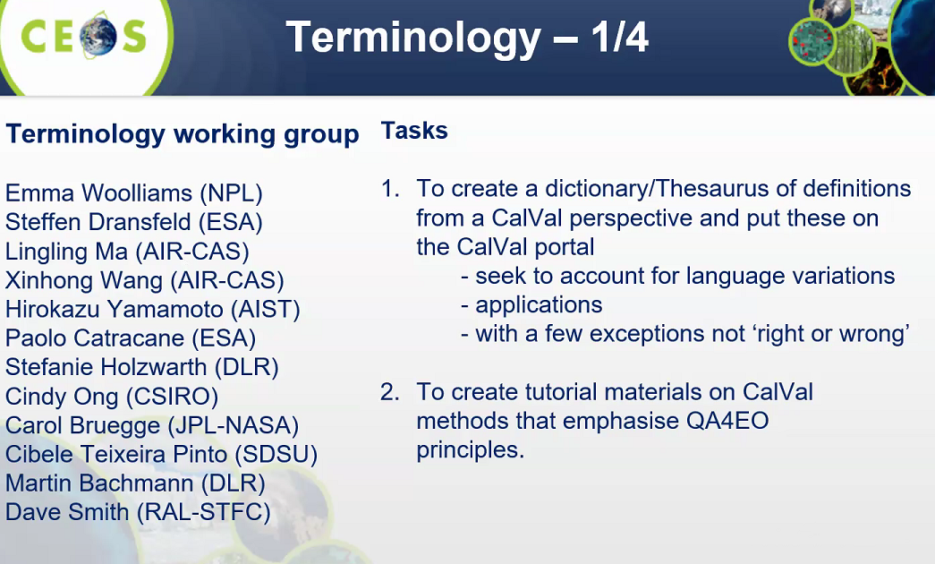  Set of definitions for cal/val, explaining and clarifying the differences of words.  For well-defined words, information about them/tutorials that emphasise QA4EO.  Interoperability discussion/questionnaire survey results.  Fundamental data records (FDR) workshops/webinars to define.  Fundamental data records (FDR) next terminology to focus on -FCDR- Fundamental Climate Data Record (Discussion for 4-5 years on this, we are about to close this. Initiative by Chris Merchant. Fundamental Climate Data Record- better term – Albrecht).  Interoperable is not on the vocabulary on cal/val portal wiki.  “Cloud” definition, is non-trivial and we have had that discussion over the last 3-4 days. It may be not the place to include this.  Albrecht: ECV is a group of geophysical parameters, CDR is a climate data record for a time span and can be from an ECV parameter.  Nigel: FDR does not have to be specific to a climate  Patrice: Can “cloud screening” be included?  (5:59)  CHAT:  from Greg Stensaas :  The current CEOS PFS are the only things being considered  from santhi sree :  is it feasible to add ISRO participation in this working group  from Cindy Ong :  Santhi, I will put you in touch with Emma  from Greg Stensaas :  Has the survey on interoperability gone to larger group as Kurt suggested in our meeting, yet  from Albrecht von Bargen :  May, I comment  from Peter Strobl :  What's the relation between FDRs and ECVs?  from Greg Stensaas :  I agree with Albecht CEOS should not have differing definitions from other standards bodies or more than one definition within CEOS  from santhi sree :  Thank you Cindy  from Greg Stensaas :  5 years already Nigel  from Patrice :  cloud screening could be included in this list ?  from Philippe Goryl :  quickly we can say that FCDR = L1, ECV = L2 or higher ???  from Peter Strobl :  or does each ECV then have a CDR?  from Albrecht von Bargen :  ECVs are defiend by GCOS and are not level 2  from dongxiaolong@mirslab.cn :  Generally ECVs are higher level data than L2  from Albrecht von Bargen :  No!  from Albrecht von Bargen :  They can be level 2 - as for example ozone columns / profiles - but can be also level 3  from Peter Strobl :  Shouldn't it then be made sure that each ECV is based on CDRs, to make sure how it's being measurable?  from dongxiaolong@mirslab.cn :  Yes. ECVs can be from and can be not from CDRs.  from Greg Stensaas :  Good discussion Peter  from Peter Strobl :  Bet we will!  from Albrecht von Bargen :  Peter, please have a look on https://gcos.wmo.int/ including the publication 200
WGCV Business
5:25 | Cal Val Portal | Philippe Goryl
(6:04) | The CEOS Cal/Val Portal website has been updated with new content and functionality – since Dec. 2019  - Terms and Definitions Wiki – since March 2020  - CEOS SAR Subgroup- Since June 2020  - PICS pages (March 2020); LIME Project (June 2020); “Supersites and Biomass Validation Workshop” (April 2020), WGCV-46 (July 2020)  - ACIX-II-LAND in progress  Continuous update of contents, information, news and tweets.  Terms and definitions Wiki- presented by Nigel, now available online. Input from Emma Woolliams [NPL] and Jaime Nickeson [NASA].  Subgroups updated and migrated in June 2020.  Dedicated area for SAR. Coordinated with Bruce Chapman [JPL NASA]  Lunar irradiance model :ESA LIME Project Info provided by Marc Bouvet [ESTEC ESA]  PICS (Info provided by Béatrice Berthelot [Magellium] and Patrice Henry [CNES]  Supersites and Biomass Info provided by Cindy Ong [CSIRO] and Fernando Camacho [EOLAB]  WGCV meetings To be reviewed by Cindy Ong before publication  AXIC II-Land results page to be updated soon. In collaboration with Erminia De Grandis [SERCO] and Georgia Doxani [SERCO]  New portal is online, thanks to Paolo  Community project, more assistance and input/feedback is welcome.  (6:10)
5:35 | Maturity Matrix | Philippe Goryl
(6:11) | EDAP - developing the maturity matrix.  ESA EDAP Project Activities  Early data assessment on various existing , new and future EO missions.  - Very High Resolution (VHR), High Resolution (HR) and Medium Resolution (MR) Optical  - Low Resolution (LR) Optical  - Synthetic Aperture Radar (SAR)  - Atmospheric  To undertake specific multi-mission studies, which contribute to interoperability across existing and future missions and help foster synergies between these missions.  To provide support for the organisation of ESA Workshops that focus on data quality assessment of different types and groups of EO mission sensors, with the aim to provide a forum for assessing and discussing the data quality of existing and future TPMs  Provide a focus on the generation of methodologies and guidelines for training and capacity building, with the relevant Mission / Data Providers, particularly for the commercial missions with regards to efficient data quality assessments in the preparation for future missions.  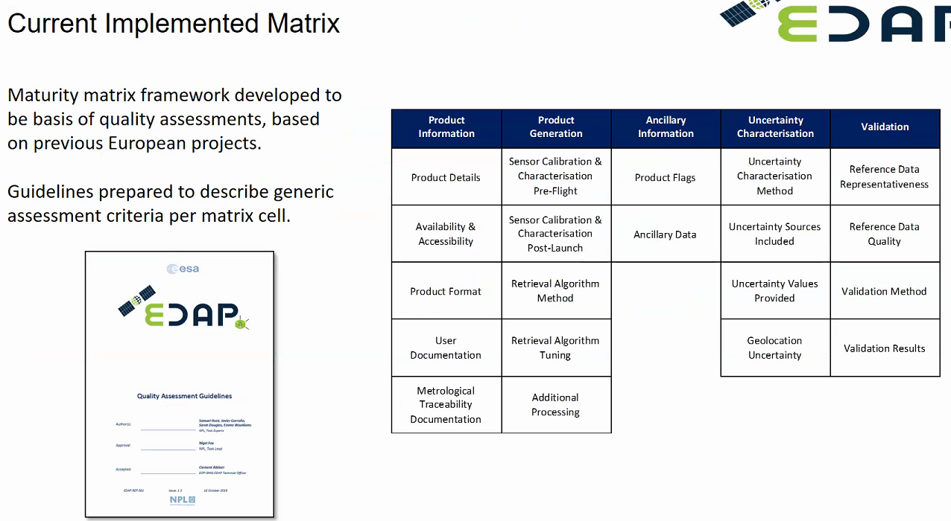  Matrix was too complex to navigate……but not developed enough for validation – 1 box of validation.  Phillipe- ask Nigel anything to add?  Nigel: Emphasise the point it is only assessing against what the data provider is doing. Tries to cover a lot of the categories. Documentation and evidence is there to backup claims.  CHAT:  from Cindy Ong :  Hi Greg, is there is a relationship between your test site catalogue and the ones we have on our calval portal?  from Greg Stensaas :  USGS Catalogue under IVOS Subgroup  from Greg Stensaas :  on portal  from Cindy Ong :  so, they are the same test or reference sites then?  from Greg Stensaas :  from PICS page on portal also - Pseudo Invariant Calibration Sites (PICS) are terrestrial sites used to monitor the long term in-flight radiometric calibration of Earth Observation optical sensors. They are used intensively by spatial agencies since long time now because they are spatially very uniform, stable spectrally and invariant with time. A long site of these sites has been identified. They are mostly located in the Sahara Desert and Peninsula Arabia. USGS catalogue lists most of them.  from Greg Stensaas :  We would like to link to Australia site catalogue or include them?? Cal/val sites are growing rapidly, CEOS endorsed sites need to be listed in PICS Land Sites (RADCALNET)  from Greg Stensaas :  areas  from Greg Stensaas :  Patrice did a great job on PICS - USGS is using additional PICS also  from Patrice :  Only applicable for optical systems. Not suitable for SAR or sounders.  from Albrecht von Bargen :  Comments on it  from Nigel fox :  note for EDAP the aim is only to assess against what the data provider says they are doing not if is good or bad for a particular application  from Greg Stensaas :  Very nice lay out, we have been trying to work the same piece in USGS RCA-EO and JACIE  to Cindy Ong (Internal) (privately):  " link to Australia site catalogue " I think the Australian sites need to be reviewed and some killed. Maybe the DEA project sites should be included.  from Nigel fox :  We should make sure we align and have a consistent view  from Greg Stensaas :  Provider provides system information or products, they present their performance assessment and document, and we Government do ours, we discuss together and then do a validation summary and document the actual performance  from Jean-Christopher Lambert BIRA-IASB :  A few PICS could be used for atmospheric instruments as well, e.g. for validation of L1B data stability over time  from santhi sree :  it's a consolidated Philosophy of Data products and as well as the Mission stability.  from santhi sree :  nicely compiled  from Patrice :  Jean-Christopher, my comment was not for PICS but for maturity matrix. I don't see how to fulfil these matrix for SAR or sounders.  from Greg Stensaas :  I agree with Santhi, nice process  from Nigel fox :  IFor SAR and other sensor there are different specific categories  from Greg Stensaas :  These are very optical oriented and I agree matrix would need to be adapted for other sensor types  from dongxiaolong@mirslab.cn :  I agree with Patrice. The maturity matrix is mainly for optical. MW sounders are different.  from Jean-Christopher Lambert BIRA-IASB :  Patrice, I agree with you for atmospheric instruments too, several entries are not applicable.  from santhi sree :  For SAR and Sounders to be further customized based on this skeleton structure. RAW data quality parameter and I and Q channel quality is very important for SAR data  from Greg Stensaas :  I believe the first one came from John Bates NOAA in beginning of CEOS CWG  from Greg Stensaas :  most of the efforts we concentrate on in JACIE is to make sure that L1 and L2 satellite information and performance is measured  from Peter Strobl :  brings us back to what means L1 and L2 across missions and agencies...  from Albrecht von Bargen :  ... in a single number as WGISS likes to have?  Schaepman-Strub et al. 2006 (https://www.sciencedirect.com/science/article/abs/pii/S0034425706001167):” As the terms ‘surface reflectance’ and ‘at-surface reflectance’ do not allow for the determination of the irradiance conditions of the data product, we advise to follow a more precise terminology ..." In my opinion he same is true for 'cloud', 'cloud shadow' etc.
5:55 | New workplan tasks/proposals???
(6:45) | Cindy: anyone with comments about Baotou sandy site for acceptance to RadCalNet?  Accepted.  Nigel: it is already to go, just not visible to outside world.  Kurt: congrats, to AIRS and to Emma from NPL with documentation and getting quality.  Nigel: Need to have sites ready for the 1st review and no need for 2nd review
6:05 | Meeting Summary | Cindy Ong
Actions for meeting reviewed:
WGCV-47-01 Cindy to provide Kerry with a descriptive paragraph on RadCalNet for the CEOS Work Plan Completed
WGCV-47-02 All interested in the Baotou documentation for RadCalNet entry to email cindy.ong@csiro.au. A vote on entry for Boatou will be made on day 4 of WGCV-47. Completed
WGCV-47-03 WGCV to work towards consolidating the contributions for the WGCV components of the GHG task before 8 August. Cindy will facilitate.
WGCV-47-04 Kurt to work with Cindy on FDA-15’s future plan.
WGCV-47-05 Peter Strobl to investigate the use of the Interoperability Lab for processing data for DEMIX. Philippe to investigate ESRIN/ESA cube options.
WGCV-47-06 Include approach to cloud screening in terminology discussion.
WGCV-47-07 Provide feedback from CARD4L assessment process to Medhavy
WGCV-47-0 8 Medhavy to check on access to completed assessment documentation for CARD4L
WGCV-47-09 Nigel to set up offline discussion regarding coherence of reference sites Make sure the naming convention is consistent with calval portal. Everyone to send information regarding reference site (TF, Radiometric, validation) to Greg for USGS test site catalogue.
(7:09)
6:20 | Future directions and meetings | Cindy Ong
Cindy: I will be finish in October 2020 (CEOS Plenary) Chair rotation. Kuze-san to take over as chair. Phillipe to take over as vice chair.
Mini Plenary after October -Early November to hand over- agreed.
Face to Face meeting in Japan when possible.
Also, a rain check for meeting in California with Bruce Chapman
Another rain check in Sochi, Russia (Was planned WGISS).

Cindy: Will send out doodle poll for next meeting in November.
Finished (7:32)
6:30 Adjourn

