CEOS IVOS Working Group 4:
Intercomparison of vicarious calibration methodologies and radiometric comparison methodologies over pseudo-invariant calibration sites

A Report to the CEOS/IVOS Working Group

Reference:
Version 2.4
14 September 2012

Authors:
S. Adriaensen VITO
K. Barker ARGANS Ltd
L. Bourg ACRI-ST
M. Bouvet ESA/ESTEC
B. Fougnie CNES
Y. Govaerts VITO
P. Henry CNES
C. Kent ARGANS Ltd
D. Smith RAL Space
S. Sterckx VITO
Change record:
Issue | Date | Description | Change pages
1.4 |  | First draft with all preliminary contributions received collated
1.5 | 28/07/2012 | Modification of the section on the overall approach following PH comment | Section 1.2
1.6 | 06/07/2012 | Included comments/modification from DS, CK and YG. Some editing done. | All the document
1.7 | 16/07/2012 | Included comments/modification from CK + comments from MB | Section 2, 3 and 7
1.8 and 1.9 | 24/07/2012 | Added modifications from LB, BF and DS | Section 2 and 3 and annexes
2.0 | 25/07/2012 | Editorials and first clean up by MB | All
2.1 | 02/08/2012 | Reviewed by KB – Added comments from PH | All
2.2 | 08/08/2012 | Reviewed by KB and MB – Added acronyms and fixed typos | All
2.3 | 13/09/2012 | Fixed typos by MB | All
2.4 | 14/09/2012 | Modified caption table 37. Modified figure 21 and 22 by DS. Conclusions in section 7 rephrased by DS. | Section 5, 7, 13.2

Table of Contents
Contents
1 INTRODUCTION 6
1.1 Objective of the work 6
1.2 Overview of the approach 6
1.3 Acronyms 7
2 Description of the reference dataset 9
2.1 DIMITRI database 10
2.2 SADE database 11
2.3 RAL database 11
2.4 Reference dataset Format 12
3 Methodologies 13
3.1 Overview of the methodologies compared in the CEOS/IVOS Working Group 4 13
3.2 DIMITRI 13
3.2.1 A sensor intercomparison methodology based on matching the observation geometry of nearly concomitant acquisitions from two sensors 13
3.2.2 Uncertainties 14
3.3 SADE/MUSCLE 20
3.3.1 Description of the methodology 20
3.3.2 Uncertainties 23
3.4 RAL 24
3.4.1 Description of the methodology 24
3.4.2 Uncertainties 28
3.5 OSCAR 42
4 Results for each methodology 44
4.1 DIMITRI 44
4.2 SADE/MUSCLE 49
4.3 OSCAR 51
4.4 RAL 52
4.4.1 Direct Comparisons – AATSR vs MERIS only 54
4.4.2 Nadir BRF Comparisons 56
4.4.3 Full BRF Comparisons 59
5 Intercomparison of the results of the methodologies 62
6 Discussion 64
7 Conclusions of the intercomparison 64
8 Lessons learned 65
9 General recommendations to CEOS/IVOS 65
10 Interested in exploiting the reference dataset? How to proceed? 66
11 What could be further investigated with the same reference dataset and methodologies? 66
12 References 67
13 Annexes 69
13.1 Comparison between DIMITRI and SADE L1 TOA extractions over Libya-4 69
13.1.1 Objective 69
13.1.2 Introduction 69
13.1.3 DIMITRI and SADE number of extractions over Libya 4 69
13.1.4 Comparison of DIMITRI and SADE acquisition times associated to the TOA reflectance extractions over Libya 4 70
13.1.5 Comparison of DIMITRI and SADE angular information associated to the TOA reflectance extractions over Libya 4 71
13.1.6 Radiometric comparison: DIMITRI and SADE TOA reflectance extractions over Libya 4 73
13.1.7 Conclusion of the comparison of DIMITRI and SADE extractions over Libya 4 75
13.2 Comparison of OSCAR results based on DIMITRI and SADE extractions over Libya (YG) 76
13.3 Full results of the application of the SADE/MUSCLE methodology to the reference dataset 78

INTRODUCTION

Objective of the work
The objective of the work described in this report was to compare the results of several methodologies making use of pseudo-invariant sites for vicarious calibration or for radiometric intercomparisons. The sensors considered in this work are spaceborne medium spatial resolution sensors with multi-spectral capabilities operating in the visible to thermal infrared. It should be emphasized that the objective of this work was NOT to derive absolute radiometric calibration coefficients from four methodologies for further operational use. This work only aimed at identifying and understanding the differences between the results of the methodologies.
This work was carried out in the frame of the CEOS/IVOS Working Group 4 focusing on pseudo-invariant sites.

Overview of the approach
Three sites were selected, the so-called Libya-4, Niger-2 and Dome-C, for which time series of cloud screened Top of Atmosphere (TOA) reflectance averaged over pre-defined regions of interest were generated. The sensors for which data were extracted are: AATSR, MERIS, MODIS-Aqua, POLDER-3 and VEGETATION-2. The time series of extractions covers the years 2006 to 2009. These data were distributed in a predefined format and constitute what is hereafter called the reference dataset. Each participating team applied its vicarious calibration methodologies and/or sensor-to-sensor radiometric intercomparison methodologies to this reference dataset. MERIS data (2nd reprocessing) were chosen as a radiometric reference to which other sensor radiometry was compared. MERIS was chosen because its spectral sampling facilitates the matching of spectral bands from other sensors. The comparison was carried out for each methodology and for each site using standardised statistical indicators associated to the time series of radiometric differences between MERIS and other sensors. The comparison was deliberately restricted to 3 spectral regions around 560 nm, 660 nm and 860 nm in which all sensors have spectral bands to limit the analysis work. Moreover, comparisons were restricted to cases involving MERIS and AATSR, MODIS-Aqua and POLDER-3 (comparisons involving VEGETATION-2 were left out of this work due to time limitation)

Acronyms
6S-V | 6S Vector code
ATSR | Along Track Scanning Radiometer
AATSR | Advanced Along Track Scanning Radiometer
AC | Atmospheric Correction
ACCA | Automated Cloud Cover Algorithm
AERONET | AErosol Robotic NETwork
AMC | Angular Matching Criteria
ARGANS | Applied Research in Geomatics Atmosphere Nature and Space
AVHRR | Advanced Very High Resolution Radiometer
BADC | British Atmospheric Data Centre
BOA | Bottom Of Atmosphere
BRF | Bidirectional Reflectance Factor
BRDF | Bidirectional Reflectance Distribution Function
CEOS | The Committee on Earth Observation Satellites
CNES | Centre National d'Etudes Spatiales
DIMITRI | Database for Imaging Multi-spectral Instruments and Tools for Radiometric Intercomparison
DU | Dobson Unitt
ECMWF | European Centre for Medium-Range Weather Forecasts
ENVISAT | Environmental Satellite
ERS-2 | European Remote sensing Satellite
EO | Earth Observation
EOS | Earth Observing Satellite
ESA | European Space Agency
EU | European Union
EUMETSAT | European Organisation for the Exploitation of Meteorological Satellites
FTP | File Transfer Protocol
GMES | Global Monitoring for Environment and Security
GSC | GMES Space Component
HMI | Human Machine Interface
IVOS | Infrared and Visible Optical Sensors Subgroup of WGCV
JPEG | Joint Picture Experts Group
LUT | Look-Up Table
MERCI | ENVISAT MERIS Reduced Resolution Archive
MERIS | Medium Resolution Imaging Spectrometer
METRIC | MERIS Extraction Tool for Radiometric Calibration
MISR | Multi-angle Imaging SpectroRadiometer
MODIS | Moderate Resolution Imaging Spectrometer
MODTRAN | MODerate resolution atmospheric TRANsmission
MUSCLE | MUlti Sensor Calibration Environment
NCEP | National Centers for Environmental Prediction
NEODC | NERC Earth Observation Data Centre
netCDF | Network Common Data Format
NIR | Near Infrared
NPL | National Physical Laboratory
OMI | (TOMS OMI)
OSCAR | Optical Sensor Calibration with Simulated Radiances
POLDER | Polarization and Directionality of the Earth's Reflectances
QA4EO | a Quality Assurance framework for Earth Observation
RAA | Relative Azimuth Angle
RAL | Rutherford Appleton Laboratory
ROI | Region Of Interest
RSR | Relative Spectral Response
SAA | Solar Azimuth Angle
SADE | Structure d’acceuil des données d’étalonnage
SLSTR | Sea and Land Surface Temperature Radiometer
SMAC | Simplified Method for Atmospheric Correction
SNO | Simultaneous Nadir Overpass
SWIR | Short Wave Infrared
SZA | Sun Zenith Angle
TCWV | Total Columnar Water Vapour
TOA | Top Of Atmosphere
TOMS | Total Ozone Mapping Spectrometer
VIS | Visible
VITO | Vlaamse instelling voor technologisch onderzoek
VGT | VEGETATION
VAA | View Azimuth Angle
VZA | View Zenith Angle
WG | Working Group
WGCV | Working Group on Calibration and Validation
WPD | Work Package Description

Description of the reference dataset
A reference dataset of satellite observation extractions has been generated to feed the different vicarious calibration methodologies. The dataset consists of:

- the mean and standard deviation of TOA reflectances over pre-defined regions of interest;
- the associated viewing and solar geometries;
- the associated meteorological parameters extracted.
The dataset contains observations from five satellite sensors and for three fixed validation sites between 2006 and 2009. These three sites were chosen because a) the data were available in either the SADE (CNES), DIMITRI (ESA) or the RAL databases, b) they cover different surface types. Niger-2 and Libya-4 are two desert sites with a similar spectral signature of sand but the Libya-4 site is characterised by the presence of large sand dunes (which might have an impact on methodologies of interest in this document).
The corners of region of interest over the three sites are provided in Table 1.
Table 1: Validation site coordinates
Site | North Latitude | South Latitude | East Longitude | West Longitude | Surface Type
Dome C | -74.9 | -75.3 | 123.9 | 122.9 | Snow
Libya-4 | 29.05 | 28.05 | 23.89 | 22.89 | Desert
Niger-2 | 21.87 | 20.87 | 11.09 | 10.09 | Desert

The reference dataset contains observations from AATSR, MERIS, MODIS-Aqua, POLDER-3 and VEGTATION-2, and has been generated from three separate data sources; DIMITRI (maintained by ESA and ARGANS), SADE (CNES) and RAL. Table 2 summarises the reference dataset sources.
Table 2: Dataset product sources
Sensor/Site | Dome-C | Libya-4 | Niger-2
AATSR | DIMITRI  (AATSR MERCI¹) | DIMITRI  (AATSR MERCI¹) | RAL  (ATSR Archive⁷ + MERCI)
MERIS | DIMITRI  (MERIS MERCI²) | DIMITRI  (MERIS MERCI²) | SADE  (METRIC⁶)
MODIS-Aqua | DIMITRI  (LAADS³) | DIMITRI  (LAADS³) | SADE  (ICARE Archive)
POLDER-3 | DIMITRI  (CNES DVD delivery⁴) | DIMITRI  (CNES DVD delivery⁴) | SADE  (L0 products)
VEGETATION-2 | DIMITRI  (VITO FTP delivery⁵) | DIMITRI  (VITO FTP delivery⁵) | SADE  (L0 products)

List of Sources in Table 2:
¹ http://ats-merci-uk.eo.esa.int:8080/merci/welcome.do  ² http://merci-srv.eo.esa.int/merci/welcome.do  ³ http://ladsweb.nascom.nasa.gov/  ⁴ http://polder.cnes.fr/ | ⁵ http://www.vgt.vito.be/  ⁶ http://earth.eo.esa.int/pcs/envisat/meris/MERIS_Cal/  ⁷ http://www.neodc.rl.ac.uk  ⁸ http://www.icare.univ-lille1.fr

Remark: A second version of the reference dataset over Libya-4 only was generated by SADE/MUSCLE (CNES tool) from the data stored in the SADE database (rather than from the DIMITRI database). This dataset is also included in the reference dataset but it was NOT used for the intercomparison of methodologies described in this document. This second version of the reference dataset over Libya-4 was used to compare the DIMITRI and SADE database extractions with the aim of:
- identifying differences between the two database extractions due to differences post processing of the original L0/L1 data such as the application of calibration coefficients, the sensor radiometric corrections or the cloud screening and averaging over the region of interest
- estimating the uncertainties induced by these processing steps on the reference dataset.
A direct comparison of these two versions of the reference dataset over Libya-4 is described in the Annex (see section 13.1). The conclusion of this comparison is that no significant differences exist.
A comparison of the results obtained with the VITO OSCAR methodology (described in section 3.5) from these two versions of the reference dataset over Libya-4 is also presented in the Annex (see section 13.2). The main conclusion is that SADE and DIMITRI produce similar TOA reflectance extractions for all sensors with systematic differences between the output of the two database being below 0.2 %.

DIMITRI database
The DIMITRI database is maintained by ESA and ARGANS Ltd; it is a database of extracted satellite observations for six sensors over eight fixed validation sites from 2002 to present.
The DIMITRI database of extracted L1 data and tools are freely available from the CEOS CalVal portal (http://calvalportal.ceos.org/cvp/web/guest/tools). Table 2 details the sources for products located within the DIMITRI database.
For each data product stored within DIMITRI the mean and standard deviation TOA reflectance over the region of interest (ROI) is stored, along with the viewing and solar geometries, observation statistics (such as the number of pixels within the ROI) and meteorological parameters where available. A number of sensor specific corrections during the extraction from the native Level 1 (L1) products, these include:
- MERIS: application of the irradiance correction for the variations of the central wavelength of each spectral band in the field of view of the instrument (Bourg et al., 2008) as well as utilisation of the terrain corrected geolocation (using the so-called lat_cor and lon_cor parameters – latitude and longitude, respectively- in the L1b).
- AATSR: application of the latest RAL calibration coefficients (Smith and Poulsen, 2010).
- VEGETATION-2: application of a CNES supplied correction factor for the Earth-Sun distance in VITO VGT-2 products.
Each product ingested into DIMITRI is assessed for cloud cover using a variety of different automated algorithms depending on the radiometric wavelengths available. For MERIS and POLDER-3 the GlobCarbon algorithm (Ranera et al., 2005) is applied, whilst for AATSR and MODIS-A the Landsat Automated Cloud Cover Algorithm (ACCA) (Irish et al., 2006) is applied. VGT-2 data is assessed using the operational VGT cloud screening algorithm (Lissens et al., http://www.vgt.vito.be/index.html). In addition to this, manual cloud screening through visual inspection of product quicklooks is also done to flag misclassified observations.
Meteorological parameters are extracted from the source Level 1b satellite products when available; this allows extractions of windspeed and direction, surface pressure, humidity and ozone concentration from MERIS products, and water vapour and ozone concentration from VGT-2 products.
To generate the DIMITRI TOA reflectances for the reference dataset only observations which were assessed as cloud-free (either manually or automatically) and in which the ROI reflectance standard deviation was less than 1.5% were selected; these observations were also all visually inspected for cloud coverage.

SADE database
The SADE database (Henry and Maygret, 2001) is maintained by CNES and contains long time series datasets for a number of sensors over a large number of desert, sun glint, oceans, snow, and cloud targets. SADE data from MODIS-A, MERIS, POLDER-3 and VEGETATION-2 over Niger-2 have been made available for the reference dataset (AATSR2 were provided by RAL); observations over Libya-4 have also been made available to allow intercomparison with the DIMITRI database extractions. VEGETATION-2 data is directly acquired at CNES at L 1b (with geometrical modelling but without radiometric calibration); this data is then processed to L 1c in the VEGETATION Image Quality Processor using the latest calibration coefficients and the ROI information extracted. PARASOL data is directly acquired at CNES at L1 and extraction preprocessing is performed in the SQI (POLDER/PARASOL Image Quality Processor). MERIS data is provided to CNES by ESA through METRIC extractions which do not correct for the SMILE effect or terrain elevation. MODIS-Aqua data is extracted at L1 from the ICARE archive and proprocessing is performed within SADE.
All data products within SADE are screened for clouds and anomalous pixel values; unlike DIMITRI where all pixels within the ROI are included in the extraction, the SADE processing can remove pixels using filters from the site extraction provided a 90% site coverage by valid pixels.
Meteorological data within the SADE database is extracted from NCEP (http://www.ncep.noaa.gov/).

RAL database
Data extractions from AATSR over Niger-2 have been provided by RAL; these data are extracted from the ATSR archive at RAL using the MERCI interface and has the latest calibration coefficients applied (Smith and Poulsen, 2010). L1 data for the site are screened for the presence of clouds/dust using the techniques described in Smith et al 2002.
Meteorological data for the site location is extracted from ECMWF (http://www.ecmwf.int/) reanalysis files obtained via the BADC (http://badc.nerc.ac.uk/home/index.html) corresponding to the satellite observations acquisition times.

Reference dataset Format
The reference dataset files are provided for each sensor over each site and are space delimited text files. Each row within the file represents a different satellite observation over the ROI; different sensor views are treated as separate observations (e.g. AATSR Nadir and Forward views). In the dataset, missing values are set as -999.The different columns of data are detailed in Table 3.
Table 3: Dataset format column descriptions.
Column name | Description
Sensor | The name of the Sensor and Processing Version
Acquisition time | dd/mm/yyyy-hh-mn-ss
Processing time | dd/mm/yyyy-hh-mn-ss (not extracted, duplicate of acquisition time)
Site Name | The validation site name
meanTOArho | The mean TOA reflectance for each band (*)
stdevTOArho | The standard deviation of reflectance for each band (*)
VZA | The mean viewing zenith angle at each band (*), 0° = nadir, 90° = horizon
VAA | The mean viewing azimuth angle at each band (*), 0° = North, 90 = East°
NPixels | The number of pixels within the ROI for this observation
Latitude | The site centre latitude
Longitude | The site centre longitude
SZA | The mean Solar Zenith Angle, 0° = nadir, 90° = horizon
SAA | The mean Solar Azimuth Angle, 0° = North, 90 = East°
WVAP | The mean water vapour concentration in g.cm²
OZONE | The mean ozone concentration in cm.atm
PRESS | The mean surface pressure in mbar
WIND | The mean wind speed modulus in m.s⁻¹
* Sensor Bands:
AATSR: all seven bands in ascending wavelength order
MERIS: all 15 bands in ascending wavelength order
MODIS-Aqua: MODIS Band Numbers 8 - 9 - 3 - 10 - 4 - 1 - 2 - 5 - 6 – 7 (wavelengths 412 - 443 - 469 - 488 - 555 - 645 - 858 - 1240 - 1640 – 2130)
POLDER-3: all bands in ascending wavelength order: 443 - 490 - 565 - 670 - 763 - 765 - 865 - 910 - 1020
VEGETATION: all four bands in ascending wavelength order

Methodologies

Overview of the methodologies compared in the CEOS/IVOS Working Group 4
Four methodologies were intercompared:
- DIMITRI (ESA): used in this study by ACRI-ST (L. Bourg), D. Smith (RAL) and ARGANS Ltd (C. Kent).
- SADE/MUSCLE (CNES): used in this study by P. Henry and B. Fougnie (both CNES);
- Drift Monitoring approach (RAL): used in this study by D. Smith (RAL); This comprises comparisons via a nadir reference BRF model, a full BRF model and simultaneous nadir observations (for MERIS and AATSR only).
- OSCAR (Optical Sensor Calibration with Simulated Radiances): used in this study by Y. Govaerts, S. Sterckx, S. Adriaensen (all VITO).
These methodologies are detailed in the following sub-sections.

DIMITRI

A sensor intercomparison methodology based on matching the observation geometry of nearly concomitant acquisitions from two sensors
The intercalibration methodology of DIMITRI compares the time series’ of a number of sensors to that of a selected “reference” sensor; concomittant observations made under similar geometry and within a defined temporal window (doublets) are intercompared at similar spectral bands.
The DIMITRI intercomparison methodology assumes the TOA reflectance angular distribution 1) obeys the principle of reciprocity and 2) is symmetrical with respect to the principal plane (Bouvet, 2006). The day offset and strictness of angular matching between observations, as well as the allowable cloud cover percentage values can be user defined. The strictness of the angular match between two concommittant satellite observations, 1 and 2, is controlled through the Angular Matching Critera (AMC) parameter which is defined as:

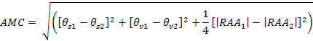 1

where: θ_{s} and θ_{v} are the solar and viewing zenith angles respectively, and RAA the Relative Azimuth Angle for satellites 1 and 2. The absolute allowable angle ranges for the viewing and solar geometries can also be defined through DIMITRI before starting the intercomparison.
Should multiple sensor observations be found (within the user defined matching criteria) for a reference sensor observation during doublet matching, the one with the closest geometric match is selected and stored within the doublet time series.
The number of corresponding doublets between sensors is dependent on the user selected AMC and temporal matching strictness; the optimal values for these will vary depending on which sensors are being compared, as well as the validation site.
Comparisons are done between similar spectral bands between two sensors. No correction is applied to account for the differences induced by the differences between the spectral bands of sensors but these can be estimated and accounted for in the methodology uncertainty budget (see next section).

Uncertainties
In a previous case study using DIMITRI data over Dome-C, AATSR, MODIS-Aqua and MERIS TOA reflectances were compared (Bouvet and Ramoino, 2010). Various aspects of the possible uncertainties were considered and quantified. The systematic uncertainty intercomparison methodology was estimated to be less than 3%, and its random uncertainty to be approximately 2%. These uncertainty estimates cannot be transferred generically to all radiometric intercomparison carried out with DIMITRI as they are specific to the intercomparison configuration used (e.g. sensors, spectral bands and site). However, similar figures of systematic and random uncertainties were obtained over the Salar de Uyuni and the Libyan Desert (Bouvet, 2006 and 2008) for multi-spectral imagers with spectral bands within 10 to 30 nm (i.e., all sensors in DIMITRI besides VEGETATION-2). The uncertainty on the present methodology intercomparison results are primarily linked to observation conditions as both target ground reflectance and atmosphere contribution to the signal depend on illumination/observation angles. Therefore relatively severe conditions were put on the angular matching criteria.
In the results presented in section 4.1, the time difference between acquisitions has been set to 10 days and the AMC to 7 degrees, a good compromise over temporally stable bright sites to get a statistically significant number of matchups.
In addition to these doublets extraction criteria, filtering criteria have been applied systematically despite specifically intended for observations over Dome-C for which the Sun zenith angle (SZA) can reach very high values: doublets are only selected for the statistics if the SZA is below 74.5 degrees for both sensors and if the air mass difference between the sensors is below 1. (Air mass is the relative amount of atmosphere of an observation with respect to the ideal ground observation at nadir with the Sun at zenith).
Then, for each spectral band allowing inter-comparisons, the ratio of TOA reflectance from the “calibration sensor” is divided by the “reference sensor”; mean and standard deviation computed and a statistical filtering at ± 2 standard deviations around the mean is applied. The filtered average and standard deviation constitute the final inter-comparison result, expressed in percent of TOA reflectance.
Using these defined constraints, residual uncertainty resulting from differences in observation or illumination conditions is assumed to be randomly distributed and is estimated to be approximately 1 - 2% on the reflectance ratio by analysis of single sensor variability and quadratic summing of single-sensors variability into ratios uncertainty, for each channel and site. Single sensor variability is estimated as the RMS (root mean square) deviation with respect to a normalised radiance L_{N}(λ)model – reflectance times the cosine of the SZA –expressed as a second order polynomial of the Sun zenith angle (see section 3.4.1). For the reference sensor, MERIS, the selected dataset for this estimation is the MODIS one, as it provides the higher number of doublets and the full range of view zenith angles. It is likely that these estimates are slightly pessimistic as no attempt has been done to model L_{N} by classes of view zenith angle: estimates obtained using the MERIS data from AATSR comparison dataset, in which the VZA range is more restricted, provides significantly lower variability. However the impact on the ratio uncertainties is limited by the quadratic sum.
Sensors spectral response curves are also an important point to consider in regard to:
- the atmosphere: one can mention molecular scattering (in the blue part of the spectrum, not applicable here) and absorption by atmospheric gases, showing smooth to sharp spectral features, and also time and space dependent through local variations;
- site ground reflectance: the spectral shape of the reflectance spectrum can induce systematic biases of several per-cents if not accounted for.
Relative Spectral Responses (RSR) of the four sensors are presented below for the channels around 560, 665 and 865 nm respectively. Representative “equivalent central wavelengths” have been derived as the barycenters of the RSR. They are listed in Table 4 and shown in Figure 1 for the 3 intercompared channels.
Table 4: Sensors equivalent central wavelength for all sensors, and shift with respect to MERIS (nm). “wrt” means “with respect to”
 | MERIS | AATSR | MODIS-A | POLDER-3
"560" channel wavelength | 559.9 | 560.0 | 553.9 | 563.9
Variation wrt MERIS |  | 0.1 | -6.0 | 3.9
"665" channel wavelength | 664.8 | 660.0 | 645.8 | 670.0
Variation wrt MERIS |  | -4.8 | -19.0 | 5.2
"865" channel wavelength | 865.1 | 862.5 | 856.9 | 863.5
Variation wrt MERIS |  | -2.6 | -8.2 | -1.6

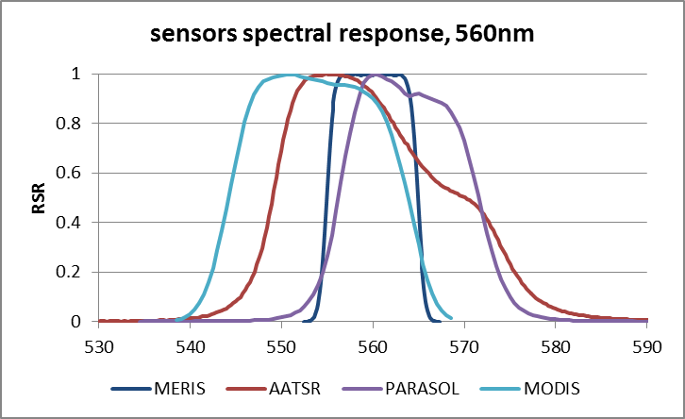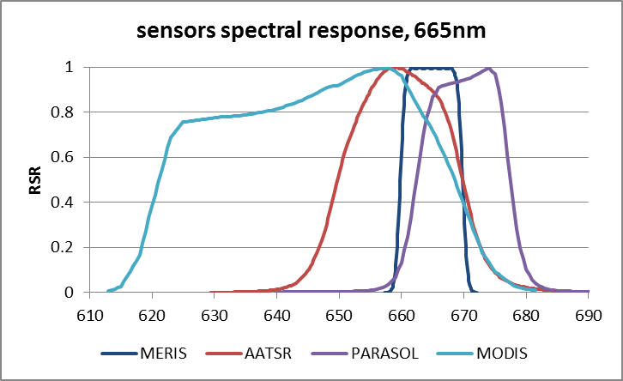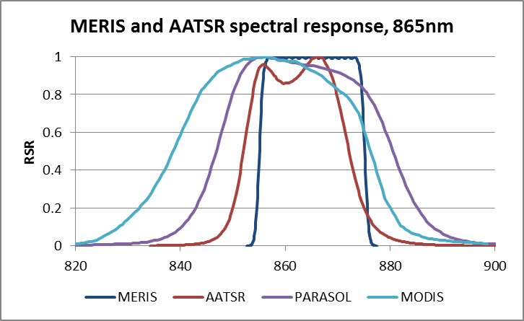
Figure 1: Sensors Relative Spectral Response (RSR) for the three inter-compared channels.

MERIS has been selected as the reference sensor for this current study; as it provides the best spectral sampling in the VIS-NIR region of the selected sensors, it has been used to estimate uncertainties induced by the differences in the sensor spectral responses:
- a high spectral resolution model of ozone atmospheric absorption has been built by cubic-spline interpolation of the operational values used for the correction of MERIS channels in the Level 2 processing. This model can then be used after convolution over the various RSR to assess the variations introduced in the TOA spectra under various observation and environmental conditions.
- MERIS channels have been used to derive TOA spectral slope of the average spectra over each of the site, in order to assess the differences introduced by the spectral distance between the compared spectral channels. As MERIS TOA reflectance behaves rather linearly over the spectral ranges of interest, a simple linear interpolation has been performed using RSR averaged wavelengths for other sensors (referred to as equivalent wavelengths). However, this may have some limitations as it does not account for the dissymmetry of some of the response curves, but is enough to provide first order assessment for those sites with high spectral variability.
Results of those two models are summarised below Table 5 and and illustrated on Figure 3 to Figure 6. Table 7 presents the total uncertainty linked to RSR for the two types of sites and the three inter-compared channels. As being signed bias, uncertainties are arithmetically summed.
Ozone absorption is mostly a concern at Dome-C, where air mass has an average value of 4 (MERIS) and can reach up to 8, while mean total column ozone is about 275 DU (from MERIS meteo annotations). The estimated systematic differences induced by the different RSRs computed for these average values are listed in Table 5. A systematic difference of almost 3% can be observed for MODIS at 665nm.In fact this MODIS spectral band was discarded from a previous comparisons over Dome-C (Bouvet and Ramoino, 2010) for this specific reason.
Table 5: O3 induced bias for comparison with MERIS (“-“ means MERIS is higher; in green figures below 0.25%, in orange within [0.25%,0.5%] and in red above 0.5%).
O3 absorption variability for typical conditions
 | Desert typical (M=2.3, UO3=290 DU) |  |  | Dome C (typical M=4, UO3=275 DU)
Wavelength (nm) | 560 | 665 | 865 | 560 | 665 | 865
AATSR | 0.0% | -0.4% | 0% | 0.1% | -0.7% | 0%
MODIS | 0.4% | -1.7% | 0% | 0.7% | -2.7% | 0%
POLDER-3 | -0.2% | 0.4% | 0% | -0.4% | 0.6% | 0%

Site spectral variability is much higher over desert sites than over snow (see Figure 2). The spectral slope is very high in the green-red region, and as the spectral differences are significant, corresponding differences in reflectance can be expected: it reaches about 3% for both the green and red channels for MODIS compared to MERIS. This is further illustrated on Figure 4 to Figure 6, for all sensors and each channel.

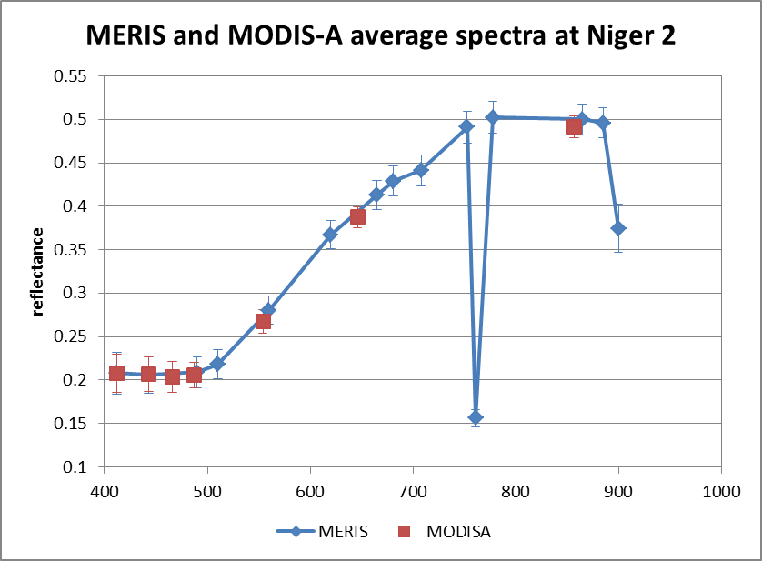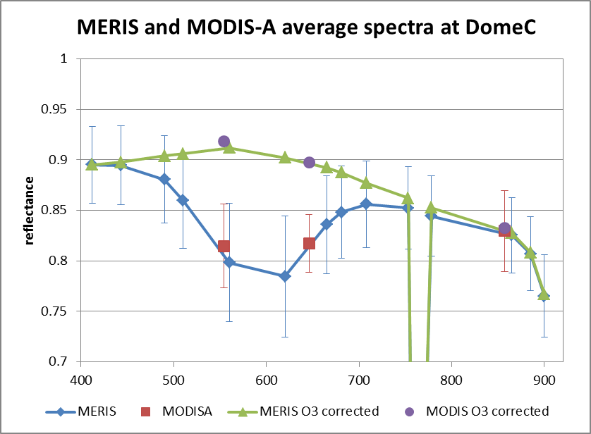
Figure 2: Average spectra of MERIS (solid line and symbols) and MODIS-A (symbols only) over Niger 2 (left) and Dome-C (right). O3 corrected spectra have also been included for Dome-C.

Table 6: Site spectral variability induced bias for comparison with MERIS (“-“ means MERIS is higher; in green figures below 0.25%, in orange within [0.25%,0.5%] and in red above 0.5%)
Site reflectance variability, based on MERIS average spectra (O3-corrected)
 |  | DESERT |  |  | Dome C
Wavelength (nm) | 560 | 665 | 865 | 560 | 665 | 865
AATSR vs. MERIS | 0.0% | -0.8% | 0.0% | 0.0% | 0.1% | 0.1%
MODIS vs. MERIS | -2.9% | -3.1% | -0.1% | 0.1% | 0.3% | 0.4%
POLDER-3 vs. MERIS | 1.9% | 0.9% | 0.0% | 0.0% | -0.1% | 0.1%

Table 7: Total uncertainty linked to spectral response (“-“ means MERIS is higher; in green figures below 0.25%, in orange within [0.25%,0.5%] and in red above 0.5%)
Total uncertainty linked to SRS, Desert and Antarctica cases
 | DESERT |  |  | Dome C
Wavelength (nm) | 560 | 665 | 865 | 560 | 665 | 865
AATSR | 0.1% | -1.2% | 0.0% | 0.1% | -0.6% | 0.1%
MODIS | -2.5% | -4.8% | -0.1% | 0.8% | -2.5% | 0.4%
POLDER-3 | 1.7% | 1.2% | 0.0% | -0.4% | 0.5% | 0.1%

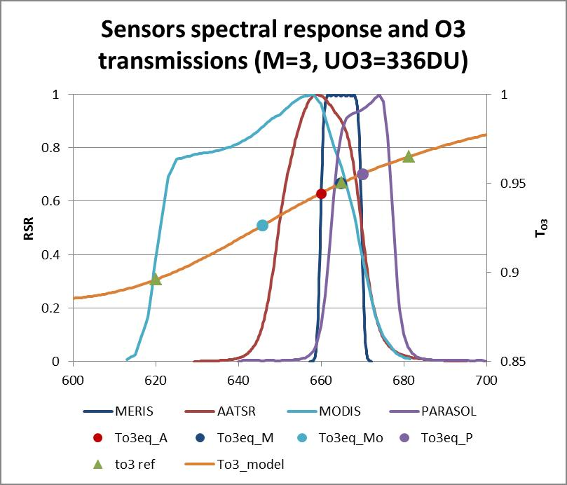
Figure 3: MERIS, AATSR, MADIS-A and POLDER-3 RSR for the 665nm channels (left vertical axis) with O3 transmittance superimposed (right vertical axis, for M=3 and DU=336 DU; high spectral resolution model: solid line, RSR averaged values for each sensor: coloured circles, with same colour coding that RSR curves. Green triangles are MERIS channels operational values for same conditions).
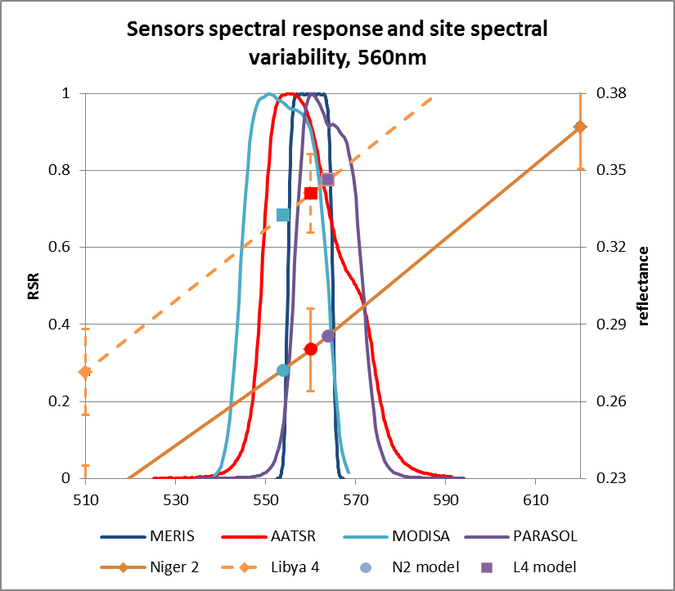
Figure 4: MERIS, AATSR, MADIS-A and POLDER-3 RSR for the 560nm channels (left vertical axis) with desert sites reflectance superimposed (right vertical axis, Niger-2: solid line, Libya-4 dashed line, MERIS interpolated at other sensors equivalent wavelengths: coloured squares, with same colour coding that RSR curves.

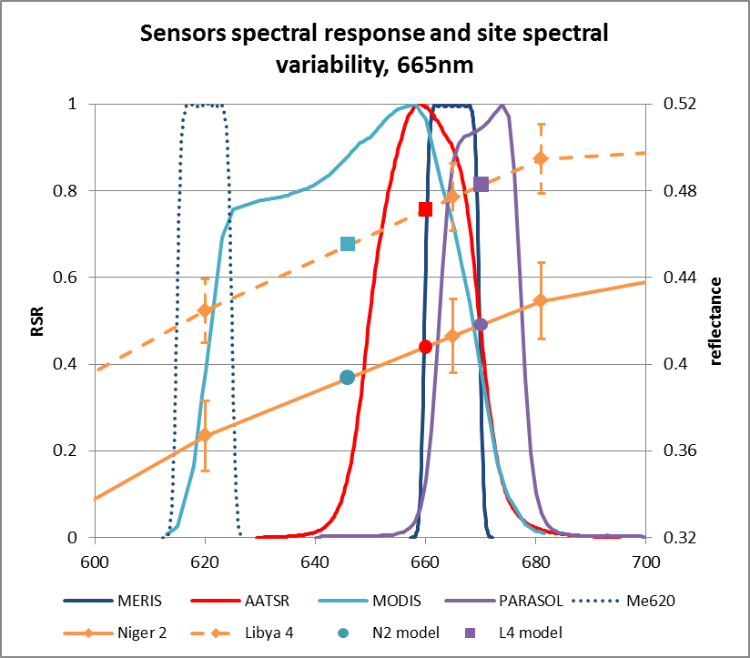
Figure 5: Same as Figure 4 but for the channels around 665nm.
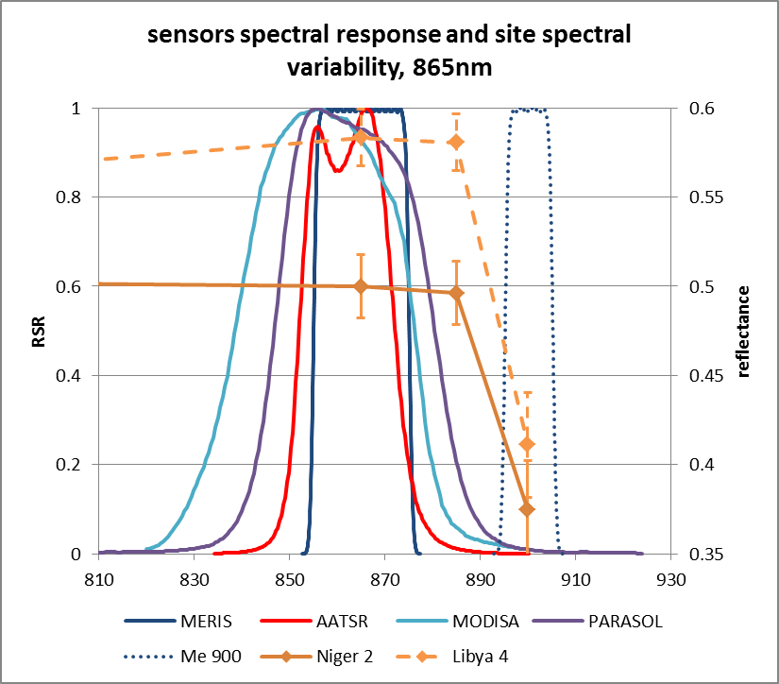
Figure 6: Same as Figure 4 but for the channels around 865nm.

SADE/MUSCLE

Description of the methodology

Geometrical matchup
As it is very difficult to obtain acquisitions of two sensors at the same time (and so for the same geometrical conditions), this method uses matched measurements for which the simultaneity is not required. An important assumption of the method is to consider a radiometric stability of the sites over the whole considered period (here 4 years). Pairs of measurements which are selected are those which were acquired in the same geometrical and solar conditions in order to limit the impact of the bidirectional behaviour of the site, but also possibly the atmospheric contribution, on calibration results. Nevertheless, searching for exact geometrical conditions for the two sensors would lead to a very poor number of matchups, while a minimum number of pairs is required for a sufficient precision of the derived cross-calibration. Consequently, a small difference between geometries of the sensor to be calibrated and MERIS (taken as the reference) measurements has to be tolerated for the geometrical matching; a window is defined around the exact geometry of the sensor to be calibrated. The size of this geometrical window, defined with the following equations, is a compromise between the need to obtain a sufficient number of matched measurements and the need to avoid errors in the inter-calibration due to the bidirectional behaviour of the reflectance of the site. This definition makes the hypothesis that the bidirectional behaviour of the site is the same on each side of the principal solar plane. The reciprocity principle is not considered.
$\begin{aligned} \left|θ_{s}^{\text{CAL}}−θ_{s}^{\text{REF}}\right|<2° \\ \left|θ_{v}^{\text{CAL}}−θ_{v}^{\text{REF}}\right|<2° \\ \left|\left|ϕ_{s}^{\text{CAL}}−ϕ_{v}^{\text{CAL}}\right|−\left|ϕ_{s}^{\text{REF}}−ϕ_{v}^{\text{REF}}\right|\right|<5°\end{aligned}$ 2
where:
$(θ_{v},ϕ_{v})$ are viewing zenith and azimuth angles
$(θ_{s},ϕ_{s})$ are solar zenith and azimuth angles

Construction of the reference reflectance
Once measurements of reference sensor and sensor to calibrate are matched, a loop described in the following Figure 7 is performed for each pairs of measurements. The goal of this loop is to model the reflectance that the reference sensor, i.e. MERIS, would have measured in the same geometrical conditions and same spectral bands than the sensor to be calibrated (noted CAL sensor). Three separate steps are needed. Starting from MERIS TOA reflectance, the first one consists of inverting bottom of atmosphere (BOA) reflectance. The atmospheric correction uses all required atmospheric parameters which are stored with each measurements in the SADE database (can be different from the ones provided by ARGANS in the reference dataset). Once the initial measurement is transferred at the ground level (BOA), a spectral resampling is performed to simulate the BOA reflectance for each spectral band of the CAL sensor. The last step of this processing is to transfer BOA reflectance for CAL sensor bands to TOA reflectance, adding the atmospheric contribution corresponding to initial CAL measurements.
The atmospheric correction process is described in the section 3.3.1.3, while spectral resampling is detailed in section 3.3.1.4.

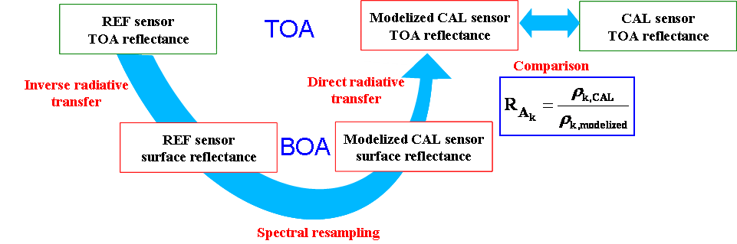
Figure 7: CAL sensor versus REF sensor (MERIS) inter-calibration synoptic method

Atmospheric contribution
In the calibration loop, two computation steps are required regarding atmospheric contributions: 1) an inverse computation to derive the surface reflectances from TOA reflectances for MERIS spectral bands and 2) a direct computation to obtain the TOA reflectance modelled from MERIS in the CAL sensor spectral bands.
For these atmospheric corrections, the SMAC model is used with coefficients computed using CAL sensor and MERIS spectral responses. SMAC model needs inputs from meteo data from NCEP (water vapour and pressure) and from ozone data (TOMS, OMI satellites). These ancillary data inputs are obtained daily by automatic operational procedures and stored in the SADE database. For aerosol optical properties, in the absence of a reliable information source above deserts, a constant representative value of 0.2 (at 550nm) is considered for optical thickness, associated with a desert aerosol model.
Since the value of aerosol optical thickness is used twice, firstly to remove the atmospheric contribution and secondly to add again the atmospheric contribution after the spectral interpolation, the assumption on the aerosol properties does not introduce any bias, but of course, day to day variations of aerosol properties may happen and add noise in calibration results. The method relies on statistics to cancel errors due to this assumption.

Spectral interpolation
The spectral interpolation of the surface (or BOA) reflectance between spectral bands of MERIS and spectral band of CAL sensor is performed using a Spline function. This function models the spectral behaviour of desert sites by a smooth curve between spectral bands of the reference sensor. When the spectral surface reflectance is elaborated, surface reflectance for each band of the CAL sensor is computed by weighting with the respective instrumental spectral response.
Therefore, the number and position of the MERIS spectral bands regarding to spectral bands to model (of the CAL sensor) is very important and is strongly linked to the final accuracy of the result, namely in the short-wavelength part of the visible where the spectral reflectance of the desert is not flat. If a too strong discrepancy exists between spectral bands of the two instruments to inter-calibrate (number of bands, central wavelength but also possibly bandwidth), biases may occur for some spectral bands in the inter-calibration results between the two instruments.

Inter-calibration coefficients computation
The last step of the inter-calibration processing is to compare the reflectance computed using the reference sensor and the one effectively measured by the CAL sensor. The calibration coefficient is in fact a relative calibration coefficient of sensor CAL referring to MERIS noted as REF sensor. This relative cross-calibration coefficient is defined by the following equation:
$A_{k,{\text{CAL}}_{\text{REF}}}(t)=\frac{A_{k,\text{REF}}(t)}{A_{k,\text{CAL} }(t)}=\frac{ρ_{k,\text{CAL} }}{ρ_{k,\text{REF}}}$ 3

where:
$A_{k,\text{CAL}}(t)$ is the absolute calibration of sensor CAL for spectral band, k. In general, this coefficient is taken from the official level-1 calibration;
$ρ_{k,\text{CAL}}$ is the reflectance measured by the “to be calibrated” sensor for spectral band k and produced using calibration coefficients . This measurement could also take into account an old or a new set of calibration coefficients for testing;
$ρ_{k,\text{REF}}$ is the reference reflectance in spectral band k : it corresponds to the reflectance simulated using measurements from MERIS (REF sensor);
$A_{k,\text{REF}}(t)$ is the calibration recommended by MERIS
This ratio is computed for each matched (pairs of) measurements of the two sensors. Because this method is based on a statistical approach, the final relative cross-calibration coefficient corresponds to average over the all set of matched measurements of each elementary ratio, after discarding outline measurements due to saturation or abnormal behaviour. Therefore, all the results are expressed in terms of relative differences $A_{k,{\text{CAL}}_{\text{REF}}}$ to MERIS calibration.

Uncertainties
The accuracy of this method depends on three main aspects:
- the atmospheric corrections which introduce greater uncertainties for the shorter wavelength,
- the spectral behaviour of the site and of the sensor,
- the match-up strategy to tackle the site stability and directionality.
The uncertainty induced by the atmosphere corrections can be separated in 2 terms: the poor knowledge of the atmospheric conditions (no aerosol information, meteo parameters uncertainties…) and the approximation of the correction model. It will mainly impact the blue bands as pointed out by the higher values of the standard deviation (mainly random uncertainty) but also by the differences in the results over the various sites (mainly bias).
It is not possible to derive a general error budget, and it has to be evaluated on a case by case basis depending on the sensors and the spectral bands under consideration.
The final accuracy also depends on the number of available match-ups. The statistical approach allows reduction of the ‘random’ part of the uncertainties and, for instance, partly compensates the lack of information about aerosol thickness.
No specific uncertainty studies have been conducted in the frame of this inter-calibration comparison exercise and so, only some orders of magnitude can be given. They are listed in Table 8 when comparing spectral bands which are close to each other (typically for MODIS vs MERIS intercalibration):
Table 8: Orders of magnitude of the contributing elements of the uncertainty induced by the atmospheric corrections in the SADE/MUSCLE methodology.
 | Blue | Green | Red | NIR
Atmosphere correction error | 2.5% | 1.75% | 1% | 1%
Spectral model (site + sensor) | 1% | 1% | 1% | 1%
Matchup error (geometry) | 1.5% | 1.5 | 1.5% | 1.5%
Total | 3.08% | 2.51% | 2.06% | 2.06%

Other considerations have to be taken into account for some other inter-calibrations:
- For the AATSR vs MERIS inter-calibration the matchup error can be reduced to 0.5% since the two sensors are on the same platform. The atmosphere misknowledge error is also reduced.
- Due to its large spectral bands, VGT-2 spectral interpolation is less accurate when comparing to MERIS. In this case the spectral model error is in the order of 1.5%.
- Because the PARASOL 1020 nm band is out of the range of the MERIS spectral domain, it has to be simulated by extrapolation of the MERIS spectrum. The spectral model error has to be set around 5%.
- The behaviour of some spectral bands can increase the uncertainty budget. The limitation of the stray light correction for Parasol 443 nm band and the non linearity at high reflectance for MODIS 469 nm band lead to take into account for these two bands an additional radiometric error of 4%.

RAL

Description of the methodology
RAL have employed measurements from desert and ice scenes to determine the long term drift of the ATSR sensors VIS/NIR/SWIR channels (Smith et al, 2002). The underlying principle behind the method is that the sites remain radiometrically stable (<1%) over long time periods (years) so any variations due to atmospheric conditions average out by statistical analysis. Any surface anisotropy and/or seasonal effects are accounted for by fitting a model to the ATSR measurements to obtain a reference Bidirectional Reflectance Factor (BRF) model and comparing the individual measurements to obtain the time series to deduce the long term drift as illustrated in Figure 8. The technique has been extended and developed to provide inter-satellite comparisons with other sensors (Smith et al, 2012 – under review). This is very useful where direct match ups are not possible because the observations from different sensors are either not time coincident and/or the view and solar geometry are not matching, for example ENVISAT/ERS-2, ENVISAT/EOS-A and in future with Sentinel-3.
Figure 8: Schematic of methodology to compare top-of-atmosphere radiances of two sensors via a reference BRF model (VZA is the View Zenith Angle)

Because the ATSR sensors were on highly repeatable orbits and have a narrow field of view range (<15°) it is possible to treat the BRF as a simple function of the scattering angle, γ where:
$−\text{cos}\left(\text{180}−γ\right)=\text{cos}θ\text{cos}θ_{0}+\text{sin}θ\text{sin}θ_{0}\text{cos}\left(φ−φ_{0}\right)$ 4
However, we have found that this approach becomes unreliable when extending the analysis to sensors with wider swaths such as MERIS and MODIS. The main problem has been that as the swath moves away from nadir, so the observations become more sensitive to the view azimuth. Hence, for this intercomparison and for future analysis we have modified the BRF model to account for the view azimuth dependency.
Starting from basics, the BRF is generally a function of wavelength, view zenith, solar zenith and relative azimuth. We can reduce the number of degrees of freedom by creating separate BRF for wavelength and view zenith which leaves two degrees of freedom to deal with. As indicated in Figure 9 for satellites on Sun-synchronous orbits (i.e. for ENVISAT) the solar zenith angle and relative azimuth are strongly correlated. For AATSR, MERIS and MODIS we obtain a correlation coefficient of >0.9 between solar zenith and relative azimuth angles. Hence in this case the BRF can be considered as a function of solar zenith angle, i.e.
$R\text{cos}(θ_{0})=a_{0}+a_{1}θ_{0}+a_{2}θ_{0}^{2}$ 5
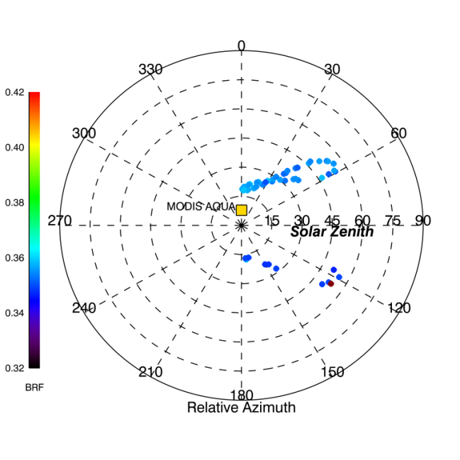
Figure 9: Polar plots showing the solar geometry with respect to AATSR, MERIS and MODIS-A for a view zenith angle of 10°±5°. The colour coding of the points represents the 555nm BRF measurements. Similar plots are obtained for all view zenith angles.

The coefficients for each spectral band and view zenith angle are obtained by fitting a polynomial to the normalised radiance defined as the BRF multiplied by the cosine of the solar zenith angle. We prefer this approach over fitting to BRF since this is closer to the actual sensor measurements which are assumed to be linear with radiance not reflectance. This makes it easier to interpret results, particularly at low solar zenith angles where normalised radiances are <0.1 even though the BRF can be high. Also, as with Heidinger et al (2010) the variation of Rcos(θ₀) with solar zenith angle is almost linear with solar zenith angle. For the view zenith angle we adopt the convention of Roujean et al (1992) where view zenith is positive for forward scattering (relative azimuth >90deg) and negative to the backscattering plane (relative azimuth <90degrees). Hence there are sets of coefficients for view angles -30°±5°, -20°±5°, -10°±5°, 0°±5°, 10°±5°, 20°±5°, 30°±5°.
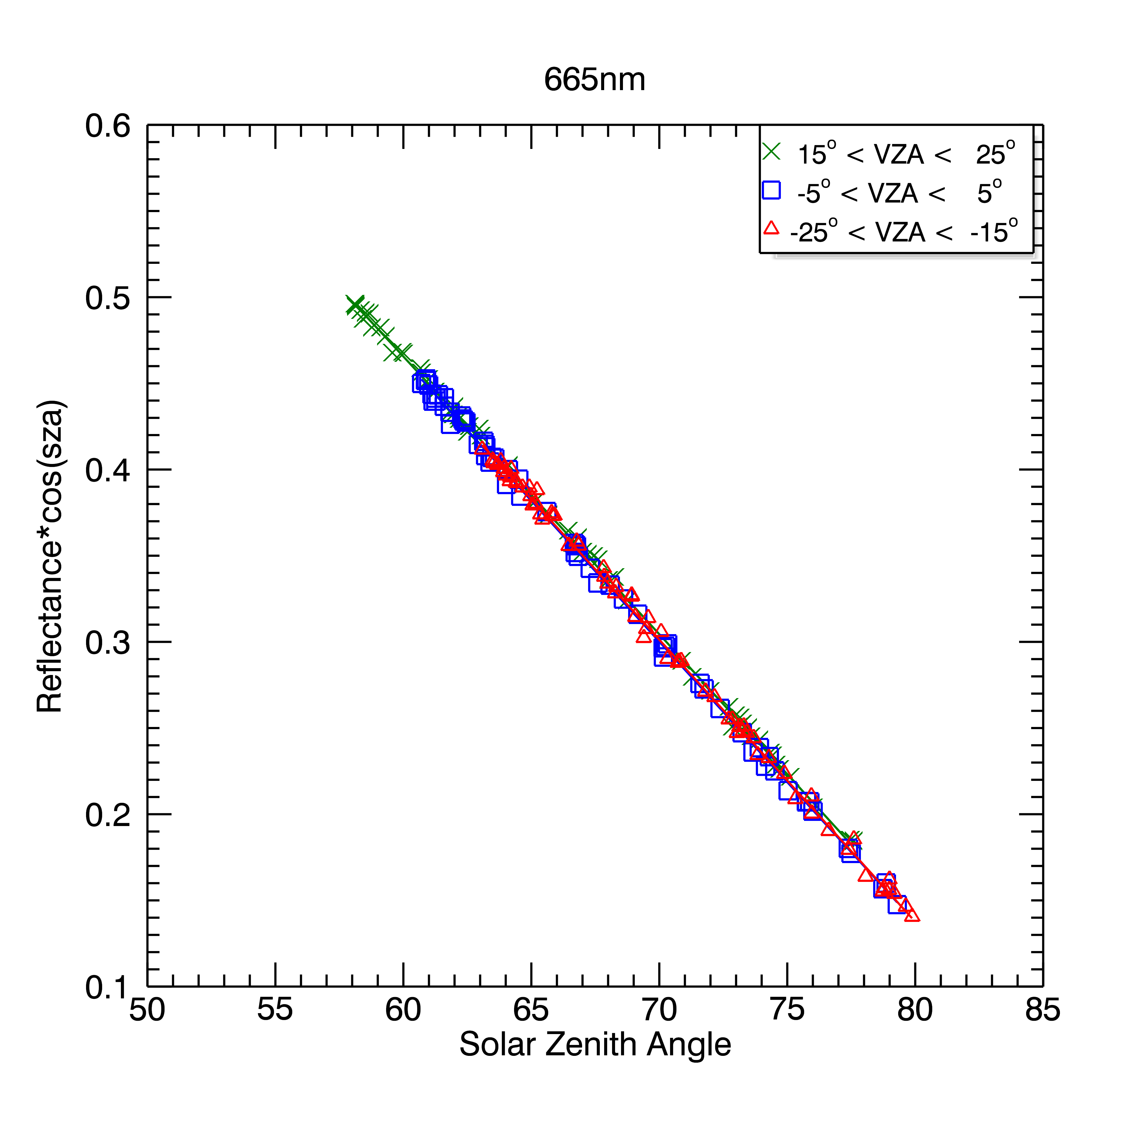
Dome-C
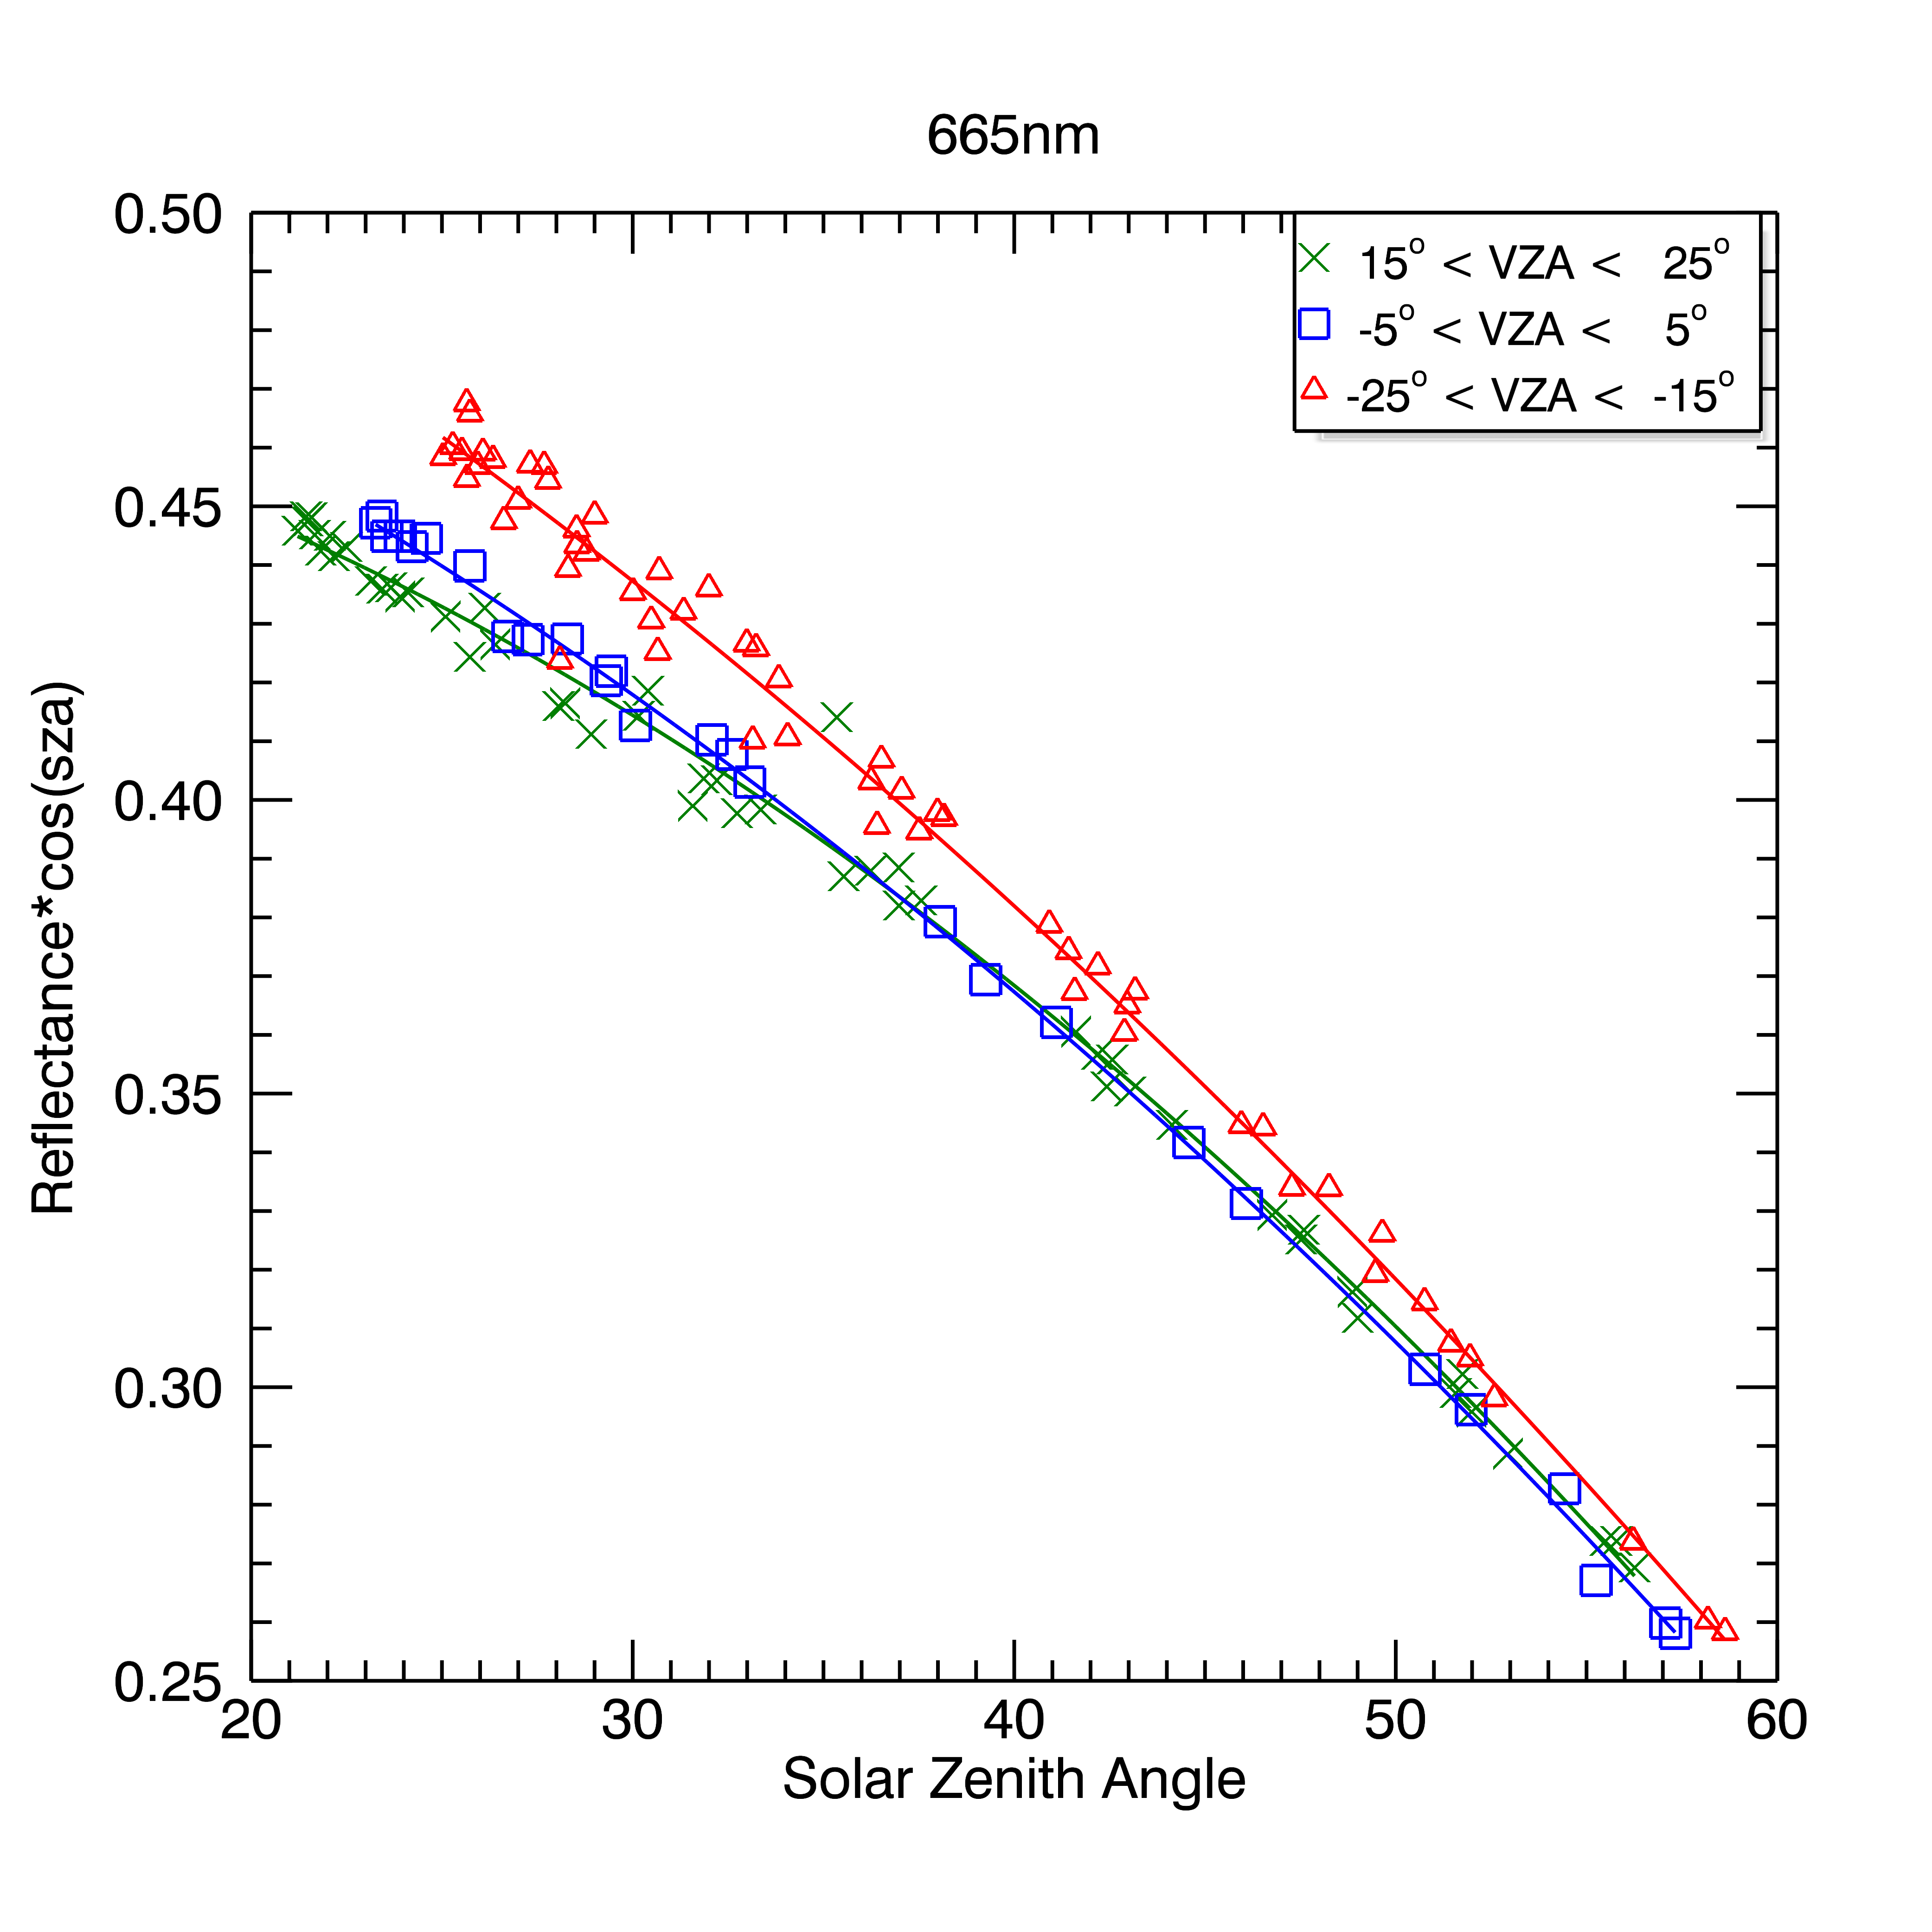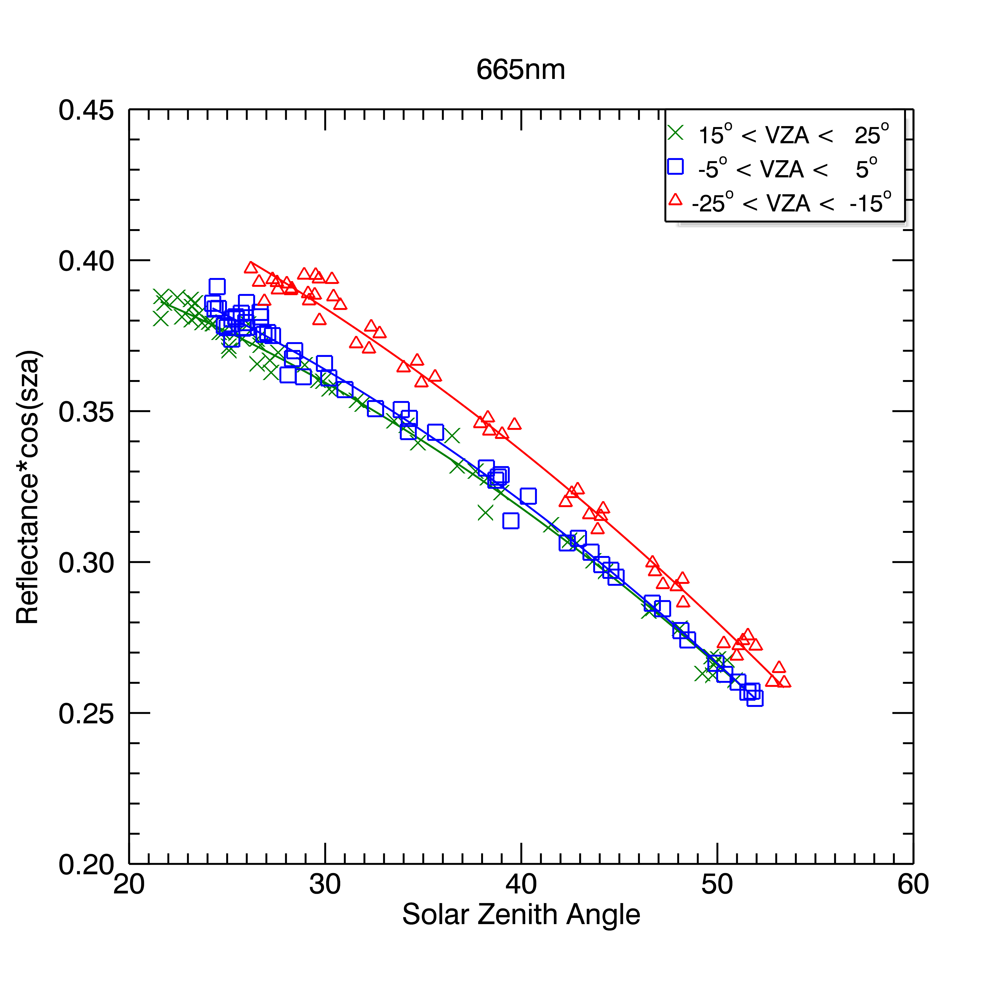
Libya-4
Niger-2
Figure 10: Examples of MERIS 665nm BRF fit for view zenith angles -20°±5°, 0°±5°, +20°±5° for Dome-C, Libya-4 and Niger-2.

Using the coefficients derived for each band and view zenith, we compute normalised radiances for the corresponding bands in the sensor under comparison (AATSR, MODIS and POLDER-3) using the solar zenith and relative azimuth angles provided in the reference datasets. Finally we compare the measurements to the reference values either as scatter plots or as time series of the ratio R_{meas}/R_{ref}.
Note for this present comparison we correct for ozone absorption since we have been assuming the spectral bands to be similar. Future analysis will include corrections for other effects including water vapour, molecular scattering (Rayleigh) and spectral differences in the site. The impact of these error sources on this analysis will be discussed in the following section.

Uncertainties
In this section we provide a breakdown on the main sources of uncertainty and an estimate of their magnitude. We do not consider the uncertainty estimates of the quoted sensor calibrations, only the uncertainties in the comparison methodology. The contributors to the uncertainty budget that will be considered in this section are:
- BRF model uncertainty
- Scatter in measurements
- Spectral mismatch

BRF model
The uncertainty in the BRF, u(R) is taken from the co-variance matrix generated by the least squares fitting function (IDL function,poly_fit.pro). These errors are dependent on the measurement errors provided to the function as a keyword parameter. For this analysis we assume the standard deviation of the average reflectance measurements over the site. The model uncertainty is expressed as:

$u^{2}\left(R_{i}\right)=\sum_{i=0}^{N}{\sum_{j=0}^{N}{{\text{cov}}_{i,j}θ_{0}^{i}}}θ_{0}^{j}$ 6
For the moment we assume that uncertainties due to the long term stability of the reference sensor BRF are negligible. The uncertainties (k=1) in the modelled BRF are summarised in Table 10. These uncertainties are considered as type A (statistical).

Table 9: Estimated uncertainty in BRF model
 | 555nm | 660nm | 870nm
Dome-C | 0.41% | 0.49% | 0.59%
Libya-4 | 0.27% | 0.25% | 0.23%
Niger-2 | 0.27% | 0.28% | 0.28%

Scatter in measurements
Histogram plots of the differences between the measurements and reference model show that the distributions can be approximated by a Gaussian distribution. Hence we can assume that the scatter around the mean is random and the standard uncertainty in the mean is defined as:
$u^{2}\left(Δ\bar{R}\right)=\frac{σ^{2}\left({R_{\text{meas}}}/{R_{\text{ref}}}\right)}{N}$ 7

Table 10: Standard uncertainty in BRF comparison due to scatter in results. These uncertainties are considered as type A (statistical).
AATSR
 | 555nm | 660nm | 870nm
Dome-C | 0.05% | 0.05% | 0.07%
Libya-4 | 0.16% | 0.11% | 0.13%
Niger-2 | 0.19% | 0.16% | 0.15%

MODIS-AQUA
 | 555nm | 660nm | 870nm
Dome-C | 0.09% | 0.10% | 0.13%
Libya-4 | 0.11% | 0.11% | 0.12%
Niger-2 | 0.15% | 0.11% | 0.10%

POLDER-3
 | 555nm | 660nm | 870nm
Dome-C | 0.17% | 0.19% | 0.27%
Libya-4 | 0.16% | 0.11% | 0.09%
Niger-2 | 0.15% | 0.11% | 0.09%

Spectral Mismatch
This is probably the main source of error and provides a physical explanation to some of the results shown later. Here there are two sources to this component: atmospheric effects and variations in the spectral reflectance of the sites under consideration.

Atmospheric contributions
Figure 11 and Figure 12 show MODTRAN-5 simulated transmissions for atmospheres over Dome-C with total columnar water vapour (TCWV) = 0.25g/cm²and a desert site (Niger-2) with TCWV = 2.14g/cm². Here we see that the main sources of atmospheric absorption in the spectral bands under comparison are molecular scattering (Rayleigh), Ozone and Water vapour.

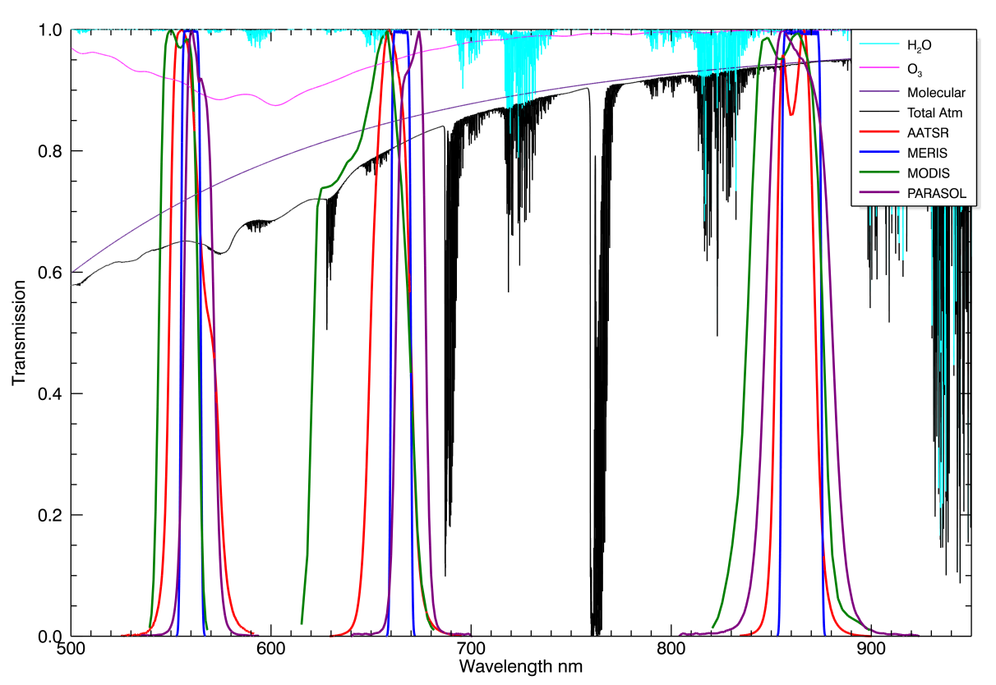
Figure 11: MODTRAN-5 simulation of atmospheric transmission for Dome-C with Ozone = 270DU, and TCWV = 0.25g/cm² , view zenith = 0° and solar zenith = 70°. Aerosol scattering is not included in this plot. Only the instrument spectral responses included in this comparison are shown.
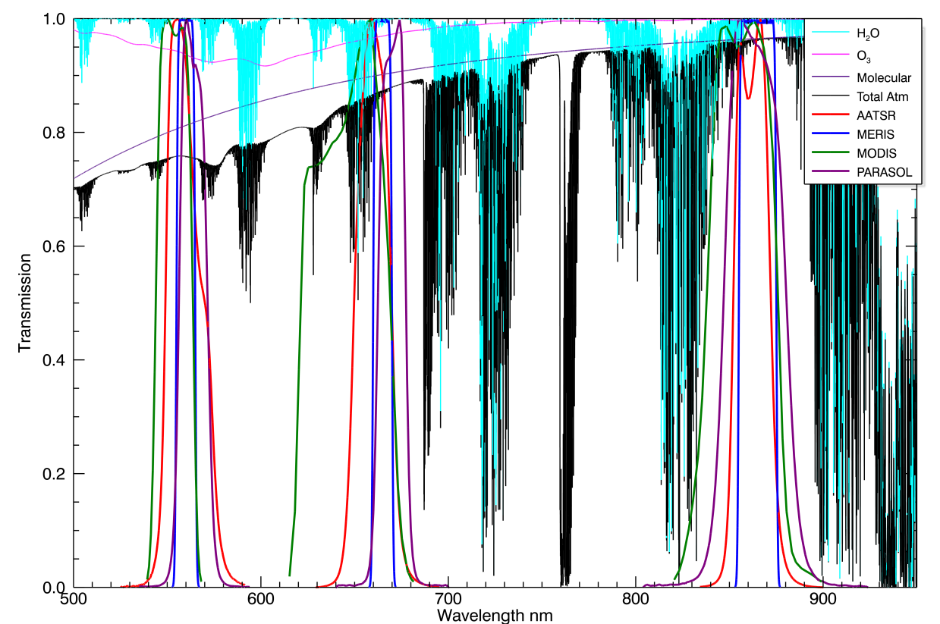

Figure 12: MODTRAN-5 simulation of atmospheric transmission for Niger-2 with Ozone = 270DU, and TCWV = 2.14g/cm² , view zenith = 0° and solar zenith = 40°. Aerosol scattering is not included in this plot. Only the instrument spectral responses included in this comparison are shown.

To estimate the effects of the atmospheric each component, we integrate the modelled transmissions over the spectral responses for each sensor and band:
$t_{\text{sens},λ}=\int{t\left(λ\right)R{\left(λ\right)}_{\text{sens},λ}dλ}/R{\left(λ\right)}_{\text{sens},λ}dλ$ 8

to obtain tables of transmission as a function of TCWV, O3 and zenith angle. Then for each measurement we estimate the systematic error by comparing the in band transmissions of the sensor relative to MERIS so that:
${\text{dt}}_{λ}=\text{100}x\left(\frac{t{\left(θ_{0}\right)}_{\text{sens},λ}t{\left(θ_{v}\right)}_{\text{sens},λ}}{t{\left(θ_{0}\right)}_{\text{MERIS},λ}t{\left(θ_{v}\right)}_{\text{MERIS},λ}}−1\text{.}0\right)\text{\%}$ 9

The average biases and uncertainties due to O₃, H₂O, Molecular scattering and all absorbers are given in Table 11 for AATSR, Table 12 for MODIS-AQUA and Table 13 for POLDER-3. For Rayleigh scattering we compute the direct component, sun->surface->sensor and sun->atmosphere->sensor, assuming that the diffuse component is included in the surface BRF measurements (where available). Note that these are estimates of the biases based on an average over the date range of the comparisons. For Dome-C we assume the surface pressure of ~650mbar based on in-situ measurements for the DOMEX-2 campaign (G. Marcelloni – personal communication) and for the desert sites we assume a surface pressure of 1000mbar.

From an examination of the data and Figure 11 and Figure 12, the main sources of bias over Dome-C are Ozone and Molecular scattering. The effect of water vapour is not significant due to the dry atmosphere. At 555nm, the spectral bias due to ozone is compensated by the molecular scattering, so the net bias due to atmospheric absorption is almost zero. At 870nm, there is effectively no difference in transmission between sensors since Ozone absorption and molecular scattering become negligible. The biggest differences are seen at 660nm where the effects of Ozone AND molecular scattering combine. The strongest difference is seen for MODIS where the spectral bandwidth at 650nm is almost double that of MERIS and extends toward the shorter wavelengths where absorption becomes stronger. Because of the low sun over Antarctica, the differences become very sensitive to atmospheric path which increases with SZA and VZA.

Over the desert sites, water vapour becomes a significant contribution to the in-band absorption. This particularly affects MODIS at 660nm and 870nm due to the broader spectral response with total biases of ~4%, but also AATSR where the total bias is ~1.8%.

Currently the RAL Space methodology includes correction for ozone absorption. Ongoing developments will include corrections to water vapour and molecular scattering which should improve the differences over different site types.
Table 11: Estimated systematic and random uncertainties in AATSR comparisons due to atmospheric absorption. TCWV and H2O columns are obtained from ECMWF re-analysis data for the site coordinates and dates of observation.
Ozone
 | 555nm |  | 660nm |  | 870nm
 | Bias | Uncert | Bias | Uncert | Bias | Uncert
Dome-C | -0.25% | 0.12% | -1.40% | 0.65% | 0.00% | 0.00%
Libya-4 | 0.57% | 0.05% | -0.02% | 0.00% | 0.00% | 0.00%
Niger-2 | 0.40% | 0.03% | 0.00% | 0.00% | 0.00% | 0.00%

H2O
 | 555nm |  | 660nm |  | 870nm
 | Bias | Uncert | Bias | Uncert | Bias | Uncert
Dome-C | 0.01% | 0.01% | -0.06% | 0.04% | -0.01% | 0.01%
Libya-4 | -0.15% | 0.05% | -1.51% | 0.42% | -0.19% | 0.06%
Niger-2 | -0.12% | 0.05% | -1.22% | 0.48% | -0.15% | 0.06%

Molecular Scattering
 | 555nm |  | 660nm |  | 870nm
 | Bias | Uncert | Bias | Uncert | Bias | Uncert
Dome-C | -0.01% | 0.02% | -0.30% | 0.11% | -0.04% | 0.02%
Libya-4 | 0.08% | 0.01% | -0.23% | 0.02% | -0.03% | 0.00%
Niger-2 | 0.09% | 0.01% | -0.23% | 0.03% | -0.03% | 0.00%

Total Atmosphere Error (Including Ozone)
 | 555nm |  | 660nm |  | 870nm
 | Bias | Uncert | Bias | Uncert | Bias | Uncert
Dome-C | -0.25% | 0.12% | -1.76% | 0.66% | -0.05% | 0.02%
Libya-4 | 0.50% | 0.07% | -1.76% | 0.42% | -0.22% | 0.06%
Niger-2 | 0.37% | 0.06% | -1.45% | 0.48% | -0.18% | 0.06%

Table 12: Estimated systematic and random uncertainties in MODIS AQUA comparisons due to atmospheric absorption. TCWV and H2O columns are obtained from ECMWF re-analysis data for the site coordinates and dates of observation.
Ozone
 | 555nm |  | 660nm |  | 870nm
 | Bias | Uncert | Bias | Uncert | Bias | Uncert
Dome-C | 1.53% | 0.62% | -3.81% | 1.48% | 0.00% | 0.00%
Libya-4 | 0.88% | 0.09% | -0.85% | 0.09% | 0.00% | 0.00%
Niger-2 | 0.58% | 0.05% | -1.39% | 0.12% | 0.00% | 0.00%

H2O
 | 555nm |  | 660nm |  | 870nm
 | Bias | Uncert | Bias | Uncert | Bias | Uncert
Dome-C | 0.00% | 0.00% | -0.05% | 0.04% | -0.07% | 0.04%
Libya-4 | -0.07% | 0.02% | -1.35% | 0.39% | -1.60% | 0.45%
Niger-2 | -0.06% | 0.02% | -1.07% | 0.36% | -1.28% | 0.41%

Molecular Scattering
 | 555nm |  | 660nm |  | 870nm
 | Bias | Uncert | Bias | Uncert | Bias | Uncert
Dome-C | -0.62% | 0.12% | -1.05% | 0.32% | -0.10% | 0.04%
Libya-4 | -0.54% | 0.04% | -0.82% | 0.08% | -0.07% | 0.01%
Niger-2 | -0.54% | 0.04% | -0.82% | 0.07% | -0.07% | 0.01%

Total Atmosphere Error (including Ozone)
 | 555nm |  | 660nm |  | 870nm
 | Bias | Uncert | Bias | Uncert | Bias | Uncert
Dome-C | 0.91% | 0.63% | -4.91% | 1.51% | -0.17% | 0.06%
Libya-4 | 0.27% | 0.10% | -3.02% | 0.41% | -1.67% | 0.45%
Niger-2 | -0.02% | 0.07% | -3.28% | 0.39% | -1.35% | 0.41%
Table 13: Estimated systematic and random uncertainties in POLDER-3 comparisons due to atmospheric absorption. TCWV and H2O columns are obtained from ECMWF re-analysis data for the site coordinates and dates of observation.
Ozone
 | 555nm |  | 660nm |  | 870nm
 | Bias | Uncert | Bias | Uncert | Bias | Uncert
Dome-C | 0.02% | 0.00% | 0.33% | 0.07% | 0.00% | 0.00%
Libya-4 | -0.86% | 0.09% | 0.11% | 0.01% | 0.00% | 0.00%
Niger-2 | -0.28% | 0.02% | 0.31% | 0.02% | 0.00% | 0.00%

H2O
 | 555nm |  | 660nm |  | 870nm
 | Bias | Uncert | Bias | Uncert | Bias | Uncert
Dome-C | -0.01% | 0.00% | 0.00% | 0.00% | -0.03% | 0.01%
Libya-4 | -0.16% | 0.05% | 0.11% | 0.03% | -0.66% | 0.17%
Niger-2 | -0.12% | 0.05% | 0.08% | 0.03% | -0.52% | 0.18%

Molecular Scattering
 | 555nm |  | 660nm |  | 870nm
 | Bias | Uncert | Bias | Uncert | Bias | Uncert
Dome-C | 0.32% | 0.05% | 0.18% | 0.03% | -0.01% | 0.00%
Libya-4 | 0.33% | 0.03% | 0.19% | 0.02% | -0.01% | 0.00%
Niger-2 | 0.33% | 0.02% | 0.18% | 0.01% | -0.01% | 0.00%

Total Atmosphere Error (including Ozone)
 | 555nm |  | 660nm |  | 870nm
 | Bias | Uncert | Bias | Uncert | Bias | Uncert
Dome-C | 0.33% | 0.05% | 0.51% | 0.08% | -0.04% | 0.01%
Libya-4 | -0.69% | 0.11% | 0.41% | 0.04% | -0.67% | 0.17%
Niger-2 | -0.07% | 0.06% | 0.57% | 0.04% | -0.53% | 0.18%

Site Albedo
For Dome-C we use the spectral albedo measurements of Hudson et-al and interpolate to obtain the reflectance at the band centres, see Figure 13. Uncertainties in these differences are estimated at 1% for the purposes of this analysis.

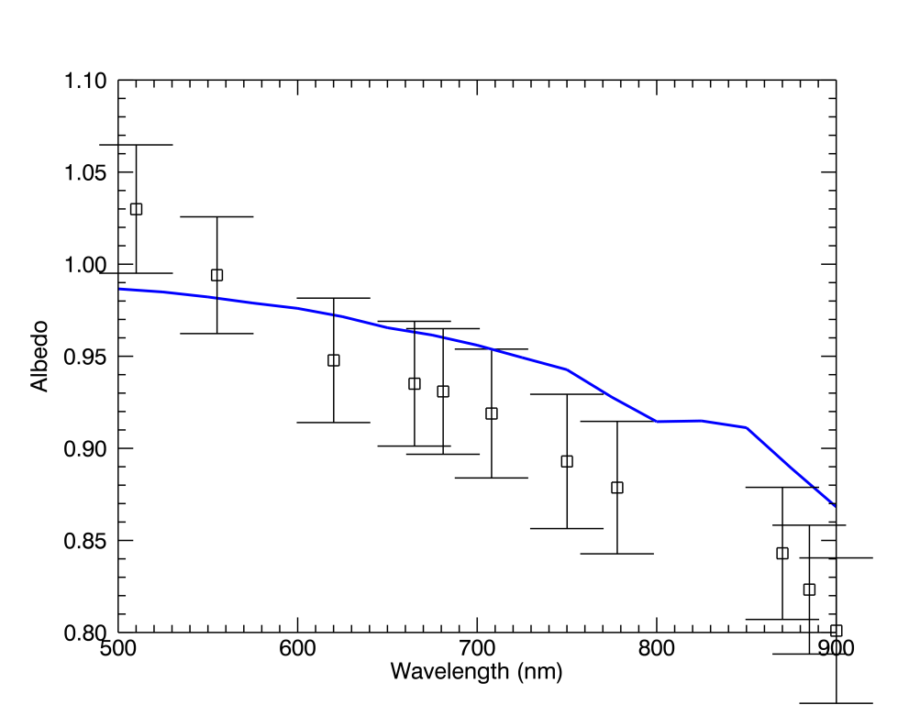
Figure 13: Dome-C spectral reflectance measurements of Hudson et al (Solid line) compared to average MERIS measurements (squares with error bars). The MERIS data have been atmospherically corrected but not adjusted for surface anisotropy.

For the Desert sites we do not have in-situ measurements of the site spectral reflectance readily available. Hence we estimate the spectral variance using the average of the MERIS BRF measurements, similar to the approach used for the DIMITRI analysis. Here we first correct the MERIS reflectance for atmospheric absorption effects already accounted for using the results of MODTRAN simulations to obtain the average for the sites in Figure 14. A key assumption is that the resulting MERIS reflectance is representative of the surface reflectance plus any residual atmospheric effects, in particular aerosol.

Looking at the data in Figure 14, the biggest differences occur at 660nm, particularly for the MODIS band.

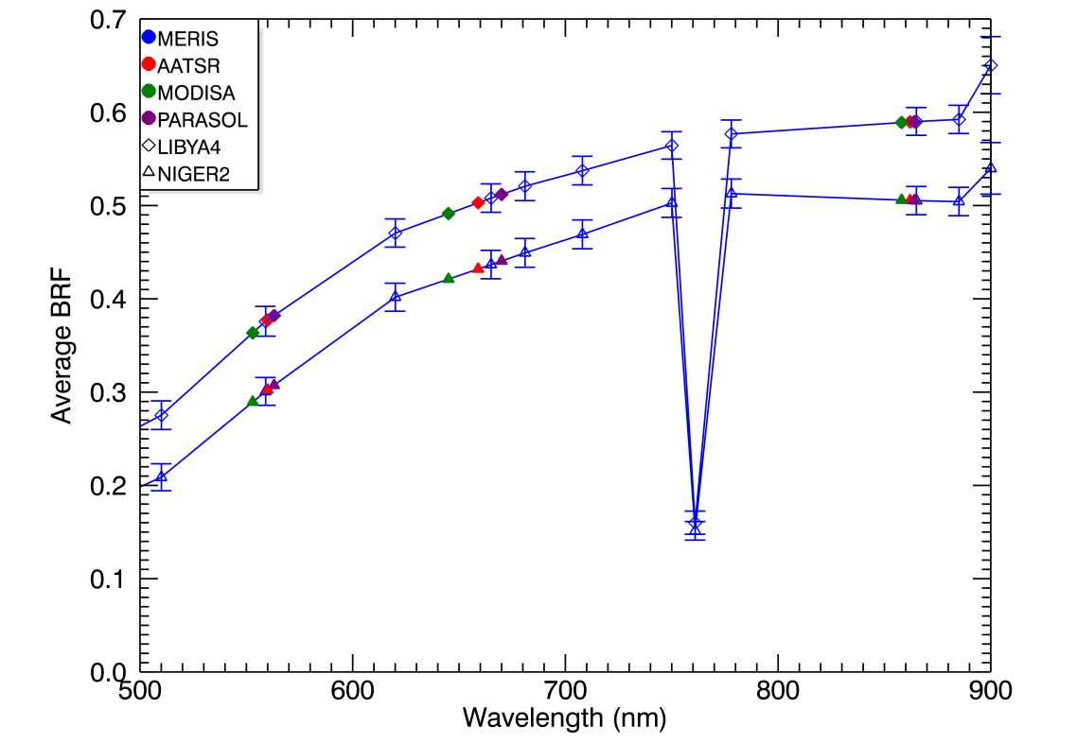

Figure 14: Average MERIS measurements over Libya-4 and Niger-2. The MERIS data have been atmospherically corrected but not adjusted for surface anisotropy. Interpolated values for AATSR, MODIS-A and POLDER-3 are overlaid.
Table 14: Estimated systematic and random uncertainties due to spectral variation in the site reflectance. These estimates assume that atmospheric components excluding aerosol are removed from the site albedo.
AATSR
 | 555nm |  | 660nm |  | 870nm
 | Bias | Uncert | Bias | Uncert | Bias | Uncert
Dome-C | -0.01% | 1.00% | 0.25% | 1.00% | 0.15% | 1.00%
Libya-4 | 0.28% | 0.58% | -0.66% | 0.57% | -0.05% | 0.55%
Niger-2 | 0.38% | 0.54% | -0.70% | 0.56% | 0.07% | 0.55%

MODIS-A
 | 555nm |  | 660nm |  | 870nm
 | Bias | Uncert | Bias | Uncert | Bias | Uncert
Dome-C | 0.08% | 1.00% | 0.33% | 1.00% | 0.88% | 1.00%
Libya-4 | -1.99% | 0.58% | -2.36% | 0.57% | -0.16% | 0.55%
Niger-2 | -2.45% | 0.54% | -2.51% | 0.56% | 0.21% | 0.55%

POLDER-3
 | 555nm |  | 660nm |  | 870nm
 | Bias | Uncert | Bias | Uncert | Bias | Uncert
Dome-C | -0.05% | 1.00% | -0.10% | 1.00% | 0.20% | 1.00%
Libya-4 | -2.19% | 0.60% | -5.91% | 0.71% | -1.91% | 0.71%
Niger-2 | -2.93% | 0.55% | -6.31% | 0.69% | -1.23% | 0.69%

Total Uncertainty
In Table 15 and Figure 15 we present the combined total systematic and random uncertainties taking into account the contributions described above. The tables also contain estimates excluding bias contributions from ozone since the intercomparison method already includes a correction for ozone. The random uncertainties are taken as the root sum square of the individual components. Note that we have assumed that all uncertainty estimates are uncorrelated.

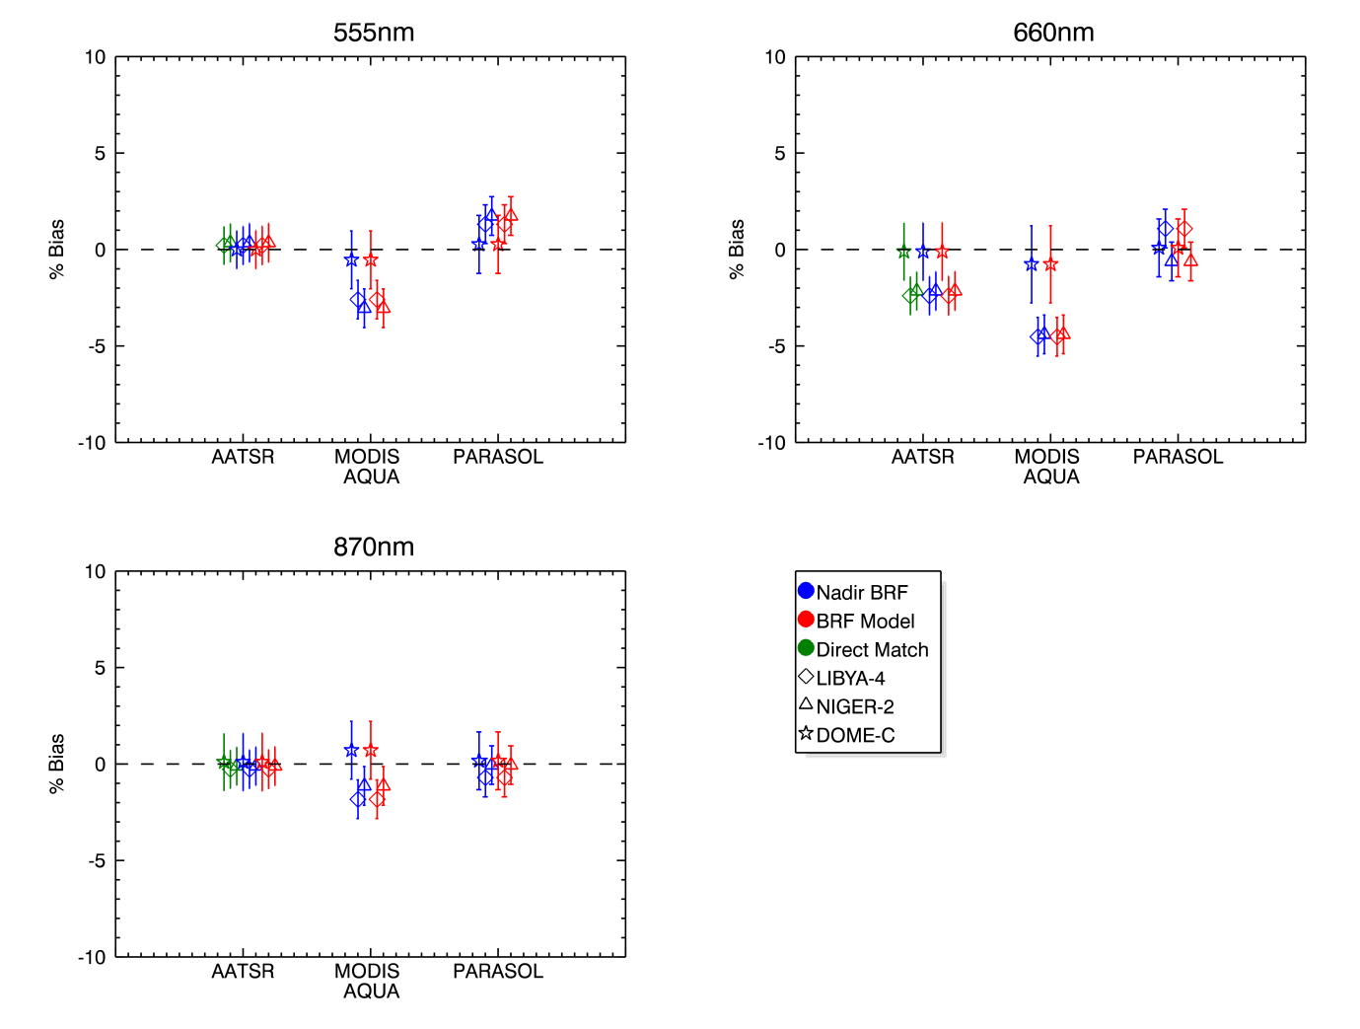
Figure 15: Estimated systematic errors (Type-B) as shown by symbols with random uncertainties (Type-A) as error bars on RAL intercomparisons.
Table 15: Estimated total systematic and random uncertainties in the intercomparison results.
AATSR
Including bias due to O3
 | 555nm |  | 660nm |  | 870nm
 | Bias | Uncert | Bias | Uncert | Bias | Uncert
Dome-C | -0.26% | 1.09% | -1.51% | 1.30% | 0.10% | 1.16%
Libya-4 | 0.78% | 0.66% | -2.42% | 0.76% | -0.27% | 0.61%
Niger-2 | 0.75% | 0.64% | -2.15% | 0.81% | -0.11% | 0.64%
Excluding O3 bias – This analysis
 | 555nm |  | 660nm |  | 870nm
 | Bias | Uncert | Bias | Uncert | Bias | Uncert
Dome-C | -0.01% | 1.09% | -0.11% | 1.30% | 0.10% | 1.16%
Libya-4 | 0.21% | 0.66% | -2.40% | 0.76% | -0.27% | 0.61%
Niger-2 | 0.35% | 0.64% | -2.15% | 0.81% | -0.11% | 0.64%

MODIS AQUA
Including bias due to O3
 | 555nm |  | 660nm |  | 870nm
 | Bias | Uncert | Bias | Uncert | Bias | Uncert
Dome-C | 0.99% | 1.25% | -4.58% | 1.88% | 0.71% | 1.17%
Libya-4 | -1.72% | 0.66% | -5.38% | 0.75% | -1.83% | 0.76%
Niger-2 | -2.47% | 0.63% | -5.79% | 0.74% | -1.14% | 0.75%
Excluding O3 bias – This analysis
 | 555nm |  | 660nm |  | 870nm
 | Bias | Uncert | Bias | Uncert | Bias | Uncert
Dome-C | -0.54% | 1.25% | -0.77% | 1.88% | 0.71% | 1.17%
Libya-4 | -2.60% | 0.66% | -4.53% | 0.75% | -1.83% | 0.76%
Niger-2 | -3.05% | 0.63% | -4.40% | 0.74% | -1.14% | 0.75%

POLDER-3
Including bias due to O3
 | 555nm |  | 660nm |  | 870nm
 | Bias | Uncert | Bias | Uncert | Bias | Uncert
Dome-C | 0.28% | 1.37% | 0.41% | 1.31% | 0.16% | 1.45%
Libya-4 | 0.45% | 0.67% | 1.19% | 0.63% | -0.71% | 0.63%
Niger-2 | 1.45% | 0.62% | -0.31% | 0.64% | -0.06% | 0.65%
Excluding O3 bias – This analysis
 | 555nm |  | 660nm |  | 870nm
 | Bias | Uncert | Bias | Uncert | Bias | Uncert
Dome-C | 0.26% | 1.37% | 0.08% | 1.31% | 0.16% | 1.45%
Libya-4 | 1.31% | 0.67% | 1.08% | 0.63% | -0.71% | 0.63%
Niger-2 | 1.73% | 0.62% | -0.62% | 0.64% | -0.06% | 0.65%

OSCAR

Description of the methodology
VITO has undertaken the development of an Optical Sensor CAlibration with simulated Radiance (OSCAR) facility dedicated to the routine vicarious calibration of radiometers, specifically the future ESA Proba-V mission. In this CEOS/IVOS exercise, the results of the comparison of the satellite observations extracted from the DIMITRI database with the simulated reflectance using OSCAR over Libya-4 is presented. Niger-2 and Dome C were not considered in this analysis because of the non availability of a BRDF model.
The proposed approach relies on a combination of various vicarious calibration methods based on the exploitation of reflected radiance by clouds, atmospheric molecules or bright desert surfaces. For bright desert targets, simulated TOA BRF defines an absolute calibration reference. These simulations are based on the radiative properties originally proposed by Govaerts and Clerici (2004). Several improvements have been implemented with respect to this original work:
- The radiative transfer simulations are based on the 6S-V code developed by (Kotchenova et al. 2006; Kotchenova and Vermote, 2007).
- The characterization of the surface properties of the desert site Libya-4 are now based on MODIS and MISR observations.
- A specific aerosol model has been derived for the Sahara region based on the analysis of AERONET data accounting for spheroid particles.
This methodology was applied to the data from the reference dataset over Libya-4. The corresponding TOA BRFs r_{o}(t,Ω) acquired at time t have been simulated under the same the geometry of observation Ω. For each time series of the couple (r_{o}(t,Ω); r_{s}(t,Ω)), where r_{o}(t)and ; r_{s}(t) stand for the observed and simulated TOA BRF respectively, the following statistics have been derived:
$\overline{R}=\frac{1}{N_{t}}\sum_{t}{\frac{r_{o}(t,Ω)}{r_{s}(t,Ω)}}$ 10
where N_{t} is the number of valid observations, i.e. after removal of the outliers at a 2σ confidence interval (Table 16). For the AATSR observations, only the nadir camera has been considered. Almost all these radiometers observe in the 0.44, 0.55, 0.66, 0.84 and 1.62μm spectral intervals that are referred to here as the common spectral bands.

Table 16: Number of valid observations from the reference dataset Nt in the common spectral bands during the 2006–2009 period over LIBYA-4.
BAND | 0.44μm | 0.55 μm | 0.66 μm | 0.84 μm | 1.62 μm
VEGETATION | 723 |  | 700 | 709 | 695
AATSR |  | 114 | 117 | 119 | 120
POLDER-3 | 4078 | 4072 | 4225 | 4205
MODIS-A | 848 | 864 | 846 | 839 | 822
MERIS | 371 | 378 | 372 | 367

Uncertainties
The simulated radiances are affected by several uncertainties resulting from error in the characterization of the atmosphere and surface radiative properties. Typically, atmospheric uncertainties are assumed weakly correlated in time. Hence, when a long time series is processed, these errors can be assumed random are therefore reduce. Such reasoning does not hold for surface properties. For the same target, errors will be repeated from day to day so that these errors should be considered systematic. However, when several desert targets are used, the uncertainty on the surface characterization can be assumed uncorrelated and these errors can be considered as random. This strongly motivates the use of more than one desert targets with the OSCAR facility.
In the current analysis where only one target is used, the uncertainty on the simulated TOA BRF during the four year period is about 3 - 6% according to the spectral band.

Results for each methodology
In the following section, the results of the each methodology relative to the MERIS data from the 2nd reprocessing are presented for 3 spectral intervals in which AATSR, MERIS, MODIS-A and POLDER-3 have spectral bands. These spectral intervals are located around 560 nm, 670 nm and 870 nm.

DIMITRI
DIMITRI results are presented below in Table 17 to Table 19 for the three wavelengths. For each sensor and each site are listed: the number of doublets, the average ratio (expressed as a relative difference in percent), the standard deviation of the ratio, and the Type A and Type B uncertainty estimates.
Results are also plotted on Figure 16.
Table 17: Results from DIMITRI at 560nm:
MERIS 2nd reproc vs.  Sensor | Site | N samples | Mean relative difference in % between sensor and MERIS 2nd reprocessing | Stddev of the relative difference in % | Estimated methodology Type A uncertainty (random uncertainty) | Estimated methodology Type B uncertainty (systematic uncertainty)
AATSR | LIBYA-4 (DIMITRI) | 73 | 2.34% | 0.55% | 1.5% | 0.1%
AATSR | DOME-C | 88 | 2.30% | 0.76% | 1.1% | 0.1%
AATSR | NIGER-2 | 54 | 2.52% | 0.53% | 1.6% | 0.1%
POLDER-3 | LIBYA-4 (DIMITRI) | 125 | -1.30% | 1.78% | 1.9% | 1.7%
POLDER-3 | DOME-C | 173 | -1.93% | 2.65% | 1.2% | -0.4%
POLDER-3 | NIGER-2 | 158 | -1.50% | 2.15% | 1.8% | 1.7%
MODIS-A | LIBYA-4 (DIMITRI) | 313 | -3.91% | 1.52% | 1.8% | -2.5%
MODIS-A | DOME-C | 132 | 1.14% | 1.74% | 1.2% | 0.8%
MODIS-A | NIGER-2 | 304 | -4.87% | 2.03% | 1.8% | -2.5%

Table 18: Results from DIMITRI at 665nm
:MERIS 2nd reproc vs.  Sensor | Site | N samples | Mean relative difference in % between sensor and MERIS 2nd reprocessing | Stddev of the relative difference in % | Estimated methodology Type A uncertainty (random uncertainty) | Estimated methodology Type B uncertainty (systematic uncertainty)
AATSR | LIBYA-4 (DIMITRI) | 73 | -0.11% | 0.44% | 1.5% | -1.2%
AATSR | DOME-C | 89 | 1.46% | 0.57% | 0.8% | -0.6%
AATSR | NIGER-2 | 57 | -0.03% | 0.50% | 1.5% | -1.2%
POLDER-3 | LIBYA-4 (DIMITRI) | 125 | -1.56% | 1.26% | 1.9% | 1.2%
POLDER-3 | DOME-C | 171 | -1.24% | 1.58% | 0.8% | 0.5%
POLDER-3 | NIGER-2 | 160 | -2.19% | 1.62% | 1.7% | 1.2%
MODIS-A | LIBYA-4 (DIMITRI) | 315 | -6.30% | 1.27% | 1.8% | -4.8%
MODIS-A | DOME-C | 134 | -2.07% | 1.28% | 1.0% | -2.5%
MODIS-A | NIGER-2 | 310 | -6.32% | 1.45% | 1.7% | -4.8%

Table 19: Results from DIMITRI at 865nm
MERIS 2nd reproc vs.  Sensor | Site | N samples | Mean relative difference in % between sensor and MERIS 2nd reprocessing | Stddev of the relative difference in % | Estimated methodology Type A uncertainty (random uncertainty) | Estimated methodology Type B uncertainty (systematic uncertainty)
AATSR | LIBYA-4 (DIMITRI) | 74 | 2.47% | 0.59% | 1.6% | 0.0%
AATSR | DOME-C | 90 | 2.77% | 0.64% | 0.9% | 0.1%
AATSR | NIGER-2 | 56 | 2.56% | 0.54% | 1.5% | 0.0%
POLDER-3 | LIBYA-4 (DIMITRI) | 124 | -3.02% | 1.05% | 1.9% | 0.0%
POLDER-3 | DOME-C | 171 | -1.66% | 1.37% | 0.9% | 0.1%
POLDER-3 | NIGER-2 | 160 | -3.39% | 1.28% | 1.7% | 0.0%
MODIS-A | LIBYA-4 (DIMITRI) | 310 | -2.43% | 1.16% | 1.8% | 0.0%
MODIS-A | DOME-C | 141 | 0.35% | 0.91% | 1.0% | 0.4%
MODIS-A | NIGER-2 | 310 | -1.74% | 1.35% | 1.7% | 0.0%

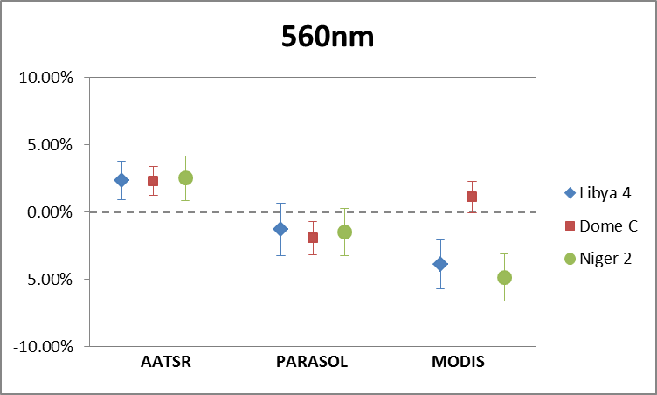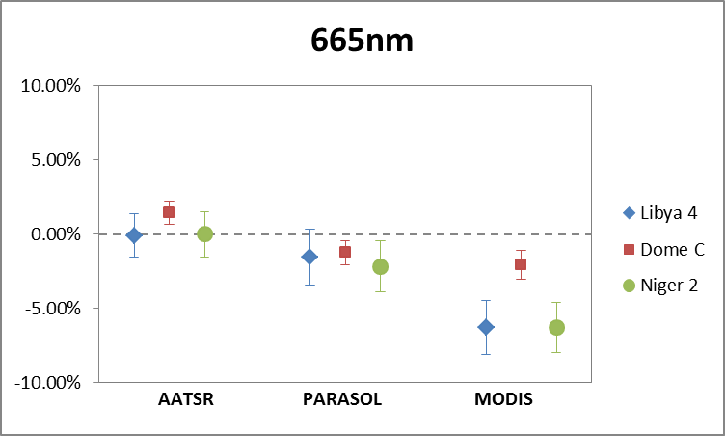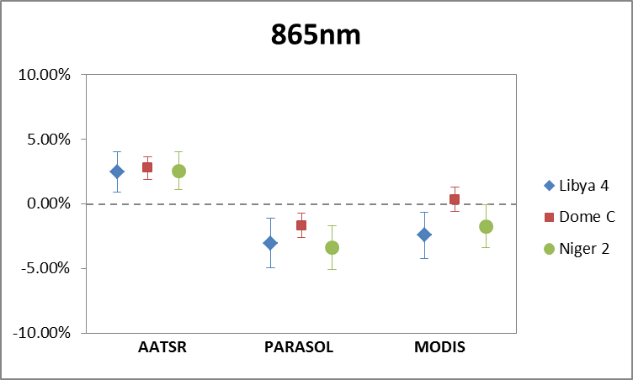
Figure 16: Overall results of DIMITRI for all sensors and sites, wavelength per wavelength with associated Type A uncertainty

These results can be summarised by the following characteristics:
- AATSR and POLDER-3 tend to show a systematic behaviour with respect to MERIS for the three channels: AATSR being slightly higher, POLDER-3 slightly lower, all within about 2%,
- There is a very good cross-site consistency for those two sensors at 560 nm, and also at 865 for AATSR. Cross-site consistency degrades at 665 for AATSR and at 865 for POLDER-3 and is generally very poor for MODIS. There is however a relatively good cross-site consistency when restricted to Desert sites for all sensors.
- Discrepancies between MERIS and MODIS can reach 6% in the red,
- Large inter-sensor discrepancies as well as large cross-site discrepancies are highly correlated with Type B systematic errors.
This latter point is of particular interest and has been investigated further. Correction of Type B systematic errors, even if not stricto sensu part of the current DIMITRI methodology, has been drafted to evaluate its potential for the method improvement:
- Ozone absorption has been corrected for using the model described in section 3.2 and a fixed amount of absorber, as reliable data is not available for all sensors,
- Site BRF spectral shape has been accounted for by interpolating MERIS at evaluated sensor’s wavelength (by linear interpolation between bracketing MERIS channels)
- No attempt to correct for water vapour absorption has been done.
The results are shown on Figure 17, which can be directly compared to Figure 16.
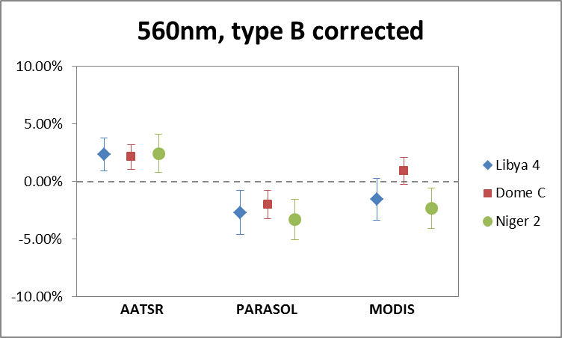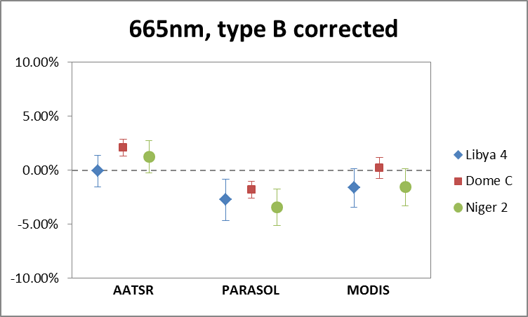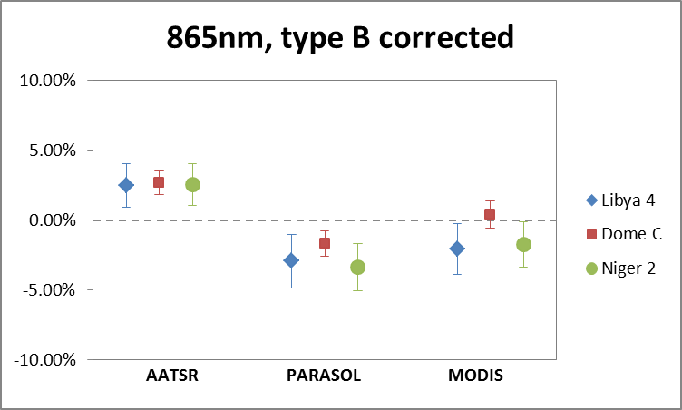
Figure 17: Overall results of DIMITRI for all sensors and sites, wavelength per wavelength with associated Type A uncertainty .
It appears immediately that, despite the crude corrections, the very large cross-site discrepancies in the green and red bands are significantly reduced. The fact that they do not disappear suggest that the corrections are of limited accuracy:
- For 560 and 665nm, one can question the ozone correction done with a constant mass of absorber (275 DU at Dome-C, 300 DU at Libya-4 and Niger-2, according to rough statistics on MERIS overpasses): a variation of the ozone concentration from 300 DU to 250 has an impact of about 1.5% at 560 and 1% at 665nm;
- For 665 and 865nm, absorption by the water vapour has a significant impact, as discussed in section 3.2: up to 2% for AATSR in the red, and for MODIS in the red and NIR;
- the spectral interpolation of the reference sensor channels at evaluated channels follows a very simplistic model while correcting for significant biases in the green and red over deserts;
- and finally auxiliary data used for the corrections – normalised spectral response functions, ozone optical depths – also have uncertainties that should be evaluated.

SADE/MUSCLE
In this section, the series of results obtained from the SADE/MUSCLE methodology described in 3.3.1 is presented. The results are provided for bands located around 560 nm, 660 nm and 860 nm and for AATSR, MODIS-A and POLDER-3 in Table 20. The full suite of results (all spectral bands and VEGETATION-2) is given for reference in Annex (section 13.3)
Table 20: Results of the MUSCLE methodology over Libya-4 and Niger-2 for bands located around 560 nm, 660 nm and 860 nm. Results are provided for AATSR, MODIS-A and POLDER-3 using MERIS as reference sensor.
560 nm:MERIS 2nd reproc vs.  Sensor | Site | N samples | Mean relative difference in % between sensor and MERIS 2nd reprocessing | Stddev of the relative difference in % | Estimated methodology uncertainty on mean relative difference in %
AATSR | LIBYA-4 | 139 | +2.8% | 1.4% | 2%
AATSR | NIGER-2 | 98 | +3.1% | 3.5% | 2%
POLDER-3 | LIBYA-4 | 216 | -2.5% | 1.9% | 2.5%
POLDER-3 | NIGER-2 | 240 | -3.1% | 1.9% | 2.5%
MODIS-A | LIBYA-4 | 139 | -1.6% | 0.9% | 2.5%
MODIS-A | NIGER-2 | 97 | -2.3% | 2.4% | 2.5%

660 nm:
MERIS 2nd reproc vs.  Sensor | Site | N samples | Mean relative difference in % between sensor and MERIS 2nd reprocessing | Stddev of the relative difference in % | Estimated methodology uncertainty on mean relative difference in %
AATSR | LIBYA-4 | 139 | +2.4% | 1.2% | 1.5%
AATSR | NIGER-2 | 98 | +2.3% | 2.4% | 1.5%
POLDER-3 | LIBYA-4 | 216 | -2.8% | 1.5% | 2%
POLDER-3 | NIGER-2 | 240 | -3.3% | 1.7% | 2%
MODIS-A | LIBYA-4 | 139 | -0.8% | 0.7% | 2%
MODIS-A | NIGER-2 | 97 | -1.3% | 1.4% | 2%
860 nm:
MERIS 2nd reproc vs.  Sensor | Site | N samples | Mean relative difference in % between sensor and MERIS 2nd reprocessing | Stddev of the relative difference in % | Estimated methodology uncertainty on mean relative difference in %
AATSR | LIBYA-4 | 139 | +3.1% | 1.1% | 1.5%
AATSR | NIGER-2 | 98 | +2.9% | 2.1% | 1.5%
POLDER-3 | LIBYA-4 | 216 | -2.7% | 1.3% | 2%
POLDER-3 | NIGER-2 | 240 | -2.8% | 1.4% | 2%
MODIS-A | LIBYA-4 | 139 | -0.8% | 0.8% | 2%
MODIS-A | NIGER-2 | 97 | -1.0% | 1.3% | 2%

For the results shown in Table 20 , MERIS was used as reference sensor in the SADE/MUSCLE methodology. It is also possible to use the same approach to compute the expected simulated observations of MERIS. These results are provided in .

Table 21: Results of the SADE/MUSCLE methodology for pseudo-invariant sites for MERIS by taking MERIS as a reference sensor. Results are shown for the spectral bands chosen for the methodology intercomparison.
Band | Site | Nsamples | Mean relative  difference (%) | Standard deviation
560 nm | LIBYA-4 | 1206 | +0.0001 | 1.1%
 | NIGER-2 | 1004 | +0.0002 | 2.0%
665 nm | LIBYA-4 | 1206 | +0.000 | 0.8%
 | NIGER-2 | 1004 | +0.000 | 1.1%
865 nm | LIBYA-4 | 1206 | +0.000 | 0.7%
 | NIGER-2 | 1004 | +0.000 | 0.9%

OSCAR
The results of the relative difference expressed in percent between the satellite derived TOA BRFs and the SIXSV simulations are shown in Table 22. The associated standard deviations are given in Table 23. Considering the differences between the radiometers of the reference dataset in the five common spectral regions of interest, one can see that:
- 0.44 μm: POLDER-3, MODISA and MERIS observations agree within 1%. Only the VEGETATION data exhibit lower values than the other radiometers by about 2%
- 0.55 μm: There is a 3% variation range in the data, AATSR exhibiting the higher BRF values and POLDER-3 the lower ones. MODIS-A and MERIS are very consistent.
- 0.66 μm: There is a 5.5% difference between VEGETATION and AATSR, AATSR exhibiting the higher BRF values and VEGETATION the lower ones. POLDER-3, MODIS-A and MERIS observations agree within 1.5%.
- 0.84 μm: There is a 6.5% difference between VEGETATION and AATSR, AATSR exhibiting the higher BRF values and VEGETATION the lower ones. POLDER-3, MODIS-A and MERIS observations agree within 2%.
1.62 μm: There is a 5% difference between VEGETATION and AATSR, AATSR exhibiting the higher BRF values and VEGETATION the lower ones. MODISA agrees within 1% with AATSR.
Figure 18 gives a synthesis of the results when all the processed spectral bands are considered. On average, SIXSV simulations tend to slightly underestimate observations to the exception of the VEGETATION instrument.
Table 22: The relative difference expressed in percent between the satellite derived TOA BRFs and the 6S-V simulations estimated in the common spectral intervals over Libya-4.
BAND | 0.44μm | 0.55 μm | 0.66 μm | 0.84 μm | 1.62 μm
VEGETATION | +0.79% |  | -3.14% | -2.46% | -1.13%
AATSR |  | +3.89% | +2.81% | +4.21% | +3.82%
POLDER-3 | +3.08% | +0.71% | -0.23% | -0.00%
MODIS-A | +3.36% | +2.95% | +0.58% | +1.55% | +2.05%
MERIS | +2.60% | +2.80% | +1.41% | +1.50%

Table 23: Standard deviation of the relative difference between satellite derived TOA BRFs and 6S-V simulations estimated in the common spectral intervals over Libya-4.
BAND | 0.44μm | 0.55 μm | 0.66 μm | 0.84 μm | 1.62 μm
VEGETATION | 2.82% |  | 1.05% | 1.26% | 1.52%
AATSR |  | 1.32% | 1.06% | 1.42% | 0.85%
POLDER-3 | 5.20% | 2.81% | 2.23% | 1.79%
MODIS-A | 1.98% | 1.91% | 1.55% | 1.45% | 1.41%
MERIS | 1.57% | 1.43% | 1.07% | 1.25%
Figure 18: Overall results of the ratio $\overline{R}$ for the satellite derived TOA BRFs and the SIXSV simulations over the Libya4 site.

RAL
The results presented in this section are for:

- Direct comparisons with no adjustment for solar or view geometry. This is effectively the same as a Simultaneous Nadir Overpass, SNO. For the sites under comparison SNOs are only possible between AATSR and MERIS.
- Nadir BRF comparisons. Here we perform the analysis for view zenith angles < 5 degrees from nadir. Over the time period covered we typically obtain a few 10’s of match-ups.
- Full BRF comparisons. Here we perform the analysis for view zenith angles up to 45 degrees (with the exception of POLDER-3 where we currently limit the view to 25 degrees). This significantly increases the number of comparisons to 100’s.

The random uncertainties are taken from Table 15 rounded up to the nearest 0.5%.
A summary of the intercomparison results for the RAL methodologies are shown in Figure 19 and Table 24 below. The distribution of the differences, in particular that for AATSR and MODIS-AQUA shows a good correlation with the systematic biases shown in Figure 15.
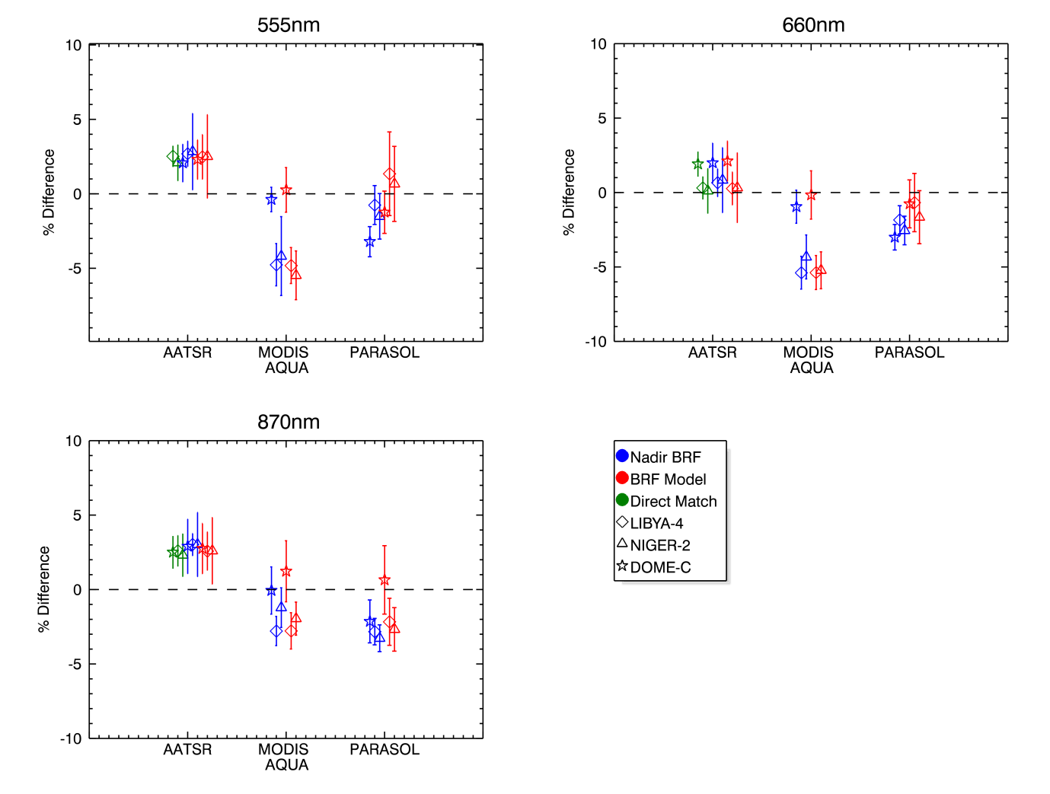
Figure 19: Intercomparisons using direct matchups, nadir BRF and full BRF model. Error bars represent the k=1 standard deviation of the differences between the measurements and reference. No corrections for systematic biases have been included in this plot.

If the systematic errors are accounted for we can see that the difference in results between desert and ice targets is reduced, Figure 20. At 660nm and 870nm for AATSR and MODIS the differences are reduced to within the uncertainties. At 555nm, there remains a difference between the desert and ice targets for MODIS. This could be because of an under-estimate of the error due to spectral response differences at this wavelength. The results for POLDER-3 show no significant change in distribution after bias adjustment as expected by the error analysis. The main cause of variability in these results is most likely due to how the methodology handles the more complex POLDER-3 geometry, and is under further investigation.

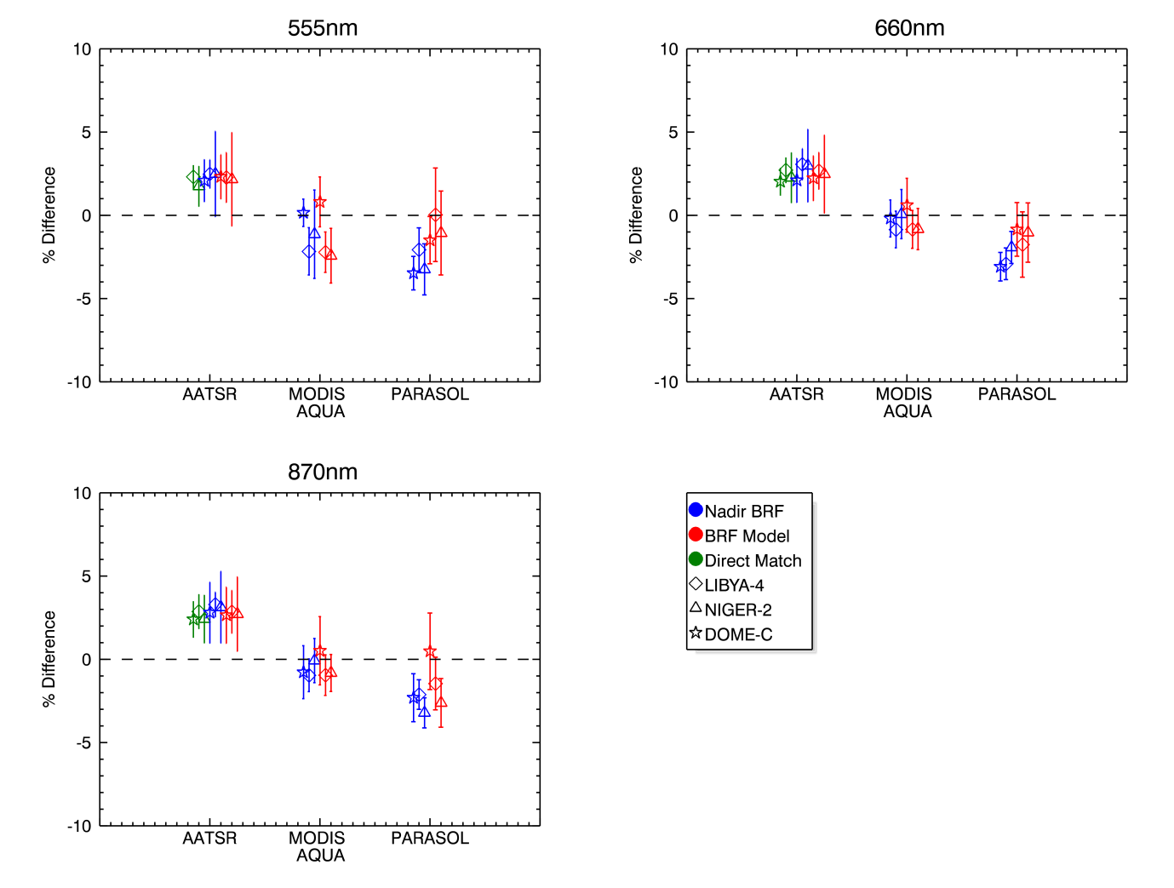
Figure 20: Intercomparisons using direct matchups, nadir BRF and full BRF model including a correction for systematic uncertainties. Error bars represent the k=1 standard deviation of the differences between the measurements and reference.

Direct Comparisons – AATSR vs MERIS only
Because AATSR and MERIS are on the same platform, simultaneous nadir observations over the site are automatically obtained for the same overpass time (within seconds) and the same view and solar geometry. In effect this is a special case of the DIMITRI comparison and is a useful test of the BRF model comparisons.

Table 24: Results of the RAL Space methodology over Libya-4 and Niger-2 for bands located around 560 nm, 660 nm and 860 nm. Results are provided for AATSR, MODIS-A and POLDER-3 using MERIS as reference sensor.
555nm
MERIS 2nd reproc vs.  Sensor | Site | N samples | Mean relative difference in % between sensor and MERIS 2nd reprocessing | Stddev of the relative difference in % | Estimated methodology Type A uncertainty (random uncertainty) | Estimated methodology Type B uncertainty (systematic uncertainty)
AATSR | DOME-C | 100 | 2.11 | 0.84 | 1.0 | -0.01
AATSR | LIBYA-4 (DIMITRI) | 105 | 2.52 | 0.71 | 1.0 | 0.21
AATSR | NIGER-2 | 159 | 2.09 | 1.22 | 1.0 | 0.35

659nm
MERIS 2nd reproc vs.  Sensor | Site | N samples | Mean relative difference in % between sensor and MERIS 2nd reprocessing | Stddev of the relative difference in % | Estimated methodology Type A uncertainty (random uncertainty) | Estimated methodology Type B uncertainty (systematic uncertainty)
AATSR | DOME-C | 100 | 1.91 | 0.84 | 1.5 | -0.11
AATSR | LIBYA-4 (DIMITRI) | 105 | 0.31 | 0.77 | 1.0 | -2.40
AATSR | NIGER-2 | 158 | 0.11 | 1.52 | 1.0 | -2.15

870nm
MERIS 2nd reproc vs.  Sensor | Site | N samples | Mean relative difference in % between sensor and MERIS 2nd reprocessing | Stddev of the relative difference in % | Estimated methodology Type A uncertainty (random uncertainty) | Estimated methodology Type B uncertainty (systematic uncertainty)
AATSR | DOME-C | 100 | 2.50 | 1.10 | 1.5 | 0.10
AATSR | LIBYA-4 (DIMITRI) | 105 | 2.60 | 1.04 | 1.0 | -0.27
AATSR | NIGER-2 | 154 | 2.31 | 1.45 | 1.0 | -0.11

Nadir BRF Comparisons
Here we apply the BRF model as described in section 3.4.2.1 but restricting the view zenith angle to within ±5° (i.e. nadir) where the azimuth dependency of the observations is assumed to be negligible. In this case there is no restriction on the date range of the sensor observations since it is assumed that the BRF of the site is time invariant. Results are shown in Table 25

Table 25: Results of the RAL Space methodology, with restriction on VZA but no restriction on date range.

555nm
MERIS 2nd reproc vs.  Sensor | Site | N samples | Mean relative difference in % between sensor and MERIS 2nd reprocessing | Stddev of the relative difference in % | Estimated methodology Type A uncertainty (random uncertainty) | Estimated methodology Type B uncertainty (systematic uncertainty)
AATSR | DOME-C | 26 | 2.07 | 1.28 | 1.0 | -0.01
AATSR | LIBYA-4 (DIMITRI) | 24 | 2.69 | 0.86 | 1.0 | 0.21
AATSR | NIGER-2 | 70 | 2.83 | 2.57 | 1.0 | 0.35
POLDER-3 | DOME-C | 14 | -3.22 | 1.01 | 1.5 | 0.26
POLDER-3 | LIBYA-4 (DIMITRI) | 36 | -0.76 | 1.31 | 1.0 | 1.31
POLDER-3 | NIGER-2 | 31 | -1.52 | 1.53 | 1.0 | 1.73
MODIS-A | DOME-C | 50 | -0.39 | 0.82 | 1.5 | -0.54
MODIS-A | LIBYA-4 (DIMITRI) | 39 | -4.77 | 1.42 | 1.0 | -2.60
MODIS-A | NIGER-2 | 54 | -4.19 | 2.65 | 1.0 | -3.05
660nm
MERIS 2nd reproc vs.  Sensor | Site | N samples | Mean relative difference in % between sensor and MERIS 2nd reprocessing | Stddev of the relative difference in % | Estimated methodology Type A uncertainty (random uncertainty) | Estimated methodology Type B uncertainty (systematic uncertainty)
AATSR | DOME-C | 26 | 1.99 | 1.34 | 1.5 | -0.11
AATSR | LIBYA-4 (DIMITRI) | 24 | 0.66 | 0.94 | 1.0 | -2.40
AATSR | NIGER-2 | 70 | 0.83 | 2.19 | 1.0 | -2.15
POLDER-3 | DOME-C | 14 | -3.01 | 0.86 | 1.5 | 0.08
POLDER-3 | LIBYA-4 (DIMITRI) | 36 | -1.84 | 0.95 | 1.0 | 1.08
POLDER-3 | NIGER-2 | 31 | -2.55 | 0.96 | 1.0 | -0.62
MODIS-A | DOME-C | 50 | -0.96 | 1.11 | 2.0 | -0.77
MODIS-A | LIBYA-4 (DIMITRI) | 39 | -5.39 | 1.10 | 1.0 | -4.53
MODIS-A | NIGER-2 | 54 | -4.33 | 1.48 | 1.0 | -4.40

865nm
MERIS 2nd reproc vs.  Sensor | Site | N samples | Mean relative difference in % between sensor and MERIS 2nd reprocessing | Stddev of the relative difference in % | Estimated methodology Type A uncertainty (random uncertainty) | Estimated methodology Type B uncertainty (systematic uncertainty)
AATSR | DOME-C | 26 | 2.90 | 1.84 | 1.5 | 0.10
AATSR | LIBYA-4 (DIMITRI) | 24 | 3.02 | 0.75 | 1.0 | -0.27
AATSR | NIGER-2 | 70 | 3.02 | 2.16 | 1.0 | -0.11
POLDER-3 | DOME-C | 14 | -2.15 | 1.44 | 1.5 | 0.16
POLDER-3 | LIBYA-4 (DIMITRI) | 36 | -2.83 | 0.89 | 1.0 | -0.71
POLDER-3 | NIGER-2 | 31 | -3.28 | 0.90 | 1.0 | -0.06
MODIS-A | DOME-C | 50 | -0.07 | 1.59 | 1.5 | 0.71
MODIS-A | LIBYA-4 (DIMITRI) | 39 | -2.79 | 0.98 | 1.0 | -1.83
MODIS-A | NIGER-2 | 54 | -1.22 | 1.33 | 1.0 | -1.14

Full BRF Comparisons
We apply the BRF model as described in section 3.4.2.1 to the full range of view and solar geometry of the reference sensor. Data are screened so that any measurements outside the valid range are not included in the comparison. There is no restriction on the date range of the sensor observations since it is assumed that the BRF of the site is time invariant. Results are shown in Table 26.

Table 26: Full BRF comparison results.

555nm
MERIS 2nd reproc vs.  Sensor | Site | N samples | Mean relative difference in % between sensor and MERIS 2nd reprocessing | Stddev of the relative difference in % | Estimated methodology Type A uncertainty (random uncertainty) | Estimated methodology Type B uncertainty (systematic uncertainty)
AATSR | DOME-C | 45 | 2.30 | 1.33 | 1.0 | -0.01
AATSR | LIBYA-4 (DIMITRI) | 93 | 2.48 | 1.50 | 1.0 | 0.21
AATSR | NIGER-2 | 212 | 2.51 | 2.80 | 1.0 | 0.35
POLDER-3 | DOME-C | 72 | -1.24 | 1.42 | 1.5 | 0.26
POLDER-3 | LIBYA-4 (DIMITRI) | 324 | 1.34 | 2.81 | 1.0 | 1.31
POLDER-3 | NIGER-2 | 271 | 0.66 | 2.52 | 1.0 | 1.73
MODIS-A | DOME-C | 256 | 0.26 | 1.50 | 1.5 | -0.54
MODIS-A | LIBYA-4 (DIMITRI) | 114 | -4.82 | 1.21 | 1.0 | -2.60
MODIS-A | NIGER-2 | 115 | -5.48 | 1.64 | 1.0 | -3.05
660nm
MERIS 2nd reproc vs.  Sensor | Site | N samples | Mean relative difference in % between sensor and MERIS 2nd reprocessing | Stddev of the relative difference in % | Estimated methodology Type A uncertainty (random uncertainty) | Estimated methodology Type B uncertainty (systematic uncertainty)
AATSR | DOME-C | 45 | 2.11 | 1.35 | 1.5 | -0.11
AATSR | LIBYA-4 (DIMITRI) | 93 | 0.27 | 1.10 | 1.0 | -2.40
AATSR | NIGER-2 | 212 | 0.32 | 2.34 | 1.0 | -2.15
POLDER-3 | DOME-C | 72 | -0.77 | 1.61 | 1.5 | 0.08
POLDER-3 | LIBYA-4 (DIMITRI) | 324 | -0.68 | 1.96 | 1.0 | 1.08
POLDER-3 | NIGER-2 | 271 | -1.66 | 1.78 | 1.0 | -0.62
MODIS-A | DOME-C | 256 | -0.17 | 1.62 | 2.0 | -0.77
MODIS-A | LIBYA-4 (DIMITRI) | 112 | -5.38 | 1.14 | 1.0 | -4.53
MODIS-A | NIGER-2 | 116 | -5.23 | 1.24 | 1.0 | -4.40

870nm
MERIS 2nd reproc vs.  Sensor | Site | N samples | Mean relative difference in % between sensor and MERIS 2nd reprocessing | Stddev of the relative difference in % | Estimated methodology Type A uncertainty (random uncertainty) | Estimated methodology Type B uncertainty (systematic uncertainty)
AATSR | DOME-C | 45 | 2.75 | 1.69 | 1.5 | 0.10
AATSR | LIBYA-4 (DIMITRI) | 93 | 2.58 | 1.28 | 1.0 | -0.27
AATSR | NIGER-2 | 212 | 2.60 | 2.23 | 1.0 | -0.11
POLDER-3 | DOME-C | 72 | 0.64 | 2.30 | 1.5 | 0.16
POLDER-3 | LIBYA-4 (DIMITRI) | 324 | -2.17 | 1.58 | 1.0 | -0.71
POLDER-3 | NIGER-2 | 271 | -2.68 | 1.46 | 1.0 | -0.06
MODIS-A | DOME-C | 256 | 1.22 | 2.05 | 1.5 | 0.71
MODIS-A | LIBYA-4 (DIMITRI) | 112 | -2.78 | 1.22 | 1.0 | -1.83
MODIS-A | NIGER-2 | 114 | -1.96 | 1.11 | 1.0 | -1.14

Intercomparison of the results of the methodologies
In Figure 21, a summary of the results for all methodologies, sites and spectral bands is given. These 3 plots give the mean relative difference over the 2006-2009 period obtained from each methodology between each sensor radiometry and the MERIS 2nd reprocessing data. The error bar is NOT the associated uncertainty, it is simply the standard deviation obtained from the same data with which the mean difference is computed.
In Figure 22, the same results than in Figure 21 are presented but with a correction for the Type B uncertainties obtained for the DIMITRI and RAL methodologies (as given in Table 7 and Table 15 respectively).

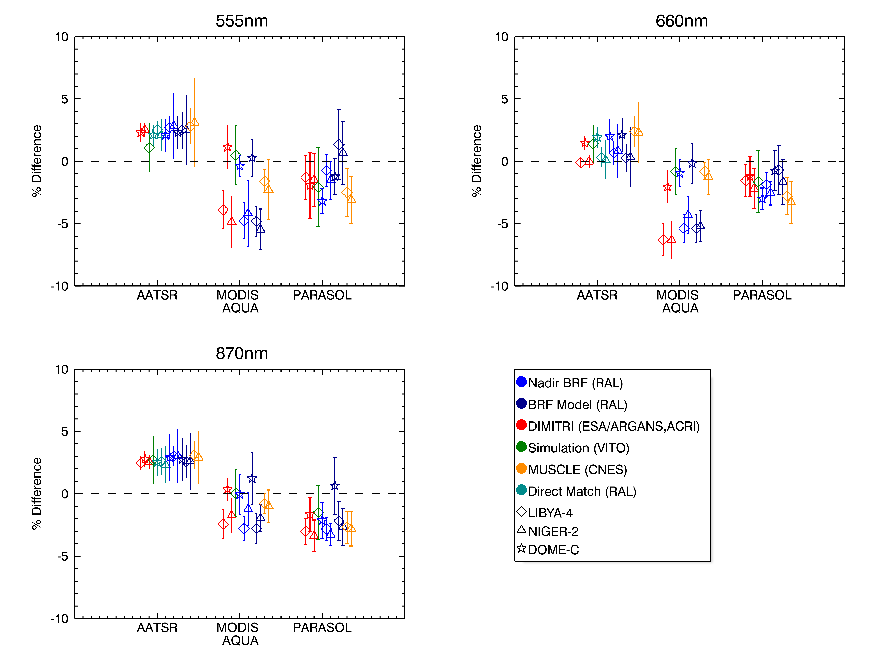
Figure 21: Summary of the intercomparison of all methodologies showing the mean relative difference between a given sensor and MERIS expressed in percent. The error bar is the associated standard deviation expressed in percent. No correction for Type B uncertainties is applied.

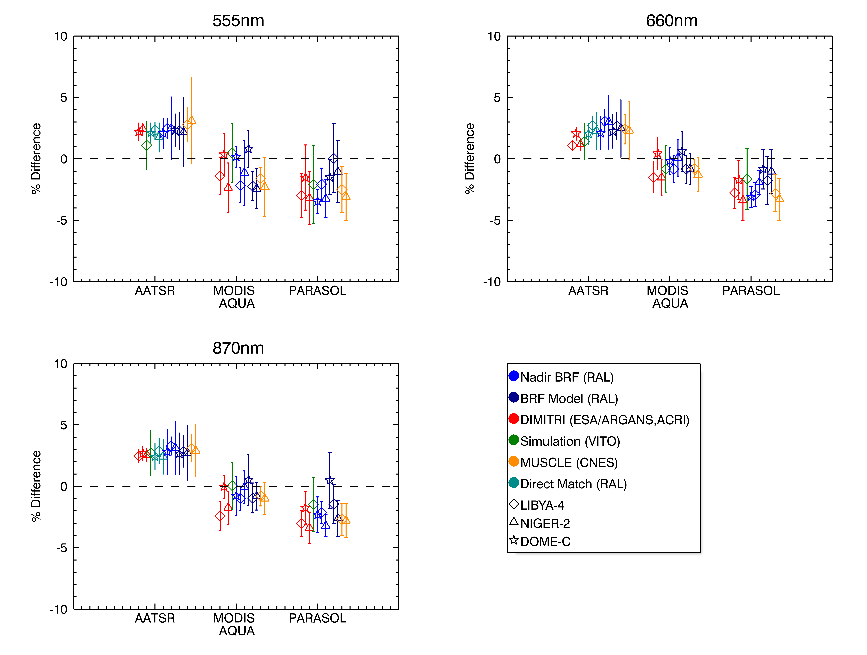
Figure 22: Summary of the intercomparison of all methodologies showing the mean relative difference between a given sensor and MERIS expressed in percent. The error bar is the associated standard deviation expressed in percent. A correction for Type B uncertainties is applied to the RAL methodologies and to the DIMITRI methodology.

Discussion
In Figure 21, the standard deviation associated to the calculation of the mean relative difference between each sensor and the MERIS 2nd reprocessing data is given as error bar. It should however be emphasized that this standard deviation is not meant to provide an actual uncertainty estimate. Such standard deviation figures differ from what should be the (Type A and/or Type B) uncertainties associated to the mean relative difference between each sensor and the MERIS 2nd reprocessing. Type A and B uncertainties are not available for all methodologies presented in this document and these could thus not all be displayed consistently across methodologies on the same plots. It was actually not the purpose of this work to derive uncertainties associated to each methodology but rather to compare the results of all methodologies at the level of mean radiometric differences relative to the MERIS 2nd reprocessing data. The provided standard deviations associated to these mean relative radiometric differences between sensors and MERIS 2nd reprocessing are only meant to provide the reader with a guess estimate of the variability associated with the calculation of these mean radiometric differences.
One of the objectives of the comparison was to identify differences in results from the two desert sites due to the presence of dunes. We do not find significant differences in results for each methodology over these two sites.
Methodologies that do NOT take into account the difference in spectral responses between instruments when comparing similar spectral bands (DIMITRI and RAL) produce mean relative differences between sensors and MERIS 2nd reprocessing that appear to be site dependant. Indeed, while the results over the desert sites Niger-2 and Libya-4 are consistent for all methodologies, they differ significantly from those obtained over Dome C. The discrepancies in mean relative differences are particular pronounced for the MODIS bands. Of all other sensors (AATSR and POLDER-3) band, the MODIS band spectral responses differ most from the MERIS bands (see for instance Figure 1). The observed discrepancies between Dome C and the two desert sites are however well explained by the estimated Type B uncertainties of the DIMITRI and RAL methodologies (see Figure 15 and Table 7). This emphasises the need for correcting for differences in spectral responses between similar bands from different sensors before drawing conclusions on their relative calibration differences. Such provided Type B estimates give confidence that if the RAL and DIMITRI methodologies included a correction for such spectral response differences, their results would be consistent to within 2-3% with those provided by OSCAR and SADE/MUSCLE. This can also be formulated differently: when the differences between a given sensors spectral response and the corresponding MERIS band spectral response have a marginal impact, all methodologies give consistent results to within 2-3 %. This is a remarkable result.

Conclusions of the intercomparison
The following conclusions are drawn from this intercomparison:
- Having used the reference datasets for the comparison of methodologies gives confidence that the differences between results are actually due to the methodologies themselves rather than the site selection methods, cloud screening scheme or radiometric correction applied to the native L1 data.
- The different methodologies here compared give results consistent within the 2-3 % random uncertainty estimates of the methodologies, as long as the impact of differences between sensor spectral responses is accounted for.
- The use of different scene types with different spectral characteristics (ice, snow) is beneficial to test assumptions embedded in vicarious calibration and radiometric intercomparison methodologies.

Lessons learned
The lessons learned in the frame of the CEOS/IVOS WG4 on pseudo-invariant sites are:
- Generating a reference dataset to intercompare methodologies is key to the success of such type of intercomparisons;
- The verification of the reference dataset must be carefully carried out (we used the comparison of DIMITRI and SADE extractions as a verification tool);
- A clear definition of the protocol of the intercomparison and its outputs must be defined prior to the intercomparisons;
- Participating to such intercomparisons leads to the identification of possible improvements of the respective methodologies.

General recommendations to CEOS/IVOS
- A similar intercomparison protocol could be applied to other similar working groups. In short it should consist of: the definition of a reference dataset, the definition of methodology outputs on the basis of which methodologies should be compared, the reporting of results and making available publically both the reference dataset and the generated report.
- Better characterisation of the sites would lead to improved uncertainty budgets for the methodologies and possibly improvement of methodologies.
- CEOS/IVOS could consider extending the work carried out in this study to the high spatial resolution sensors.

Interested in exploiting the reference dataset? How to proceed?
The generated reference dataset (detailed in Section 2.4) is publically available on the Cal/Val portal at http://calvalportal.ceos.org/cvp/web/guest/ivos/WG4; the downloadable archive “CEOS_IVOS_WG_RefDataset_20120711.zip” includes:
- Libya4.zip: the reference dataset over Libya-4 for all sensors generated using DIMITRI
- DomeC.zip: the reference dataset over Dome-C for all sensors generated using DIMITRI
- Niger2.zip: the reference dataset over Niger-2 for all sensors generated using SADE, and AATSR data provided by RAL
- Spectral_Response.zip: the spectral response for each band for each sensor (using instrument band numbering). Each file is a semi-colon delimited CSV file which contains two columns; the hyperspectral wavelengths, and the corresponding band spectral response.
Should you extract L1 data from other sensors over the same sites than those present in the reference dataset, please make them available in the reference dataset format together with the results (=data+report) of your analysis to marc.bouvet@esa.int for further inclusion on the Cal/Val portal.

What could be further investigated with the same reference dataset and methodologies?
Because of limited time and resources, the work presented in this document was intentionally restricted to the comparison of the methodology outputs at 3 spectral bands. More work could be carried than what was presented in the document by further exploiting the references dataset to further compare the output of the various methodologies by extending the analysis to:
- The sensor blue bands;
- The sensor SWIR bands;
- The large spectral bands of VEGETATION;
- Bands that are too far apart from each other to be directly compared without any spectral correction.
The reference dataset could also be used to investigate, for each methodology, what is the shortest time series of data from two sensors required to reach the conclusions resulting from the exploitation of the full 4-year time series. This could prove relevant when selecting methodologies most appropriate for the commissioning phase of future instruments.
Of course, new methodologies can be tested using this reference dataset and in combination with the present report they can be compared to those here presented.

References
L. Bourg, L. D’Alba, P. Colagrande, 2008. MERIS Smile Effect Characterization and Correction. http://earth.eo.esa.int/pcs/envisat/meris/documentation/MERIS_Smile_Effect.pdf.
M. Bouvet, 2006. Intercomparison of imaging spectrometers over the Salar de Uyuni (Bolivia). Proceedings of the 2nd working group meeting on MERIS and AATSR calibration and geophysical validation (MACT-2006), 20-24 March, 2006. ESRIN, Frascati, Italy (ESA SP-615, July, 2006).
M. Bouvet, 2008. Radiometric intercomparison of multi-spectral imagers over natural targets, Methodology, application and outlook, Proceedings of the 2008 MERIS AATSR Validation Team Workshop, 22-26 September, ESRIN, Frascati, Italy, 2008.
M. Bouvet and F. Ramoino, 2010. Radiometric intercomparison of AATSR, MERIS, and Aqua MODIS over Dome Concordia (Antarctica), Can. J. Remote Sensing, vol. 36, no. 5, pp. 464–473, 2010.
Cosnefroy, H., Briottet, et al. (1997). "A field experiment in Saharan Algeria for the calibration of optical satellite sensors." Int. J. Remote Sensing 18(16): 3337-3359.
Govaerts, Y. M. and M. Clerici (2004). "Evaluation of radiative transfer simulations over bright desert calibration sites." IEEE Transactions on Geoscience and Remote Sensing 42(1): 176--187.
A. K. Heidinger, William C. Straka III, Christine C. Molling, Jerry T. Sullivan & Xiangqian Wu (2010): Deriving an inter-sensor consistent calibration for the AVHRR solar reflectance data record, International Journal of Remote Sensing, 31:24, 6493-6517
P. Henry and A. Meygret, 2001, Calibration of HRVIR and VEGETATION cameras on SPOT4, Adv. Space Res., vol. 28, pp. 49-58, 2001.
Kotchenova, S. Y., E. F. Vermote, et al. (2006). "Validation of a vector version of the 6S radiative transfer code for atmospheric correction of satellite data. Part I: Path radiance." Applied Optics 45: 6762-6774.
Kotchenova, S. Y. and E. F. Vermote (2007). "Validation of a vector version of the 6S radiative transfer code for atmospheric correction of satellite data. Part II. Homogeneous Lambertian and anisotropic surfaces." Applied Optics 46: 4455-4464.
R. Irish, J. Barker, S. Goward and T. Arvidson, 2006. Characterization of the Landsat-7 ETM+ Automated Cloud-Cover Assessment (ACCA) Algorithm. Photogrammetric Engineering & Remote Sensing, Vol. 72, No. 10, October 2006, pp. 1179–1188
G. Lissens, P. Kempeneers and F. Fierens, Development of a cloud, snow and cloud shadow mask for VEGETATION imagery. http://www.vgt.vito.be/index.html
F. Ranera, S. Plummer and O. Arino, 2005. A pragmatic solution for cloud detection and removal in meris l1b data. Proceeding paper from the 2005 MERIS/AATSR workshop. http://envisat.esa.int/workshops/meris_aatsr2005/participants/325/paper_MERIS_cloud_MER-AATSR.pdf
J. Roujean, M. Leroy and P.Y. Deschamps, 1992. A bidirectional reflectance model of the Earth’s surface for the correction of remote sensing data, Journal of Geophysical Research, 97(DIS), 20.455-20.468
D.L. Smith and C.T. Mutlow and C.R.N. Rao “Calibration Monitoring of the Visible and Near-Infrared Channels of Along-Track Scanning Radiometer-2 (ATSR-2) using Stable Terrestrial Sites”, Applied Optics, 41 no 3, 515-523, 2002
D. Smith and C. Poulsen, 2010. How to Apply the AATSR VIS-SWIR Calibration Corrections. http://www.aatsrops.rl.ac.uk/EDSX/OtherInfo/.
D. Smith and C. Cox, “(A)ATSR Solar Channel On-Orbit Radiometric Calibration’, 2012, Submitted to TGRS

Annexes

Comparison between DIMITRI and SADE L1 TOA extractions over Libya-4

Objective
The L1 extractions stored in the reference dataset over Dome-C and Libya-4 are all coming from DIMITRI. The objective of the work presented in this section was to assess the quality of the data over Libya 4 in the reference dataset by comparing them to similar extractions coming from the CNES SADE database.

Introduction
DIMITRI and SADE are both databases containing long time series of L1 products from a number of sensors over numerous terrestrial sites. Both DIMITRI and SADE allow reading of these products and extracting TOA reflectance averaged over a region of interest (ROI) defined on each one of these terrestrial sites. One might expect that for a common sensor and over a common site, data extracted from both databases, i.e., the time series of L1 TOA reflectances averaged of the ROI would be strictly identical. However, these time series of extractions can actually differ for several reasons. For instance, the original L1 products from which time series of extractions are produced differ, e.g.: while DIMITRI ingests the MERIS, L1b products as delivered to all MERIS users, SADE ingests MERIS L1b data in the so-called METRIC format produced by ESA but distributed to Cal/Val users only. Similarly, DIMITRI ingests VEGETATION-2 data as delivered to all users by VITO while SADE is fed with radiometrically uncalibrated VEGETATION-2 products that are not delivered to users. Moreover, there is not necessarily the same number of L1 products ingested in each database for a given sensor, over a given time period and over a given site because data ingested in each system have been retrieved from difference distribution sources and via different protocols. Radiometric correction to turn the original L1 TOA signals into TOA reflectance also slightly differ between the two systems (e.g., the so-called smile irradiance correction is applied to MERIS L1b data extracted by DIMITRI, while it is not in SADE). The cloud screening procedures used in each system also differ.

DIMITRI and SADE number of extractions over Libya 4
The reference dataset provides L1 TOA reflectance extraction over Libya-4 from both DIMITRI and SADE. Such duplication gives a unique opportunity to compare the extractions from both systems.
In Table 27, the number of extractions from each system over this site between 2006 to 2009 (4 years of data) is given. The number of extractions in each system is generally comparable. For MERIS, MODIS-A and VGT-2, 337, 518 and 596 extractions respectively can be matched in both systems using their acquisition times. It is more difficult to unambiguously match POLDER-3 extractions from SADE and DIMITRI only using the corresponding acquisition times registered in each database. POLDER-3 possesses a multi-view capability. For each site observed, 16 observation geometries are obtained at slightly different times. Each one is considered an independent acquisition in both SADE and DIMITRI (which explains the large number of extractions in Table 27 compared to other sensors). In addition, the multispectral and multipolarisation acquisitions corresponding to each observation geometry are obtained with rotating wheels of filters and polarisers, at each step, a slightly different viewing geometry and illumination are associated. SADE extractions are provided assuming the rotating wheel speed is fast enough to associate the same viewing geometry to all spectral bands, whereas in DIMITRI extraction, the exact VZA and view azimuth angle (VAA) corresponding to each spectral band viewing geometry are given. Moreover, in both systems, the acquisition time each spectral band is the same. Unfortunately, it was found that these acquisition times systematically differ between SADE and DIMITRI by an average of 333 seconds (and an associated standard deviation of 60 seconds). This is most likely due to an erroneous reading of the acquisition time over the region of interest in one of the two databases. While these inaccuracies in associating acquisition time and geometry to each measurement have no impact on vicarious calibration geometries that only rely on the observational geometry rather than the actual acquisition time, it makes the process of finding common extraction between DIMITRI and SADE rather difficult because they cannot be exactly matched temporally or angularly. One thus needs to set temporal and angular windows to match extraction from each database. 1154 extractions from SADE and DIMITRI were found with reported acquisition times not differing by more than 500 seconds and for which the VZA, VAA, SZA and solar azimuth angle (SAA) do not differ by more than 1 degree. It is not understood why the proportion of common POLDER-3 acquisitions between the two databases is low compared to other sensors.
Table 27: The number of L1 TOA reflectance extractions obtained after cloud screening and averaging over the Libya 4 site, for each sensor and for each database. The last column indicates the number of common extractions (i.e., from the same original L1 acquisition of the given sensor)
 | SADE | DIMITRI | Common
MODIS-A | 633 | 880 | 518
MERIS | 408 | 384 | 337
VEGETATION-2 | 907 | 740 | 596
POLDER-3 | 6552 | 4235 | 1154(?)

Comparison of DIMITRI and SADE acquisition times associated to the TOA reflectance extractions over Libya 4
For each one of the TOA reflectance extraction common to both SADE and DIMITRI we compare the associated acquisition time and provide in Table 28 the mean difference and the associated standard deviation. While the differences are marginal for VEGETATION-2 and MODIS-A, they are significant for MERIS and POLDER-3. It not understood where these differences come from. They might be explained by differing approach in SADE and DIMITRI in extracting the acquisition times (e.g.: the time associated to the first line of acquisition in the original L1 product rather than the actual time over the region of interest).
Table 28: The differences in acquisition times associated to the L1 TOA reflectance extractions that are common to SADE and DIMITRI
Sensor | Mean difference in acquisition times (SADE-DIMITRI) in secs | Standard deviation of the difference in acquisition time between SADE and DIMITRI
MODIS-A | 0.3 | 0.43
MERIS | 23 | 12
POLDER-3 | 333 | 60
VEGETATION-2 | 0.7 | 0.45

Comparison of DIMITRI and SADE angular information associated to the TOA reflectance extractions over Libya 4
For each one of the TOA reflectance extractions common to both SADE and DIMITRI we compare the associated viewing and sun angles. Results of such comparisons are provided in Table 29 to Table 32 by giving the mean difference and the associated standard of the SZA, the SAA, the VZA and the VAA respectively.
The largest differences between the two databases are found for the VAA, in particular for MERIS, VEGETATION-2 and MODIS-A. Detailed investigation reveals that for near nadir viewing geometry, the difference between SADE and DIMITRI VAA associated to the TOA reflectance extractions can read up to 15 degrees while it remains below 1 degree for off nadir viewing geometries. It is suspected that such differences are due to the difference in computing/extracting a representative VAA value over the region of interest as in near nadir configuration the VAA can change by 180 degrees from a pixel to the next.

Table 29: The differences in SZA associated to the L1 TOA reflectance extractions that are common to SADE and DIMITRI
Sensor | Mean SZA difference SADE-DIMITRI in degrees | Standard deviation of the SZA difference in degrees
MERIS | 0.00 | 0.00
MODIS-A | 0.00 | 0.00
POLDER-3 | -0.05 | 0.025
VGT-2 | 0.01 | 0.11

Table 30: The differences in SAA associated to the L1 TOA reflectance extractions that are common to SADE and DIMITRI
Sensor | Mean SAA difference SADE-DIMITRI in degrees | Standard deviation of the SAA difference in degrees
MERIS | 0.01 | 0.01
MODIS-A | 0.00 | 0.00
POLDER-3 | -0.02 | 0.38
VGT-2 | 0.1 | 0.35

Table 31: The differences in VZA associated to the L1 TOA reflectance extractions that are common to SADE and DIMITRI. Note that for POLDER-3 the acquisition time and viewing geometry in each spectral band is not simultaneous. Both DIMITRI and SADE thus provide viewing geometry angles for each spectral band. The highest figure in terms of mean difference for all bands is thus given in this table.
Sensor | Mean VZA difference SADE-DIMITRI in degrees | Standard deviation of the VZA difference in degrees
MERIS | -0.1 | 0.44
MODIS-A | 0.00 | 0.00
POLDER-3 | Less than 0.06 in absolute terms for all bands | Less than 0.8 for all bands
VGT-2 | 0.24 | 0.29

Table 32: The differences in VAA associated to the L1 TOA reflectance extractions that are common to SADE and DIMITRI. Note that for POLDER-3 the acquisition time and viewing geometry in each spectral band is not simultaneous. Both DIMITRI and SADE thus provide viewing geometry angles for each spectral band. The highest figure in terms of mean difference for all bands is thus given in this table.
Sensor | Mean VAA difference SADE-DIMITRI in degrees | Standard deviation of the VAA difference in degrees
MERIS | 0.61 | 2.35
MODIS-A | -0.23 | 1.12
POLDER-3 | Less than 0.31 in absolute terms for all bands | Less than 1.67 for all bands
VGT-2 | 0.51 | 3.15

Radiometric comparison: DIMITRI and SADE TOA reflectance extractions over Libya 4
Extractions that are common to both database can be directly compared at TOA reflectance level. The mean relative difference and coefficient of variation of the differences between the two databases are extracted for each spectral band of MERIS, MODIS-A, POLDER-3 and VEGETATION-2. They are presented in Table 33 to Table 36. For MERIS band at 761 nm, the mean TOA reflectance difference between SADE and DIMITRI is 0.4 %. For all other sensors and bands, the mean difference is below 0.2 %. In addition, no significant temporal trend in these time series of the differences between SADE and DIMITRI extractions is observed (not shown here).
Coefficients of variation are lower than 0.35 % for all MERIS bands, lower than 0.20 % for all A-MODIS bands compared, lower than 0.85 % for all POLDER-3 bands and lower than 0.40 % for all VEGETATION-2 bands. The coefficients of variation indicate that for a relatively rare number of the cases, direct comparison of extractions at TOA reflectance level from SADE and DIMITRI can lead to differences greater than 2 %, arguably the lower limit of absolute vicarious calibration methodology uncertainty. However, the mean relative differences over the 4 year period between DIMITRI and SADE TOA reflectance extractions are about an order of magnitude lower than such arguable absolute vicarious calibration uncertainty.
Table 33: Mean relative difference at TOA reflectance level for the common extractions to SADE and DIMITRI over Libya 4, for the period 2006 to 2009 inclusive, for MERIS. DIMITRI TOA reflectance extractions are arbitrarily chosen as references
MERIS bands | Mean TOA reflectance relative difference (SADE-DIMITRI)/DIMITRI in %: | Coefficient of variation of TOA reflectance difference in %
412 | -0.12% | 0.10%
443 | -0.08% | 0.35%
490 | -0.05% | 0.13%
510 | -0.09% | 0.17%
560 | -0.08% | 0.14%
620 | -0.08% | 0.07%
681 | -0.08% | 0.1%
709 | -0.09% | 0.06%
754 | -0.08% | 0.05%
761 | -0.4% | 0.07%
778 | -0.08% | 0.12%
865 | -0.12% | 0.11%
885 | -0.07% | 0.06%
900 | -0.1% | 0.05%
Table 34: Mean relative difference at TOA reflectance level for the common extractions to SADE and DIMITRI over Libya 4, for the period 2006 to 2009 included, for MODIS-A. DIMITRI TOA reflectance extractions are arbitrarily chosen as references
MODIS-A bands | Mean TOA reflectance relative difference (SADE-DIMITRI)/DIMITRI in %: | Coefficient of variation of TOA reflectance difference in %
412 | 0.08% | 0.20%
443 | 0.13% | 0.17%
469 | 0.18% | 0.15%
488 | 0.02% | 0.19%
555 | 0.17% | 0.08%
645 | 0.09% | 0.07%
858 | 0.08% | 0.07%
1240 | 0.00% | 0.07%
1640 | 0.01% | 0.1%
2130 | 0.03% | 0.14%

Table 35: Mean relative difference at TOA reflectance level for the common extractions to SADE and DIMITRI over Libya-4, for the period 2006 to 2009 included, for POLDER-3. DIMITRI TOA reflectance extractions are arbitrarily chosen as references
POLDER-3 bands | Mean TOA reflectance relative difference (SADE-DIMITRI)/DIMITRI in %: | Coefficient of variation of TOA reflectance difference in %
443 | -0.03% | 0.84%
490 | -0.07% | 0.51%
565 | 0.14% | 0.35%
670 | 0.1% | 0.27%
763 | 0.08% | 0.27%
765 | 0.06% | 0.26%
865 | 0.06% | 0.25%
910 | 0.09% | 0.37%
1020 | 0.01% | 0.25%

Table 36: Mean relative difference at TOA reflectance level for the common extractions to SADE and DIMITRI over Libya-4, for the period 2006 to 2009 included, for VEGETATION-2. DIMITRI TOA reflectance extractions are arbitrarily chosen as references
VGT-2 bands | Mean TOA reflectance relative difference (SADE-DIMITRI)/DIMITRI in %: | Coefficient of variation of TOA reflectance difference in %
450 | -0.12% | 0.39%
650 | 0.16% | 0.32%
850 | 0.16% | 0.26%
1670 | 0.05% | 0.13%

Conclusion of the comparison of DIMITRI and SADE extractions over Libya 4
From the comparison of SADE and DIMITRI extractions over Libya 4 we can conclude that:
- Both databases are similarly densely populated
- There are minor systematic differences in acquisition times associated to the TOA extractions for A-MODIS and VEGETATION-2 (<1 second) but larger systematic differences for MERIS (23 seconds) and POLDER-3 (333 seconds). Such differences between the two databases could lead to divergences when applying methodologies that require highly accurate acquisition times to match two sensor acquisitions up or to match a sensor acquisition with time tagged in-situ data.
- Systematic differences between the two databases in SZA and SAA are below 0.1 degrees for all sensors
- Systematic differences between the two databases in VZA and VAA are below 1 degree but can reach up to 15 degrees in VAA for near nadir observations.
Arguably the most important conclusion of this analysis SADE and DIMITRI produce TOA reflectance extractions for all sensors with systematic differences below 0.2 %. Such systematic difference is an order of magnitude lower than the generally admitted absolute vicarious calibration methodology uncertainty and sensor-to-sensor radiometric intercomparison methodology uncertainty. However, from a radiometric point of view, both databases thus provide TOA reflectance extractions of comparable quality. This is remarkable given the fact that SADE and DIMITRI L1 data were in some cases retrieved from different providers and in different format treatment, but also because SADE/MUSCLE and DIMITRI cloud screening and sensor radiometric corrections (e.g.: smile correction for MERIS or AATSR radiometric correction) differ in their algorithm and/or implementation.

Comparison of OSCAR results based on DIMITRI and SADE extractions over Libya (YG)
In this section of the Annex, the results obtained from the OSCAR methodology are given for the two versions of the reference dataset over Libya-4: the one obtained from extractions coming from the SADE database and the one coming from the DIMITRI database. The objective of this exercise is to understand if the differences between the two versions of the Libya-4 dataset due to differences in cloud screening, radiometric correction of the L1 or origin of the native L0/L1 products in DIMITRI and SADE has a significant impact on a methodology like OSCAR.
The number of acquisitions in each version of the reference dataset are given in Table 37. Results of the OSCAR methodology are visually given in Figure 23 and as a table in are given in Table 38.
The conclusion of this exercise is that the OSCAR methodology does not produce significantly different results from the SADE and DIMITRI datasets compared to the methodology uncertainty. It can be noted however that there appear to be slightly less differences between the simulated and measured MODIS-A, MERIS and POLDER-3 data from the SADE data set than from the DIMITRI ones.

Table 37: Number of observations in the reference dataset during the 2006–2009 period over Libya-4 used for the OSCAR simulations. Observations for which the difference to the simulations differed by more than 2-sigma were discarded (which explains why the numbers here presented differ from those in Table 27). For the SADE data set, AATSR data acquired directly by RAL have been used.
DIMITRI
BAND | 0.44μm | 0.55 μm | 0.66 μm | 0.84 μm | 1.62 μm
VEGETATION | 723 |  | 700 | 709 | 695
AATSR |  | 114 | 117 | 119 | 120
POLDER-3 | 4078 | 4072 | 4225 | 4205
MODIS-A | 848 | 864 | 846 | 839 | 822
MERIS | 371 | 378 | 372 | 367
CNES
VEGETATION | 862 |  | 877 | 871 | 869
AATSR | 201 | 198 | 197 | 197
POLDER-3 | 6313 | 6296 | 6298 | 6308
MODIS-A | 613 | 613 | 612 | 618 | 598
MERIS | 393 | 402 | 406 | 402

Figure 23: Overall results of the ratio between the actual observation and the 6S-v simulated observation for the over the Libya-4 site. Top: with the DIMITRI data set . Bottom: with the SADE data set.

Table 38: Ratio between satellite derived TOA BRFs and 6S-V simulations estimated in the common spectral intervals over Libya-4.

DIMITRI
BAND | 0.44μm | 0.55 μm | 0.66 μm | 0.84 μm | 1.62 μm
VEGETATION | 1.008 |  | 0.969 | 0.975 | 0.989
AATSR |  | 1.039 | 1.028 | 1.042 | 1.038
POLDER-3 | 1.031 | 1.007 | 0.998 | 1.000
MODIS-A | 1.036 | 1.032 | 1.008 | 1.017 | 1.024
MERIS | 1.026 | 1.028 | 1.014 | 1.015
SADE
VEGETATION | 1.007 |  | 0.969 | 0.977 | 0.987
AATSR |  | 1.041 | 1.030 | 1.043 | 1.039
POLDER-3 | 1.036 | 1.010 | 0.998 | 1.000
MODIS-A | 1.028 | 1.022 | 0.997 | 1.007 | 1.019
MERIS | 1.021 | 1.018 | 1.007 | 1.007
.

Full results of the application of the SADE/MUSCLE methodology to the reference dataset
In this Annex, the full suite of results obtained from the SADE/MUSCLE methodology described in 3.3.1 is presented (Table 39). It follows the same format than the results presented in section 4.4. In addition to the bands around 560 nm, 660 nm and 860 nm more bands are hereafter compared. In addition, where relevant, VEGETATION-2 is also compared to the radiometric scale.

Table 39: Results of the SADE/MUSCLE methodology for pseudo-invariant sites for AATSR, MODIS-A, POLDER-3 and VEGETATION-2 by taking MERIS as a reference sensor. Results are shown for bands from 412 nm to 1020 nm
412 nm:
Sensor | Site | N samples | Mean relative difference in % between sensor and MERIS 2nd reprocessing | Stddev of the relative difference in % | Estimated methodology uncertainty on mean relative difference in %
MODIS-A | LIBYA-4 | 139 | -0.8% | 1.9% | 3%
MODIS-A | NIGER-2 | 97 | -0.5% | 3.9% | 3%
443 nm:
Sensor | Site | N samples | Mean relative difference in % between sensor and MERIS 2nd reprocessing | Stddev of the relative difference in % | Estimated methodology uncertainty on mean relative difference in %
POLDER-3 | LIBYA-4 | 216 | -4.3% | 3.3% | 5%
POLDER-3 | NIGER-2 | 240 | -3.8% | 3.5% | 5%
MODIS-A | LIBYA-4 | 139 | -0.2% | 1.2% | 3%
MODIS-A | NIGER-2 | 97 | +0.1% | 3.0% | 3%
470 nm:
Sensor | Site | N samples | Mean relative difference in % between sensor and MERIS 2nd reprocessing | Stddev of the relative difference in % | Estimated methodology uncertainty on mean relative difference in %
MODIS-A | LIBYA-4 | 139 | -1.4% | 1.0% | 3%
MODIS-A | NIGER-2 | 97 | -1.4% | 2.6% | 3%
VGT 2 | LIBYA-4 | 124 | -3.5% | 2.4% | 3%
VGT 2 | NIGER-2 | 180 | -2.6% | 3.7% | 3%

490 nm:
Sensor | Site | N samples | Mean relative difference in % between sensor and MERIS 2nd reprocessing | Stddev of the relative difference in % | Estimated methodology uncertainty on mean relative difference in %
POLDER-3 | LIBYA-4 | 216 | -3.8% | 2.3% | 3%
POLDER-3 | NIGER-2 | 240 | -4.5% | 2.8% | 3%
MODIS-A | LIBYA-4 | 139 | +0.2% | 1.0% | 5%
MODIS-A | NIGER-2 | 97 | -1.0% | 2.4% | 5%
560 nm:
Sensor | Site | N samples | Mean relative difference in % between sensor and MERIS 2nd reprocessing | Stddev of the relative difference in % | Estimated methodology uncertainty on mean relative difference in %
AATSR | LIBYA-4 | 139 | +2.8% | 1.4% | 2%
AATSR | NIGER-2 | 98 | +3.1% | 3.5% | 2%
POLDER-3 | LIBYA-4 | 216 | -2.5% | 1.9% | 2.5%
POLDER-3 | NIGER-2 | 240 | -3.1% | 1.9% | 2.5%
MODIS-A | LIBYA-4 | 139 | -1.6% | 0.9% | 2.5%
MODIS-A | NIGER-2 | 97 | -2.3% | 2.4% | 2.5%
660 nm:
Sensor | Site | N samples | Mean relative difference in % between sensor and MERIS 2nd reprocessing | Stddev of the relative difference in % | Estimated methodology uncertainty on mean relative difference in %
AATSR | LIBYA-4 | 139 | +2.4% | 1.2% | 1.5%
AATSR | NIGER-2 | 98 | +2.3% | 2.4% | 1.5%
POLDER-3 | LIBYA-4 | 216 | -2.8% | 1.5% | 2%
POLDER-3 | NIGER-2 | 240 | -3.3% | 1.7% | 2%
MODIS-A | LIBYA-4 | 139 | -0.8% | 0.7% | 2%
MODIS-A | NIGER-2 | 97 | -1.3% | 1.4% | 2%
VGT 2 | LIBYA-4 | 124 | -4.5% | 1.3% | 2.5%
VGT 2 | NIGER-2 | 180 | -4.3% | 1.8% | 2.5%
765 nm:
Sensor | Site | N samples | Mean relative difference in % between sensor and MERIS 2nd reprocessing | Stddev of the relative difference in % | Estimated methodology uncertainty on mean relative difference in %
POLDER-3 | LIBYA-4 | 216 | -5.2% | 1.5% | 3%
POLDER-3 | NIGER-2 | 240 | -5.3% | 1.5% | 3%
870 nm:
Sensor | Site | N samples | Mean relative difference in % between sensor and MERIS 2nd reprocessing | Stddev of the relative difference in % | Estimated methodology uncertainty on mean relative difference in %
AATSR | LIBYA-4 | 139 | +3.1% | 1.1% | 1.5%
AATSR | NIGER-2 | 98 | +2.9% | 2.1% | 1.5%
POLDER-3 | LIBYA-4 | 216 | -2.7% | 1.3% | 2%
POLDER-3 | NIGER-2 | 240 | -2.8% | 1.4% | 2%
MODIS-A | LIBYA-4 | 139 | -0.8% | 0.8% | 2%
MODIS-A | NIGER-2 | 97 | -1.0% | 1.3% | 2%
VGT 2 | LIBYA-4 | 124 | -5.6% | 2.0% | 2.5%
VGT 2 | NIGER-2 | 180 | -4.1% | 2.2% | 2.5%

1020 nm:
Sensor | Site | N samples | Mean relative difference in % between sensor and MERIS 2nd reprocessing | Stddev of the relative difference in % | Estimated methodology uncertainty on mean relative difference in %
POLDER-3 | LIBYA-4 | 216 | -0.8% | 2.3% | 5%
POLDER-3 | NIGER-2 | 240 | +1.4% | 2.8% | 5%

